**Thursday 21.5.20**

**Literacy**

**L.I. To consolidate my grammar knowledge**

A grammar competition has started on Sumdog! It will run until 11.30am tomorrow morning. The leaderboard will be announced before the end of school on Friday. Good luck!

**Maths**

Number Ninjas / Maths Magicians

L.I To calculate change

Look over your group’s worksheet PPM 272. Joe has £20·74 in his bank account. He wants to buy one item on this shelf. Draw/write the names of which items he could afford to buy.

Then, answer questions 1-4. Remember you’ll have to do a take-away sum for all these calculations to work out how much money Joe will have left. Try these using a chimney sum first or by taking a guess, then use a calculator.

**Extension: Have a go at any of these money games** <https://www.topmarks.co.uk/maths-games/7-11-years/money>

**Mathletes**

**L.I To calculate the total cost**

**Look over your group’s worksheet PPM 151. Mick owns a car garage and has 2 invoices for his customers. Calculate the total amount he will charge for each customer by completing his invoices for him. Be careful, there are some hidden cost in there (per hour and the quantity of items).**

**We haven’t studied percentages yet however if you want to give it a go you can try the following. This will give you the total cost + 20%.**

***Get a calculator, type in your total, click +, click 20%, click =***

**Once you’ve got your total invoice costs,**

**If Mick bought the new tyres at £40 each, how much money did he make by selling them at £55 each?**

**Extension: Have a go at any of these money games** <https://www.topmarks.co.uk/maths-games/7-11-years/money>

**Algebros**

**L.I To calculate the total cost / discuss value for money**

**Look over your group’s worksheet PPM152. It has the cost of a camera, memory stick and batteries at 3 different stores. Calculate the total from each store (including delivery) to find out which store is the cheapest.**

**Then, complete the challenge question to plan how he can buy the three items more cheaply by buying from more than one shop. Don’t forget delivery charges!**

**Extension: Can you research the best price for a Lego Rollercoaster set.**

**What was the cheapest price?**

**Most expensive price?**

**What is the difference between these prices?**

**Art**

**L.I. To use my outdoor environment to create a piece of art**

The next time you are outside, see if you can create some art! If you are able, take some photos of your creations and upload them for your teacher to see. Here are some examples to inspire you, although you may wish to create something different.

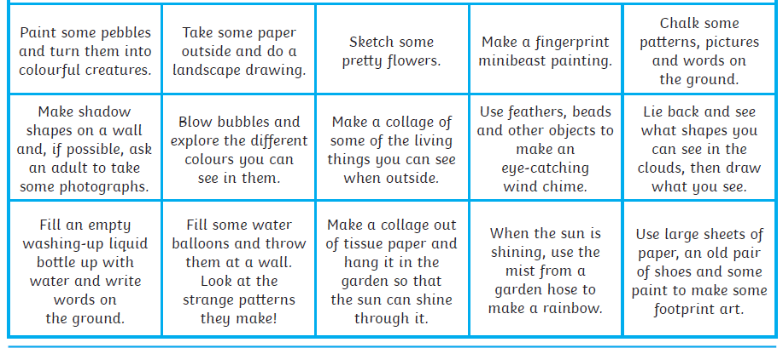

**Rights Respecting Schools**

