Windyknowe Home Learning Tasks Date issued: Wednesday 20th of May 2020
Class P2 Maths
Maths Task 1 | Maths Task 2 | Maths Task 3
L.I. To sort information using tally marks and block diagrams  You have now had a go of creating a tally table and block diagram all about ‘Favourite Food’.  You are now going to create your own tally table and block diagram. You can choose your own theme e.g. favourite Disney character, favoruite colour, favourite hobby. Ask members of your family and fill out your tally table and block diagram with their answers.  Use your tally table and block diagram from the last two weeks to help you. Once you have finished, you could send a picture to the school office for your teachers to see.  Food Type Tally Total  Pizza  Burger  Pasta  Salad  Hot Dog  Soup  Chips  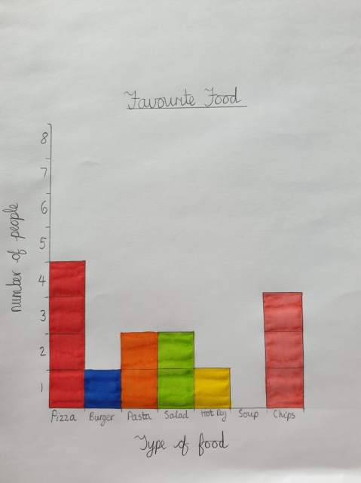  What was the most popular?  What was the least popular?  Do any have the same number? | L.I. To sort information using tally marks  Click the link below to see if you can read the tally table and find the correct answer. (Topmarks – Tally Chart Game)  https://www.softschools.com/math/data_analysis/tally_chart/ | L.I. To give and follow directions using simple language of movement  Create a maze for a teddy or toy car to travel through. You could use toys, construction blocks, books or anything  you wish.  Once complete, have a go at guiding the teddy/car through the maze.  Perhaps say how to move through the maze to a family member, who could move the toy.  When giving instructions, face the same direction as the toy before then moving it so it is easier to make the left and right turns.  Key Vocabulary might include: direction, turn, straight, forwards, backwards,  left, right, whole turn, half turn, move, journey

