Wednesday 20.5.20

Here are your jobs for today.

**Literacy Comprehension**  
**LI: to develop understanding of current events**

For comprehension today you are going to watch the news on Espresso and complete the quiz. You all did a wonderful job with this in previous weeks. Let’s see if you can beat your score or match it!   
Login to espresso education   
Username: student21929  
Password: windy29

Step 1)  
Once logged in, select Second Level & News

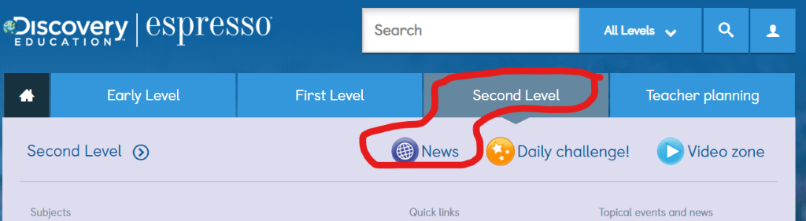

Step 2)   
Select News Bites + Quiz   
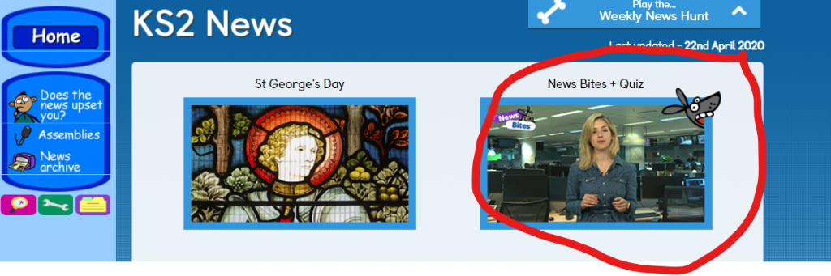

Step 3)  
Watch the news video. Afterwards, select News bites quiz and answer the questions!   
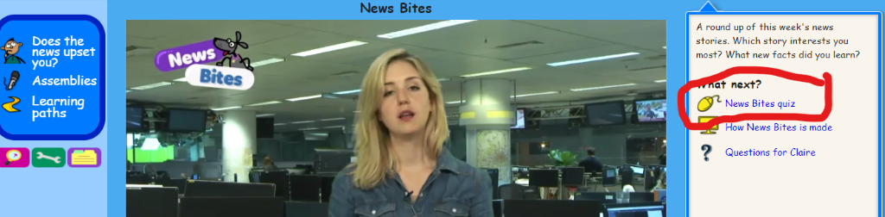

Step 4)  
Write down your score you got for the quiz and share this with your teacher!

**Numeracy**

**Rectangles**: L.I- To be able to calculate equivalent fractions

1) 8/12 2) 2/6 3) 4/24 4) 2/28 5) 4/48 6) 100/900

7) 15/150 8) 8/16 9) 3/42 10) 26/260 11) 17/51 12) 25/2500

13) 5/20 14) 5/200 15) 5/450

**Triangles**: L.I- To be able to calculate a percentage

1) 50% of 20 2) 50% of 150 3) 1) 50% of 1400

4) 25% of 24 5) 25% of 400 6) 25% of 60

7) 75% of 400 8) 75% of 1000 9) 75% of 800

10) 10% of 100 11) 10% of 400 11) 10% of 560

12) 5% of 80

**Circles**: L.I- To be able to find simple percentages

1) 50% of 8 2) 50% of 14 3) 50% of 52

4) 50% of 84 5) 50% of 108 6) 50% of 282

7) 50% of 84 8) 50% of 1000 9) 25% of 8

10) 25% of 60

**Optional Tasks**

* SumDog
* Active Learn Games

**Art Task**

**L.I. To be able to create an image in the style of Andy Warhol**

**Before you begin you will need:**

* **some paper (or use your jotter)**
* **Something to draw with e.g. pens, pencils**
* **A ruler to draw straight lines (if you don’t have a ruler you can fold your paper instead)**

**Your task today is to create an image in the style of Andy Warhol.**

1. **Read through the Andy Warhol PowerPoint saved in TEAMS-Files Section-Art Folder.**
2. **Split your paper into even boxes:**

**Mild-2**

**Spicy-4**

**Hot- 6**

**Extra Hot- more than 6**

1. **Draw the same image in each box.**
2. **Colour each image slightly differently.**

***You can add colour to your drawing using paints, chalks and/or pastels if you have them. If you don’t have any colours at home can you shade with your pencil dark, medium and light and make each image look slightly different.

Here are some images in the style of Andy Warhol to inspire you.

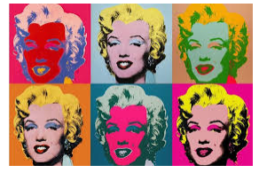 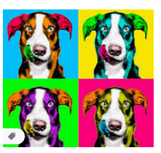

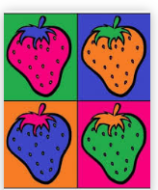 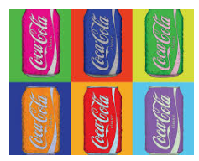

**Optional Extension Task:** Create a fact file about Andy Warhol.

**P.E – To observe and comment on skills in tennis**Make sure to check out assignments and tasks set by Mrs Howard

Today, you are going observe Roger Federer and Andy Murray play a game of tennis. Focus on just one of the players. Watching this clip: <https://www.youtube.com/watch?v=CGRzfUccmNE> Use the sheet below to help you structure your comments about that player. Think about the skills that player needs to play tennis successfully. There is also a word bank below the sheet to give you an idea of vocabulary you may use.

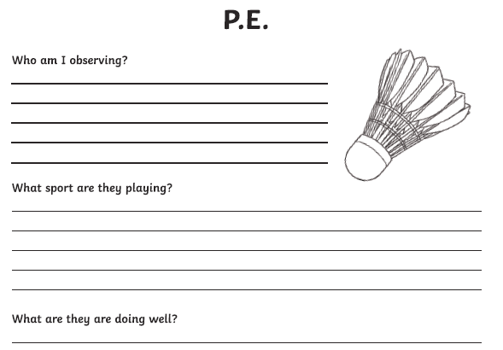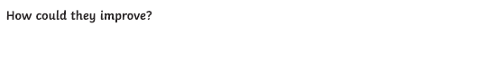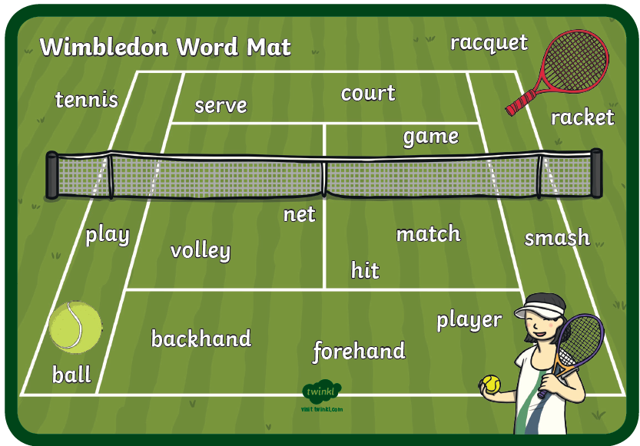

**Music**



**Mr Muller has placed new activities in your charanga inbox**

This can be access here <https://www.charangascotland.co.uk/yumu/login>

If you are unable to access charanga and you don’t have a username or password, let Mr Muller know