Tuesday 19.5.20

Writing
L.I. To write an acrostic poem
Have a look at the powerpoint to familiarise yourself with the features of an acrostic poem. Have a go at writing an acrostic poem about your chosen theme and upload it to the Assignments tab on teams.

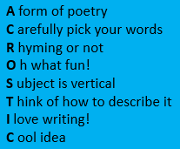

Numeracy
L.I. To estimate calculations
Look at this video to remind yourself how to round numbers. This will help you in your estimating
https://www.bbc.co.uk/bitesize/topics/zh8dmp3/articles/zpx2qty
Then, carefully go through the PowerPoint for your group. Answering the questions as you go along. Roughly calculate them in your head and then you can write your estimate down before revealing the answer.

Topic
L.I. To create my own invention
Before we started our digital learning, we researched some famous Scottish inventors. Have a look at the Famous Designers and Inventors powerpoint and complete the activity on the slides.

