Tuesday 19.5.20
Here are your jobs for today:
Writing -LI: To write an imaginative story
Watch: https://www.youtube.com/watch?v=qYAETtIIClk A movie trailer for ‘E.T - The Exta Terrestrial’
You are going to write an imaginative story about encountering a lifeform from Space! You Alien doesn’t have to look like E.T it can be completely different. Here are some things to include:
- Where did you meet the alien and what was your reaction?
- What is the alien’s name?
- Did the alien speak English?
- What does the alien look like?
- What planet did the alien come from?
- The alien is going to be around for a while, what things on planet Earth could introduce the alien to? Think food, animals, your house
- Do you and the alien become good friends?
*Draw a picture of your alien!

Numeracy - L.I-To be able to answer multiplication questions quickly and accurately
Play Hit the Button https://www.topmarks.co.uk/maths-games/hit-the-button
If you can please post your best score on Teams to let us know how you do. You can choose which table you practice. Maybe set yourself a mild, spicy and hot challenge? For example, start off with the 2 times table, then try 5 and finish with 7. This is just an idea but choose the tables you need to work on the most.
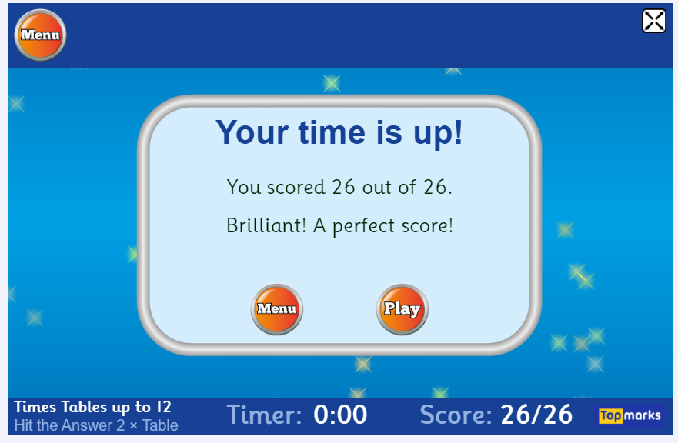
Optional Additional Tasks
- Active Learn Games- select from the games allocated to you. You can select your own level of difficulty in each game.
- Sumdog
- Explore other games on Topmarks. There are different categories to choose from. You can choose the level of difficulty on most of these.

Topic
LI – to discover key facts about the ‘Raining Glass exoplanet’.

Starter – can you click on the following link and spot where the International Space Station is? Which country or ocean is it over? Write answers in your green jotter. https://spotthestation.nasa.gov/tracking_map.cfm

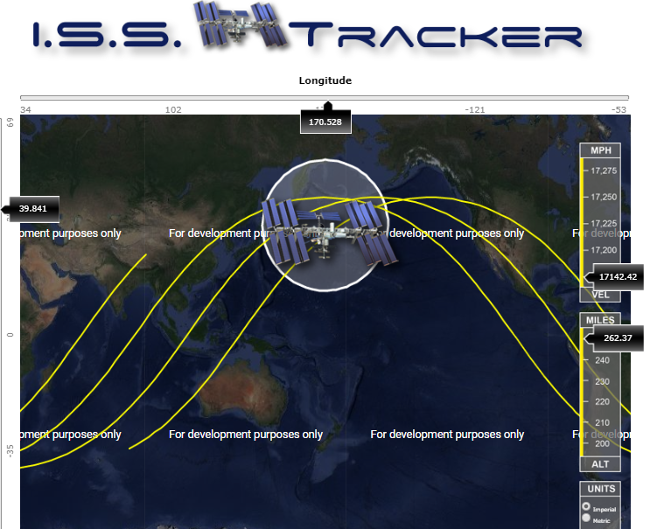

Topic Task

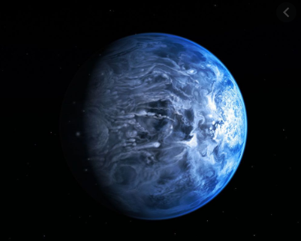
Starter – use a dictionary to find out these key words and write them down in your green jotter.
Density-
Asteroid -
Comet-
Main – watch this clip detailing the key features of the ‘Raining Glass exoplanet’
https://www.youtube.com/watch?v=cIonOmJz7gI
Use this website also
https://www.abc.net.au/news/2013-07-12/glass-rains-on-scorching-blue-planet/4815522
Mild – find 5 key facts about the Raining Glass exoplanet’
Spicy - find 7 key facts about the Raining Glass exoplanet’
Hot - find 10 key facts about the Raining Glass exoplanet’

Plenary – think of 3 ways this planet is different to ours. Type your answers on Microsoft Teams so Mr Muller and Miss Purdie can see your answers.

Music
• Short videos that tell the story of Fever!
• Lyrics and teaching guides for pupils to practise each of 5 songs
• Videos that help teach the accompanying choreography
• A Curriculum for Excellence-based creative writing and science activities
• Tips to make simple props and costumes
www.scottishopera.org.uk/fever

