Heading for High School

arrows4

**Thinking**

PE01644_

pe03254_

ED00119_

**My Journey Begins Here!**

j0215228

**Feeling**

**Talking**

**Primary / Secondary Transition**

Name \_\_\_\_\_\_\_\_\_\_\_\_\_\_\_\_\_\_\_\_

**Settling into High School**

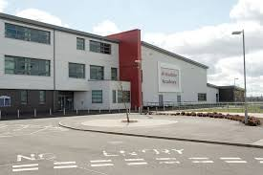

Sometimes something can happen at school that makes you upset or anxious. A lot of people feel like this especially when they are starting somewhere new.

* **Keep calm.** Tell yourself, “I can solve this problem if I stay calm.”
* **Decide what the problem is.**

- Are you frustrated because you could not do something you wanted?

- Are you upset because someone did something to you?

- Are you worried because something has gone wrong?

* **Think about possible solutions.**
* **Think about the consequences.** What will happen if you try different solutions?
* **Pick the best solution.**

Talk with a friend about what you would do in each of these situations in school.

1. You haven’t done your homework.

2. You have forgotten your student planner.

3. You are in a crowd going upstairs and you think someone pushed you.

4. You think you are lost.

5. You see someone being bullied.

6. You find someone crying in the corridor.

7. You’ve lost your purse/ wallet.

8. You see someone stealing money from someone’s bag.

9. You find someone’s purse.

10. You’ve ripped your trousers/ skirt.

Thoughts About Changing School - either draw or write your ideas in the speech bubbles

**Things that**

**I am worried**

**about**

Not being able to do the work

**HOMEWORK**

**Getting Lost**

**Being on Time**

**Dinner Time**

**The School Rules**

**Meeting new Teachers**

**Being with older pupils**

**Following a Timetable**

Pick two different colours, highlight the phrases that you are looking forward to in one colour; and use a different colour for those you are worried about.

|  |  |
| --- | --- |
| Making new friends | Learning a new timetable |
| Dinner time | Taking a shower |
| Having a different uniform | Being on time |
| Finding way around | Break times |
| Getting to school | Learning new subjects |
| Meeting others my own age | Joining clubs |
| Being with friends | School rules |
| Homework | Meeting my new tutor |
| Meeting my new teachers | Being able to do the work |
| Being with older pupils | Getting changed for sport / PE |

Use this page to make a list of the things that made you happy and the things you are worried about. Once you have done this try to think of one thing that would take away your worry, this is something we can talk over when we get together.

|  |  |
| --- | --- |
| Happy | Worries |
|  |  |

## 

Using a solution – focused approach

**Think about something that worries you about changing schools**

\\Eh548hl\Staff\Staff Shared\Social Care Team\Social Care Team\Tracey\Printable Number Line 0 to 10_files\numbers0_10.gif

MCj04244700000[1] MCj04244800000[1]

On a scale of zero to ten how worried are you about going to Secondary school?

What would make you feel less worried? \_\_\_\_\_\_\_\_\_\_\_\_\_\_\_\_\_\_\_\_\_\_\_\_\_\_\_

\_\_\_\_\_\_\_\_\_\_\_\_\_\_\_\_\_\_\_\_\_\_\_\_\_\_\_\_\_\_\_\_\_\_\_\_\_\_\_\_\_\_\_\_\_\_\_\_\_\_\_\_\_\_\_\_\_\_

Have there been times when you have been worried about something before?

\_\_\_\_\_\_\_\_\_\_\_\_\_\_\_\_\_\_\_\_\_\_\_\_\_\_\_\_\_\_\_\_\_\_\_\_\_\_\_\_\_\_\_\_\_\_\_\_\_\_\_\_\_\_\_\_\_

What happened to make things better for you? \_\_\_\_\_\_\_\_\_\_\_\_\_\_\_\_\_\_\_\_\_\_

\_\_\_\_\_\_\_\_\_\_\_\_\_\_\_\_\_\_\_\_\_\_\_\_\_\_\_\_\_\_\_\_\_\_\_\_\_\_\_\_\_\_\_\_\_\_\_\_\_\_\_\_\_\_\_\_\_\_

What point would you like to be at before going to Secondary school?

\_\_\_\_\_\_\_\_\_\_\_\_\_\_\_\_\_\_\_\_\_\_\_\_\_\_\_\_\_\_\_\_\_\_\_\_\_\_\_\_\_\_\_\_\_\_\_\_\_\_

What would make it one point nearer now?

What Will I Need For school?

j0290903

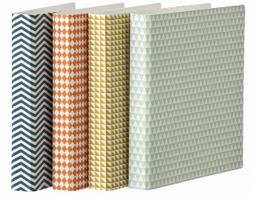 j0237451

j0290924



j0412400

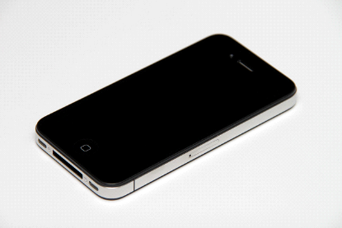

j0424224

j0396320

j0424240

Circle the things that you may need for school.

Can you draw anything else you may need for school?

Remember, you may not need the same things each day.

Break and

Lunchtime

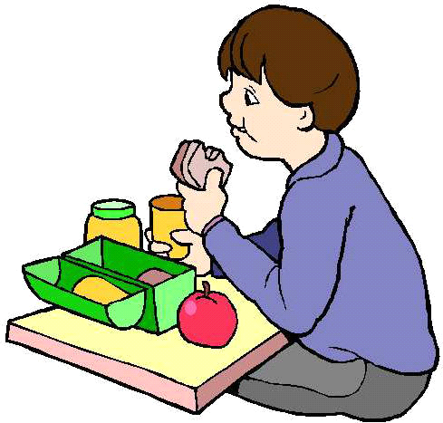

During break and lunchtime you can eat your snack. You can bring a snack from home or buy something from the school canteen.

You can go out to the playground and talk to your friends.

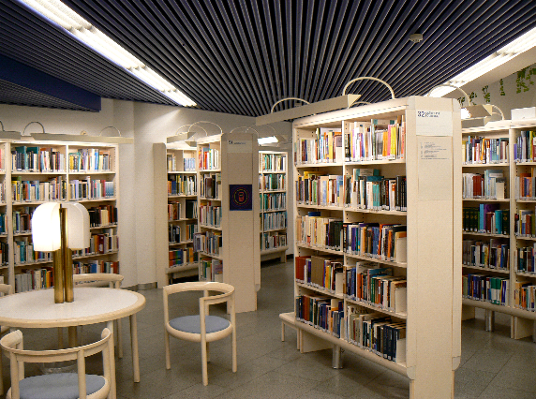

Some people may go to the library or to the pupil support area.

**What do you like to do during break and lunch times?**

Find out some information about break and lunch

at your new school ...

Starts Ends Duration

Morning Break : : minutes

I can go to the \_\_\_\_\_\_\_\_\_\_\_\_\_\_\_\_\_\_\_\_\_\_\_\_\_\_\_\_\_\_\_\_\_\_\_\_\_\_\_\_\_\_\_\_

I can bring a snack to school and eat it at this time.

Starts Ends Duration

Lunch Break : : minutes

I can go to the \_\_\_\_\_\_\_\_\_\_\_\_\_\_\_\_\_\_\_\_\_\_\_\_\_\_\_\_\_\_\_\_\_\_\_\_\_\_\_\_\_\_\_\_

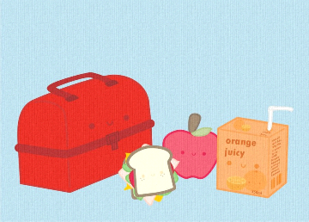

I can bring a packed lunch or I can go to the school canteen to buy lunch.

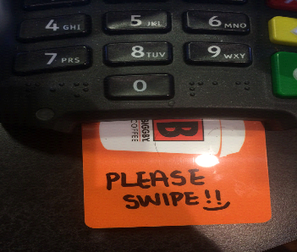

I will be given a swipe card or a lunch number to use in the canteen to buy food. An adult will show me how to use this.

Getting Organised

Timetable

You will be given a timetable to let you know when your classes will start and end, what your class subject will be and which teacher will teach your subject. It will also tell you when your breaks and lunchtime are.

Reading your timetable, at night, will help you know what to pack for the next day. Pack only what you need!

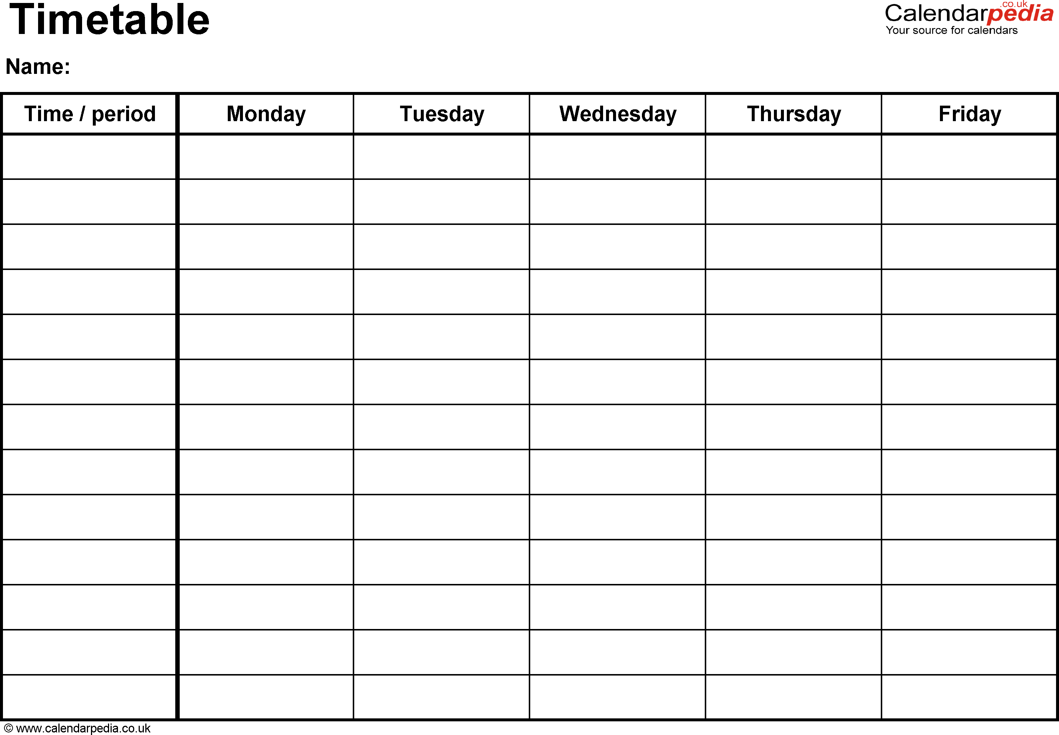

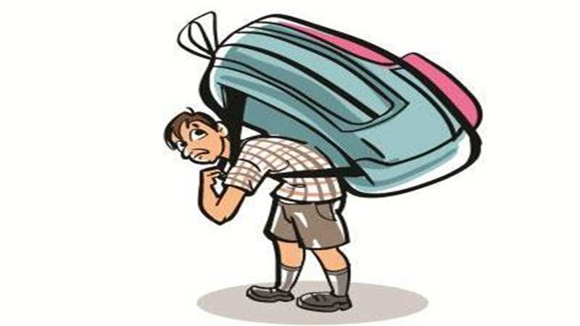

**Argh !!!!**

**I forgot to read my timetable and pack only what I need!**

If you forget something then don’t worry.

Everybody does it sometimes, even the teachers.

Homework

You may be used to getting some homework at Primary School. It is important because it helps you practice the work you have been learning in class.

In S1 you will get more homework than you have been used to in P7. Teachers will expect it to be completed and handed in on time.

What can you use to help you keep track of the homework you are given?

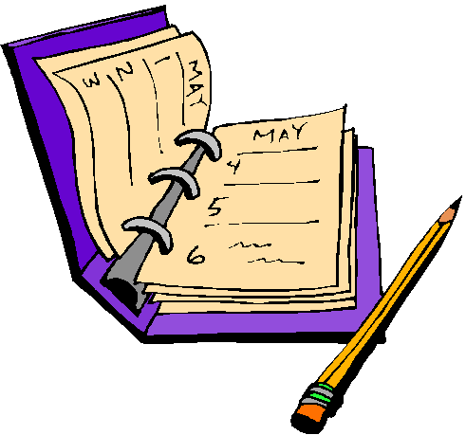

Who can help you if you do not understand some of your homework?

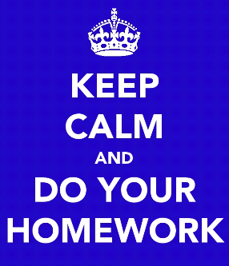

School Rules

School rules help to make a safe, respectful and positive learning experience for everyone.

What I will do to be safe, respectful and ready to learn!

Finding My Way Around

1. Some schools have maps to help you find your way around.

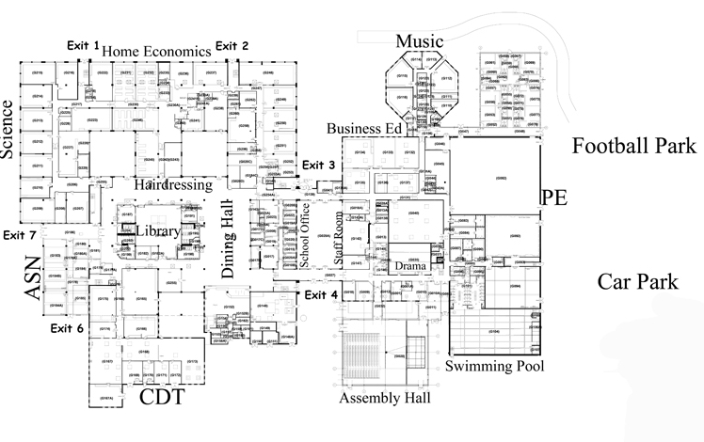

Look at your Secondary School’s website to see if you can find a map. Print it or copy it in the box below.

2. Follow the signs on the wall. They will lead you in the right direction.

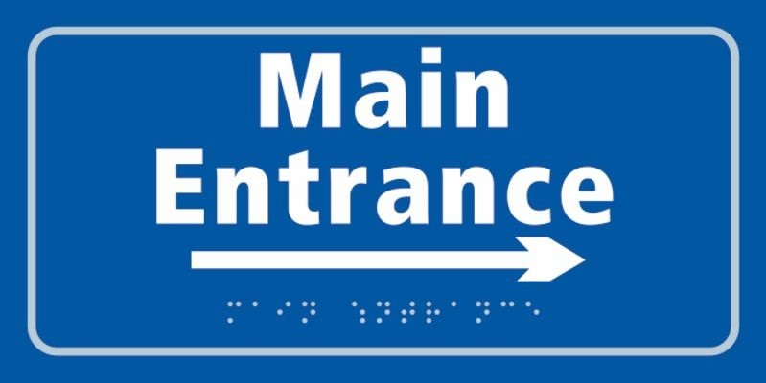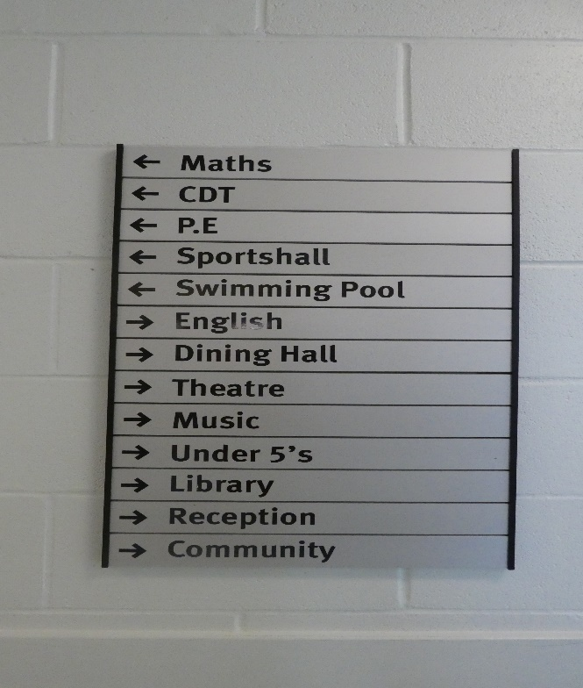

**Make a sign to direct you to the Dining Hall.**

Ask Someone to Help You

There are many people in your new school who are willing to help you find your way. Discuss who they might be and record your answers below.



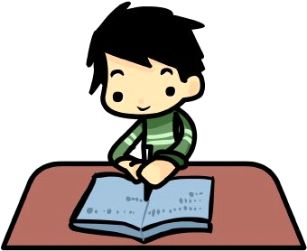

Ready to Learn?

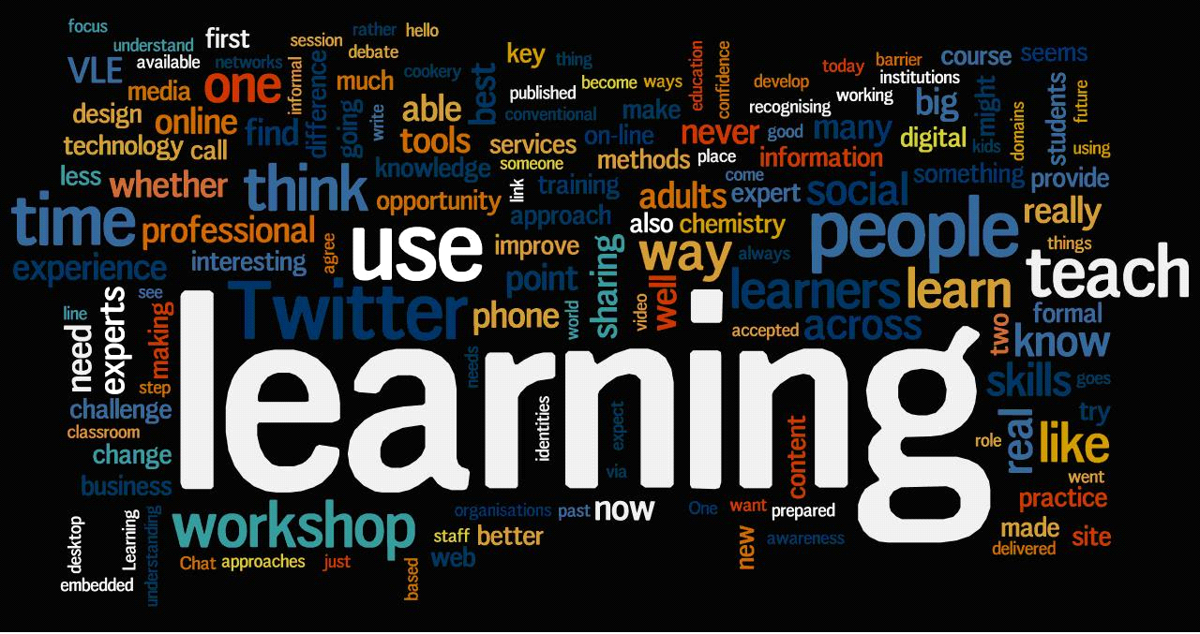

People learn in different ways.

Take the CHAMPS Quiz to figure out how you learn best!

I learn best by ...

What I Need to Know About My New School

|  |  |  |  |
| --- | --- | --- | --- |
| Target | Achieved | Date achieved | Signature |
| I know where to go if I need help |  |  |  |
| I know what to do if I am late |  |  |  |
| I know what to do if I feel ill |  |  |  |
| I know how to find my friends during the day |  |  |  |
| I know what to do if I am going to be off school |  |  |  |
| I know what to do when I come back to school if I have been off |  |  |  |

What would you do if…..

What would you do if…..

Use the game cards to help you discuss the following scenarios.

1. You forget to do your homework.
2. You forget your diary.
3. You are in a crowd going upstairs and someone falls over in the rush.
4. You think you are lost.
5. You see someone being bullied in the playground.
6. You find someone crying in the corridor.
7. You lose money.
8. You see someone stealing from someone’s bag.
9. You find something that doesn’t belong to you.
10. You rip your trousers.

I am Ready to

Start my Adventure!

**Create a positive message poster about going to Secondary School.**