**Thursday 14.5.20**

**Literacy**

Log in to Studyladder, and find the following activities in the section with your group name.

**Simile**

L.I. To identify and use plurals

* Plurals – adding ‘s’

**Personification**

L.I. To identify and use irregular plurals

* Irregular plurals

**Metaphor and Alliteration**

L.I. To use adjectives to classify

* Adjectives used to classify

**Maths**

**L.I To estimate/measure an area**

**To plan and make choices for spending within a budget**

*The following task has been allocated to you in ActiveLearn:* ***SL Real Life Problem Solving 02 Design a Park***

You are going to design your very own park!

* On the first screen, select the budget for their park.
* Drag squares of different surfaces onto a diagram of the park until the area is completely covered.
* Remove unwanted surfaces by dragging another surface over the top.
* Each surface costs a different price per square metre and you can see a running total of the money you have spent.
* On the next screen, select features and equipment by dragging them onto the diagram.
* Use the arrow keys to scroll through the items available. Items can be moved around the park or removed altogether.
* The running total of money spent updates with each item added or removed.
* Once you’re finished, click Next to access a final results screen which shows the finished park diagram and gives a summary of the costs and budget.

Now, you’ve had a practise. Try the following challenge allocated to your group (once you’ve completed your group task, feel free to try work from another if you’ve got the hang of it). Note how you got on in your Green jotter.

|  |  |  |
| --- | --- | --- |
| **Number Ninjas/ Maths Magicians** | **Mathletes** | **Algebros** |
| **Design a park that costs less than £5000** | **Design a park that costs between £4000 and £5000** | **Design a park that costs between £4000 and £5000** |
| **Design as cheap a park as possible.** | **Design as cheap a park as possible that would keep 9 children happy** | **Design the most expensive park you can that has equipment for no more than 5 children to play on.** |
| **Design a park suitable for young children** | **Design a park suitable for teenagers** | **Design a nature park suitable for the elderly** |

*Extra spicy extension (optional): Choose a budget for your park and see if you can spend exactly that amount!*

Link Lizard Ideas (optional)

Sciences – explore different surfaces, such as bark, grass, rubber tiles or recycled tyre mulch; drop a hard-boiled egg onto a surface, from the same height each time, and decide which would be best to use for a play area

Expressive Arts – Art and Design / Technologies – create a model of a local park using different materials and media using research findings

Literacy and English – write a persuasive leaflet to encourage people to visit your new park

**Art**

**L.I. To draw a picture using perspective**

I was taking a walk in my local park during our lovely weather last week, and I took some photos of the beautiful blossom trees. When I got home, I had a look at the photos and it really got me thinking about the one-point perspective drawings we were looking at last week.

Have a look at the ‘Drawing Perspective’ powerpoint to understand the terms **vanishing point, horizon line** and **lines of perspective.**

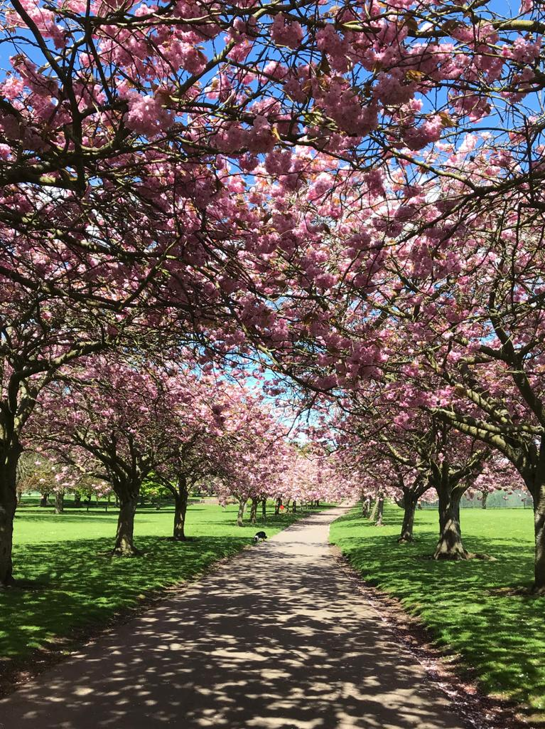

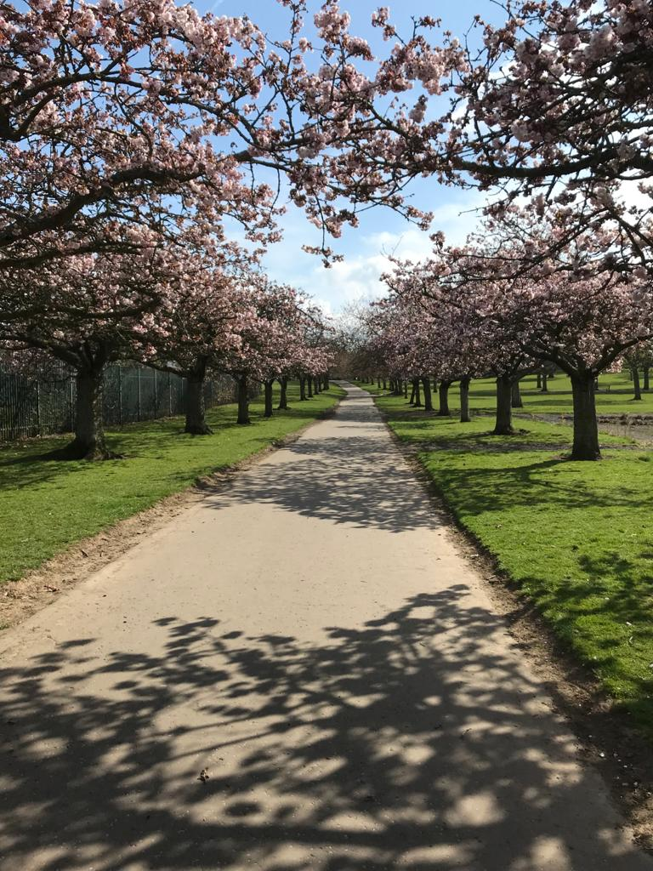

Can you spot the **vanishing point** in the photos of the blossom?

Now have a go at creating your own perspective piece. You can use the photographs attached as inspiration, or you can create your own scene. Here is an example to get you started on your own drawing:

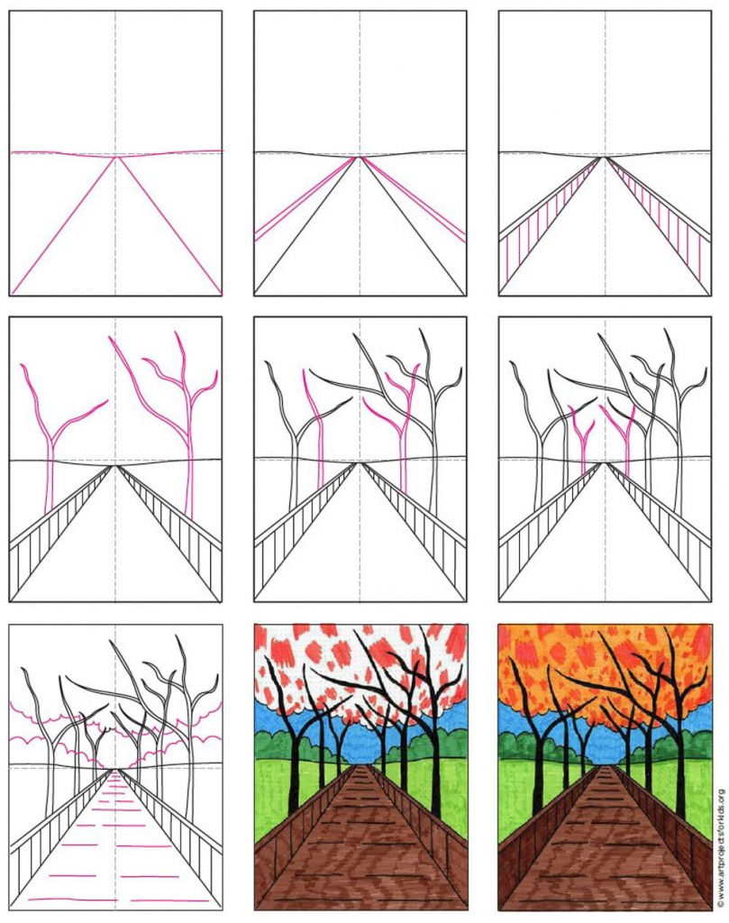

I can’t wait to see how your pictures turn out!