**Thursday 14.5.20**

**Editing Sentences**

Edit the sentences in the game by unscrambling them!  
<https://www.turtlediary.com/game/sentence-unscramble-fifth-grade.html>

**LI: to edit and correct spelling mistakes**   
Greens - You can go online or ask an adult if unsure of the incorrect spelling. Can you spot them?  
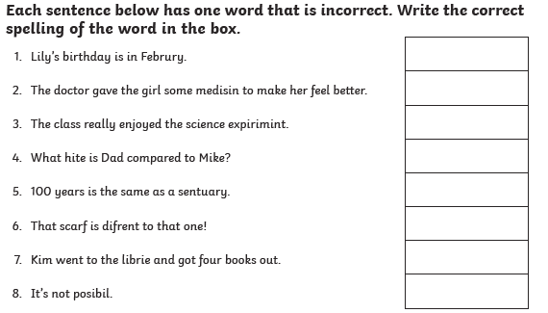

**Blues**  
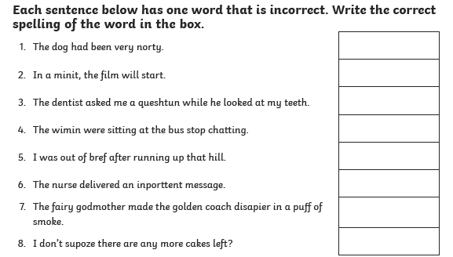

**Reds**  
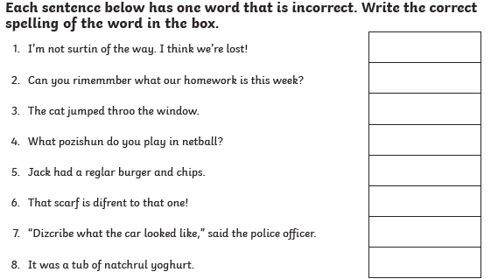

|  |
| --- |
| Some extra literacy games: Punctuation Speed check: <https://www.turtlediary.com/game/identify-correct-punctuation.html>  Prefix and Suffix game (flash required)- <http://flash.topmarks.co.uk/4762>  [**https://www.bbc.co.uk/bitesize/topics/zf2f9j6/articles/z3c6tfr**](https://www.bbc.co.uk/bitesize/topics/zf2f9j6/articles/z3c6tfr) Put your typing skills to the test! |

**Maths – LI – to use my knowledge measuring a perimeter and use it to calculate the surface area of chocolate bars.**

**Answers and working to be written in your green jotters.**

**SC**

**I can identity the perimeter on a 2D shape**

**I can multiply the width and height to calculate the total surface area**

**I can put a small ‘2’ at the end of my answers to show surface area which means**

**Starter -** <https://www.youtube.com/watch?v=d_6XOBpoDz4>

Main **(for this task you each box represents 1cm squared. So when you are asked to measure the surface area of each shape, you are going to count each box as measuring 1cm in length and 1cm in height)**

**Circles**

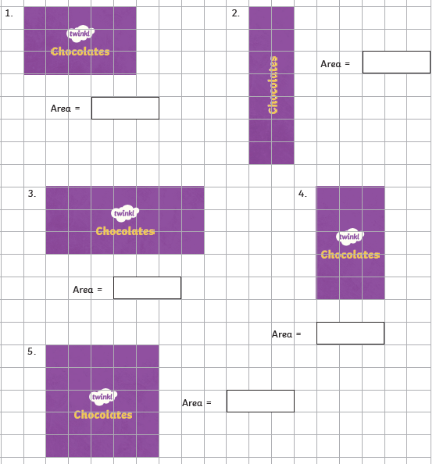

**Triangles**

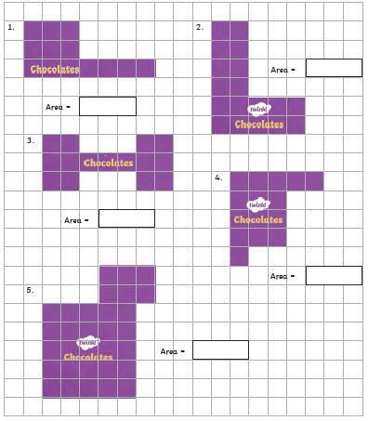

**Rectangles - remember to work out the surface area of the white squares**

**and SUBTRACT the white squares for questions 1 and 5**

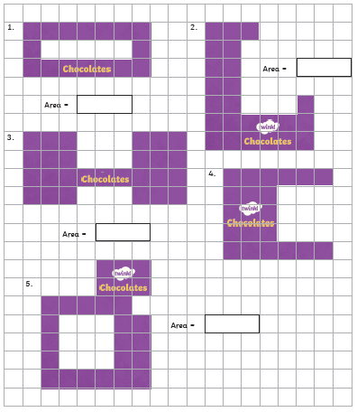

|  |
| --- |
| **Rights Respecting Schools Lesson** |

**Music**

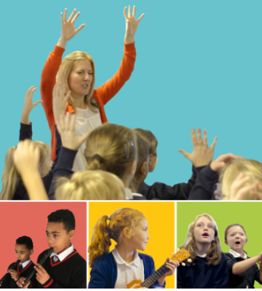

**Mr Muller has placed new activities in your charanga inbox**

This can be access here <https://www.charangascotland.co.uk/yumu/login>

If you are unable to access charanga and you don’t have a username or password, let Mr Muller know