Planet Earth comprehension self-marking sheet

\*\*\* Hot answers

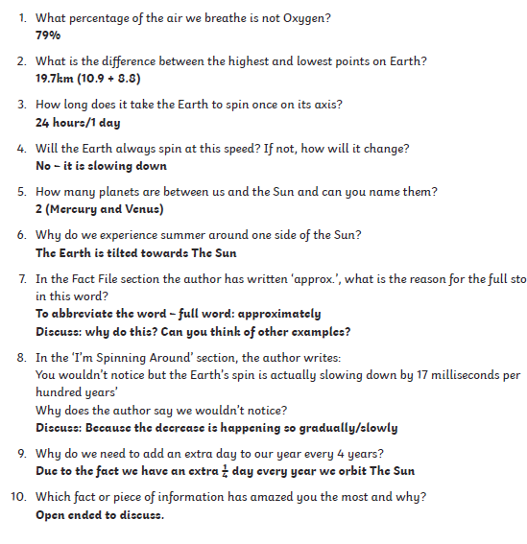

\*\*Spicy answers   
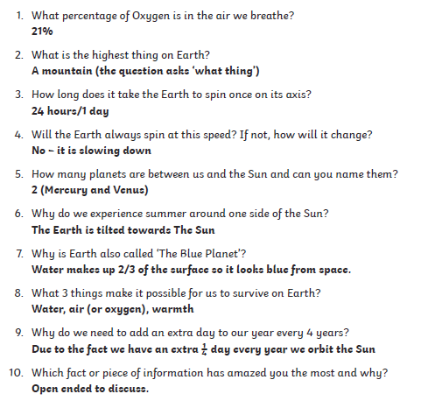  
  
\* Mild answers

