Wednesday 13.5.20

Here are your jobs for today.

**Literacy Comprehension**  
**LI: to read for information about Earth.**

For comprehension today you are going to read a passage about Earth and answer the questions suited for your group. **The passage is the same for all groups.** Answers will be posted later in the day!

Passage for all groups  
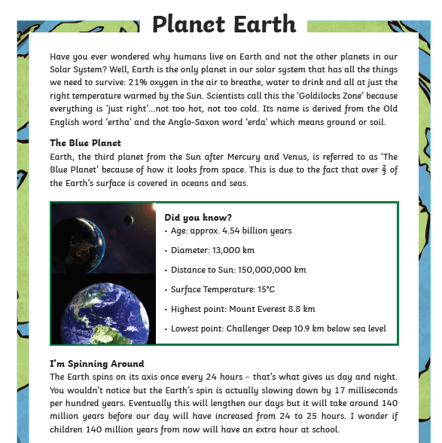

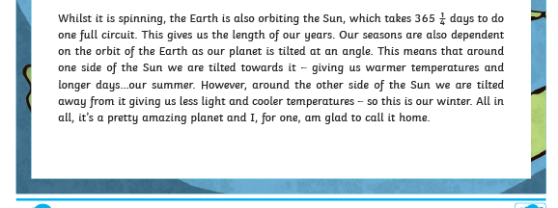

*Mild questions   
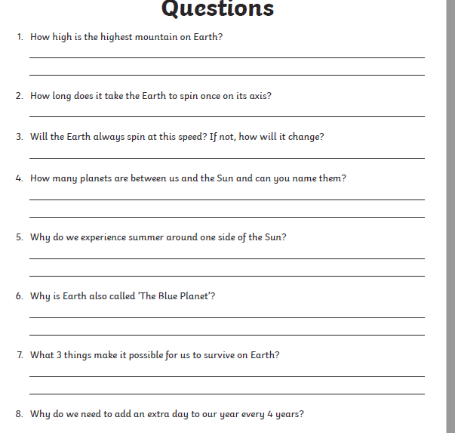  


**Spicy questions  
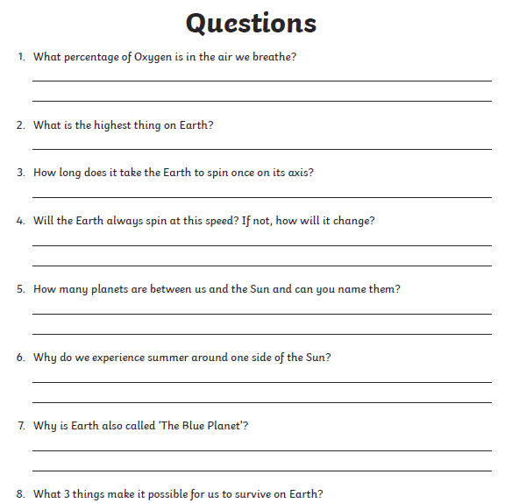  
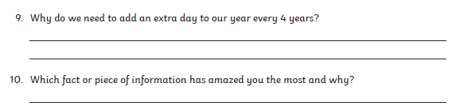

***Hot Questions

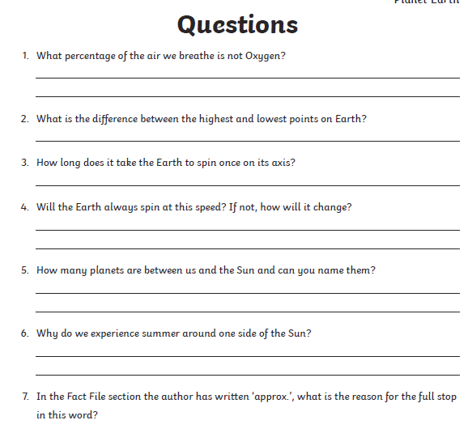  
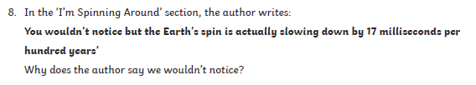  
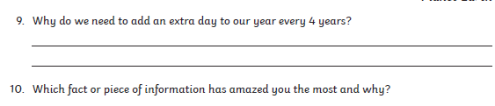

**Numeracy**

**Rectangles**: L.I- To be able to calculate equivalent fractions

1) 10/10 2) 2/6 3) 4/28 4) 2/22 5) 2/100 6) 100/600

7) 15/60 8) 8/88 9) 30/390 10) 26/52 11) 7/140 12) 25/450

**Triangles**: L.I- To be able to calculate a percentage

1) 50% of 24 2) 50% of 190 3) 1) 50% of 202

4) 25% of 400 5) 25% of 175 6) 25% of 44

7) 75% of 500 8) 75% of 2000 9) 75% of 900

10) 10% of 50 11) 10% of 130 11) 10% of 670

12) 5% of 120

**Circles**: L.I- To be able to find simple percentages

1) 50% of 2 2) 50% of 10 3) 50% of 14

4) 50% of 90 5) 50% of 108 6) 50% of 192

7) 50% of 44 8) 50% of 400 9) 25% of 50

10) 25% of 44

**Optional Tasks**

* SumDog
* Active Learn Games

**Art Task - Banksy**

**L.I. To be able to create a Banksy inspired image**

**Before you begin you will need:**

* **some paper (or use your jotter)**
* **Something to draw with e.g. pens, pencils**

Banksy is an anonymous graffiti artist. That means he keeps his identity hidden. He will not do media interviews, he won’t release his real name, and he will not allow photos or copies of his artwork to be made and sold. There is a PowerPoint presentation about him in Files on your class Teams or you can follow the links below.

<https://www.bbc.co.uk/newsround/46632542>

and

<https://www.bbc.co.uk/newsround/52561722>

**Task: Can you create an image in the style of Banksy that shares your thought or opinion about something important to you? You can do this in your jotter or on a separate piece of paper.**

Here are some examples to inspire you. You can find more on the PowerPoint if you haven’t already looked.

What do you think Banksy is trying to say through each image?

What do you notice about the colour he uses?

Does he have a detailed background?

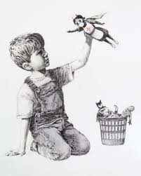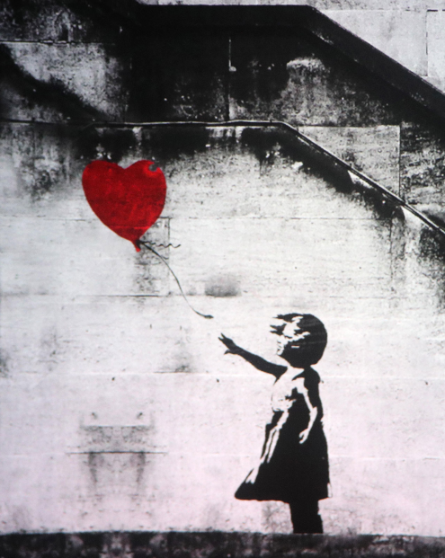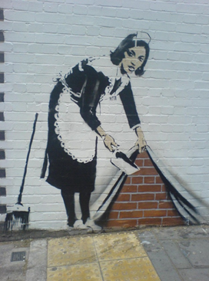

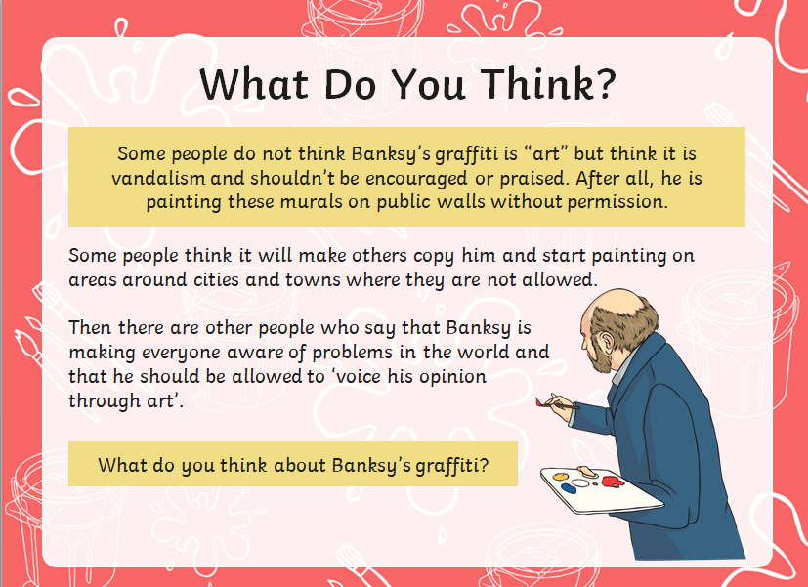

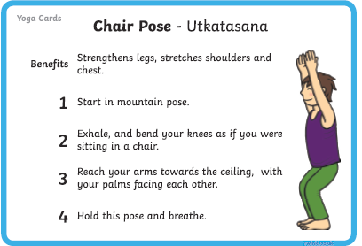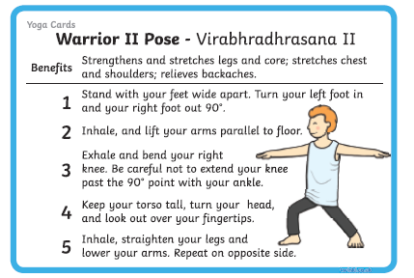**P.E – To develop balance, agility and co-ordination**Joe Wick’s video will be posted by Mrs Howard but here are some breathing exercises to try!  
Here is a Harry Potter themed yoga for anyone who hasn’t tried it! <https://www.youtube.com/watch?v=R-BS87NTV5I&vl=en>  
 Remember to only do this in a safe space!  
  
Now try these yoga poses to practise your balance, agility and co-ordination. Tip: hold these poses for 20-30 seconds and remember to breathe through the nose and out the mouth. When practising you could put on a song that calms you. Here is a recommendation from Miss Purdie – Bill Withers ‘A Lovely Day’ <https://www.youtube.com/watch?v=bEeaS6fuUoA>

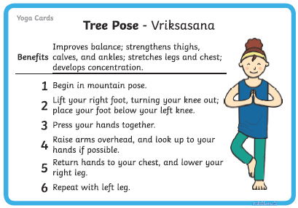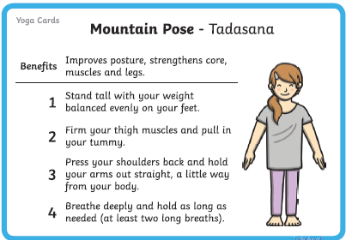

**Music**

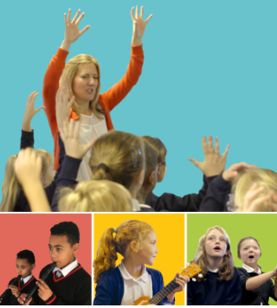

**Mr Muller has placed new activities in your charanga inbox**

This can be access here <https://www.charangascotland.co.uk/yumu/login>

If you are unable to access charanga and you don’t have a username or password, let Mr Muller know