Class: Primary 2 Other Curricular Areas Week Commencing: 11th of May 2020
Expressive Arts | Health and Well Being | French
The Wallace Monument was built in the 1860s to celebrate William Wallace’s bravery.  Using what you have in your house or garden try to build a model of the Wallace Monuments. You can use whatever you would like.  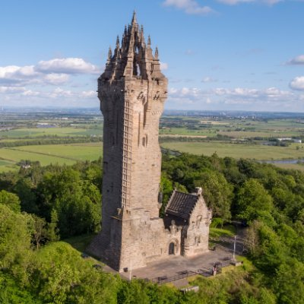 | - See Mrs Howard’s PE lesson.  - Windyknowe Rights Respecting School Challenge- PowerPoint with details attached to blog post. | We are learning to say different items of clothing in French.  Watch a practice the song. Can you match any of the clothes from the video to what you are wearing?  https://www.bbc.co.uk/teach/class-clips-video/french-ks2-clothes-and-colours/zkhxpg8  Once you have finished watching the video try to see if you can describe on thing you are wearing today- even better if you can include the colour in French as well!!
Music | RME | Topic – William Wallace
We are learning to create a rhythm pattern  Login to Charanga and click onto the ‘Your Imagination’ Yumu pack.  Listen to: Listen and Appraise – Pure Imagination. Talk about the music using the questions as a guide.  Further down, use the Warm-up Games and find the pulse (the heartbeat of the music) by marching around. Can you find different ways of showing the pulse e.g. tapping, clapping etc?  Click into: Learn to Sing the Song – Your Imagination; sing along to the song. Have a look at the Improvise with the Song section; create your own patterns for Improvise with the Song, each pattern should last for four counts (beats) to fill the gap.  Perform for your family members at home. | We are learning about world religions.  Siddhartha and the Swan watch the video below.  https://www.youtube.com/watch?v=J-UwlloVveI  These stories are all about helping others. What are some of the ways that you look after the animals around you? Think about your pets as well as animals that live in nature around you. | William Wallace is another famous historical Scot. Watch the video on the link below and create a fact file, poster or wanted poster for everything you learn.  https://www.bbc.co.uk/bitesize/topics/z8g86sg/articles/z6q8382  Willam Wallace was so brave that the people of Scotland wanted to remember him. They built a monument in Stirling to remember him. This is called the Wallace Monument.  Click on the link below for a VIRTUAL TOUR of the monument.  https://www.nationalwallacemonument.com/the-monument/

