Monday 11.5.20   
Hello Primary 6! Today we have Literacy, Numeracy and Health. Remember Mrs Howard will also be posting tasks for today in your P.E channel on TEAMS.

Here are your jobs for today:

**Literacy (Spelling & Reading)**   
**LI:to identify and spell common words**

Read the next chapter in your reading book or a book of your choice for around 30minutes. (If you are unsure what chapter you are on contact your teacher)   
Spelling – Prefix and suffix words   
Your main task is set below your common words for this week.  
  
If finished, you can also access: <https://www.topmarks.co.uk/english-games/7-11-years/spelling-and-grammar> and choose from a wide range of fun spelling activities and games! (Some may require flash to work)

|  |  |  |
| --- | --- | --- |
| **Mild**  Slowly  Sadly  Sadness  Cheerful  Jobless | **Spicy**  Troublesome  Moveable  Existence  Happiness  Antifreeze | **Hot**  Disappointment  Amazement  Magician  Mathematician  Penniless |

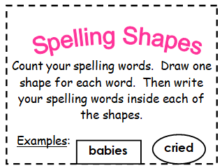

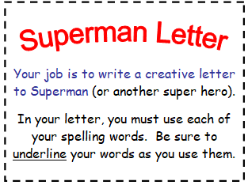

**Health**

**L.I- To develop a growth mindset**

1. Watch this clip ’How to develop a growth mindset’

<https://www.youtube.com/watch?v=vRQkxeBDEF0>

2. Can you think of a time when you thought something was too difficult but you managed to it?

**Task:** Here are some examples of negative thoughts that someone might have. Can you think of a more positive way to look at each situation? You can discuss with someone at home or write your ideas in your jotter.

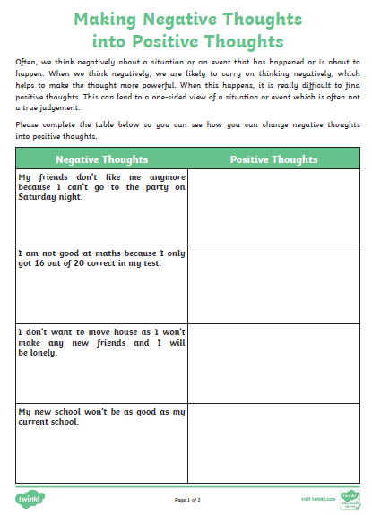

Optional Task: Create a growth mindset quote poster: here are some examples:

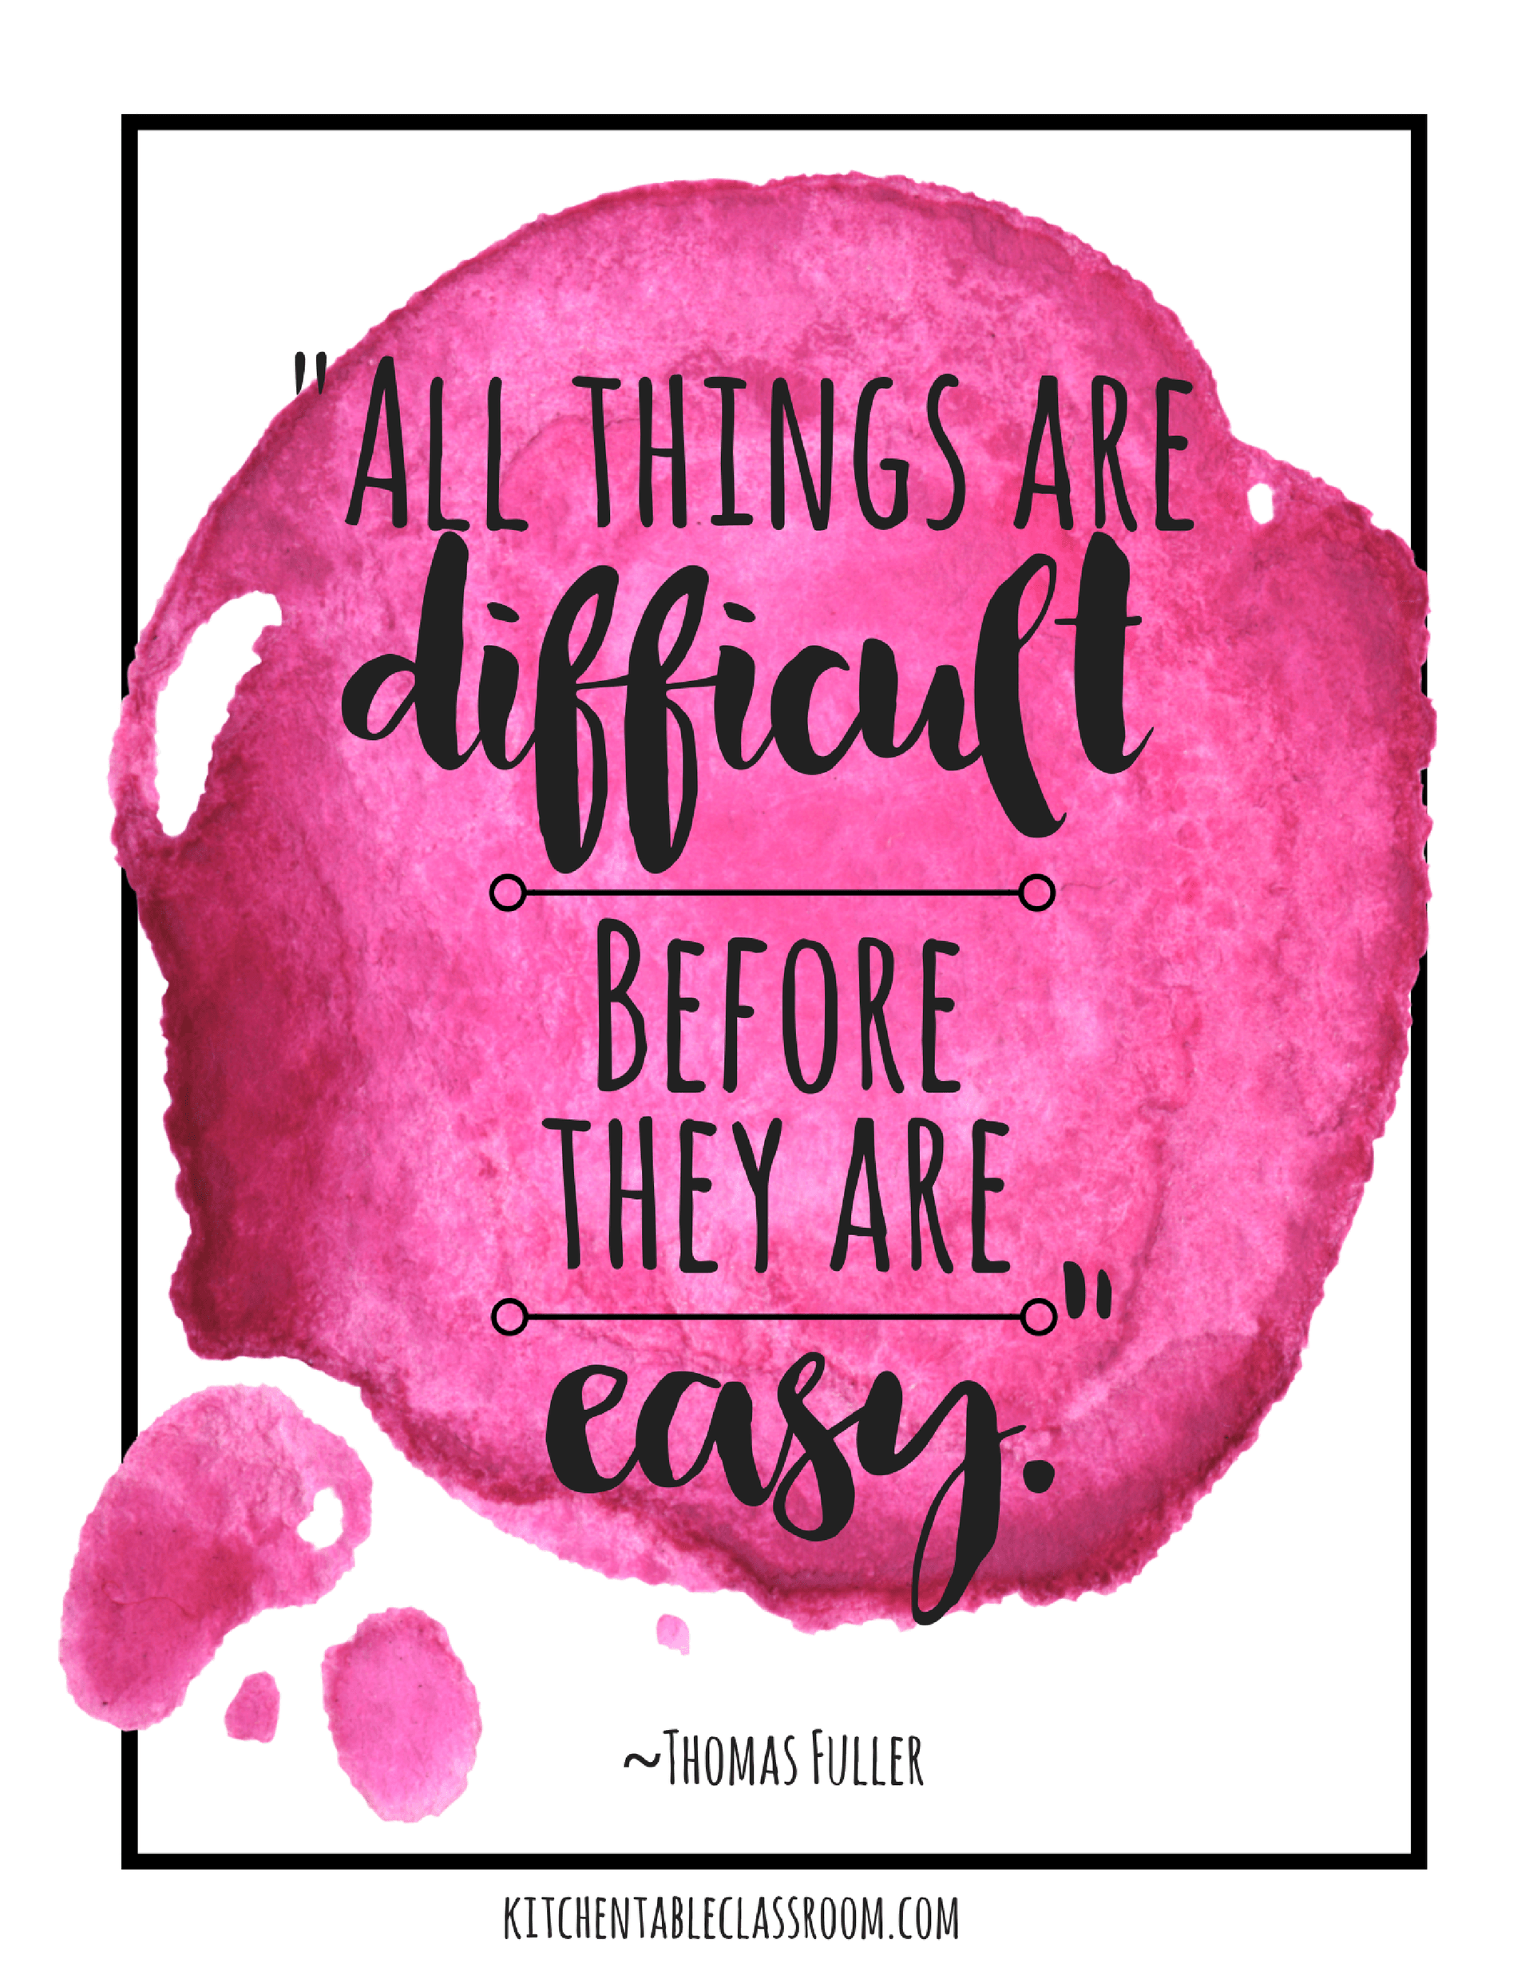  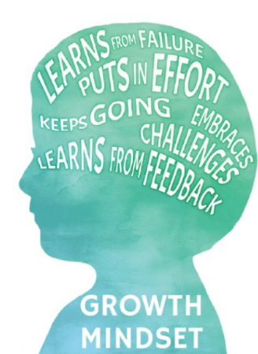

**Numeracy- Word problems**

This week we are going to apply our knowledge of multiplication. You can choose to complete mild, spicy or hot.

Mild: 1 step to each problem (2,5 and 10 timestables only)

Spicy: 1 step to each multiplication problem

Hot: more than one step to each problem using different operations (multiplication, division, addition and subtraction)

Mild Task **L.I- To be able to apply my knowledge of multiplication**

*Tip: Try drawing pictures to help you.*

1. Ben had 10 boxes of pencils. Each box has 5 pencils. How many pencils does he have altogether?
2. Ash has 2 bags of apples. Each bag 5 apples. How many apples does Ash have altogether?
3. Jenny has 5 tubs of sweets. Each tub has 10 sweets in it. How many sweets does she have altogether?
4. Lyle has 6 pots. He puts 2 plants in each pot. How many plants does he have altogether?
5. Lucy has 3 friends. She gives each friend 5 cakes. How many cakes did she give altogether?

Spicy Task **L.I- To be able to apply my knowledge of multiplication**

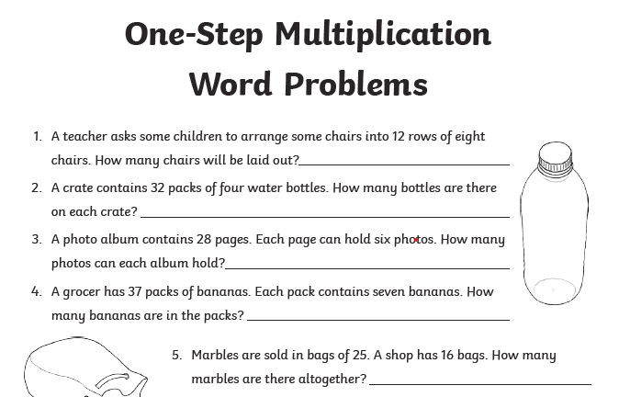

**Hot Task L.I- To be able to solve multistep problems**

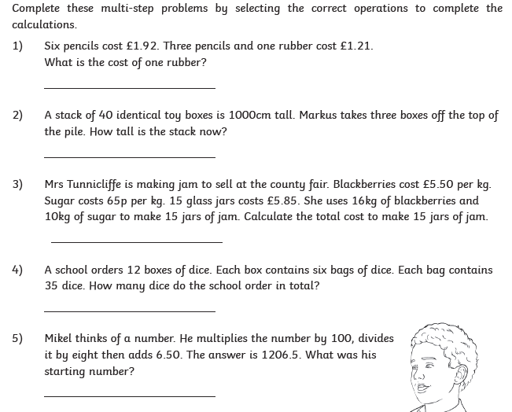

Music



• Short videos that tell the story of *Fever!*  
*• Lyrics and teaching guides for pupils to practise each of 5 songs*  
*• Videos that help teach the accompanying choreography*  
*• A Curriculum for Excellence-based creative writing and science activities*  
*• Tips to make simple props and costumes*

[**www.scottishopera.org.uk/fever**](https://scottishopera.us14.list-manage.com/track/click?u=e22f567381737e921e1f0663e&id=54b7ecf400&e=6ebd889d3b)