**Friday 8.5.20**

**Typing**

**L.I. To learn the position of each letter on a keyboard**

Last week we had a go at learning how to touch type. Let’s try the next task today. Click on this link and practice ‘Level 1 – e,i’. This actitvity only works on a **laptop**.

<https://www.bbc.co.uk/bitesize/topics/zf2f9j6/articles/z3c6tfr>

If you are on a **device**, try this activity instead:

**Mild - Hot**: <https://www.turtlediary.com/game/typing-race-beginner.html>

You can choose your level depending on how confident you are about typing

**Extra Hot**: <https://www.typerush.com/> (you can play the boat or the car race)

**Problem Solving**

**L.I. To reason logically**

Would you rather? Solve the following problems and explain your answers in your green jotter. You may use a calculator if you have one however challenge yourself mentally first.

**Key questions**

How will you compare these two scenarios?

How did you get to the answer? (a sum? picture? problem solving strategy?)

**Would you rather...**

1. ...have 5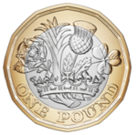 coins or 12 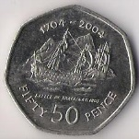 coins?
2. … have 1/2 half of a cake or three fifths of a cake? 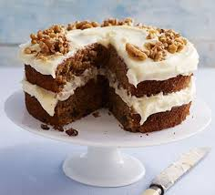
3. … climb 120 stairs over 2 minutes or 150 stairs over 100 seconds? 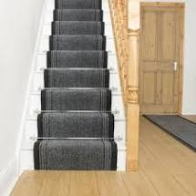
4. … eat 100g of sweets or 1/5 of a kg (kilogram) of sweets?
5. ...go water skiing for 2 hours or go snow boarding for 200 minutes?



6...be able to walk on all fours or walk backwards?

