Friday 8.5.20

VE Day   
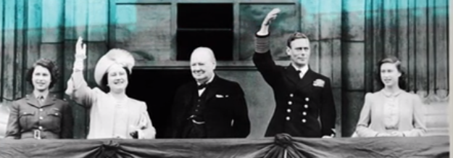

 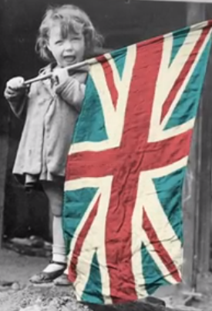

Today marks a very important day. Today is VE Day. If you don’t know what that is have a look at this video <https://www.bbc.co.uk/teach/class-clips-video/history-ks2-ve-day/z7xtmfr> Can you make any links with our World War 2 topic?  
There will be a 2 minute silence at 11 o’clock this morning

Are you up for a challenge? The take the times table speed test!  
<https://www.timestables.co.uk/speed-test/>

Can you beat your score from last week? Take a screen shot or post results to your teacher 😊

Problem Solving

L.I. To use ‘try a simpler case’ strategy

**Rectangles**

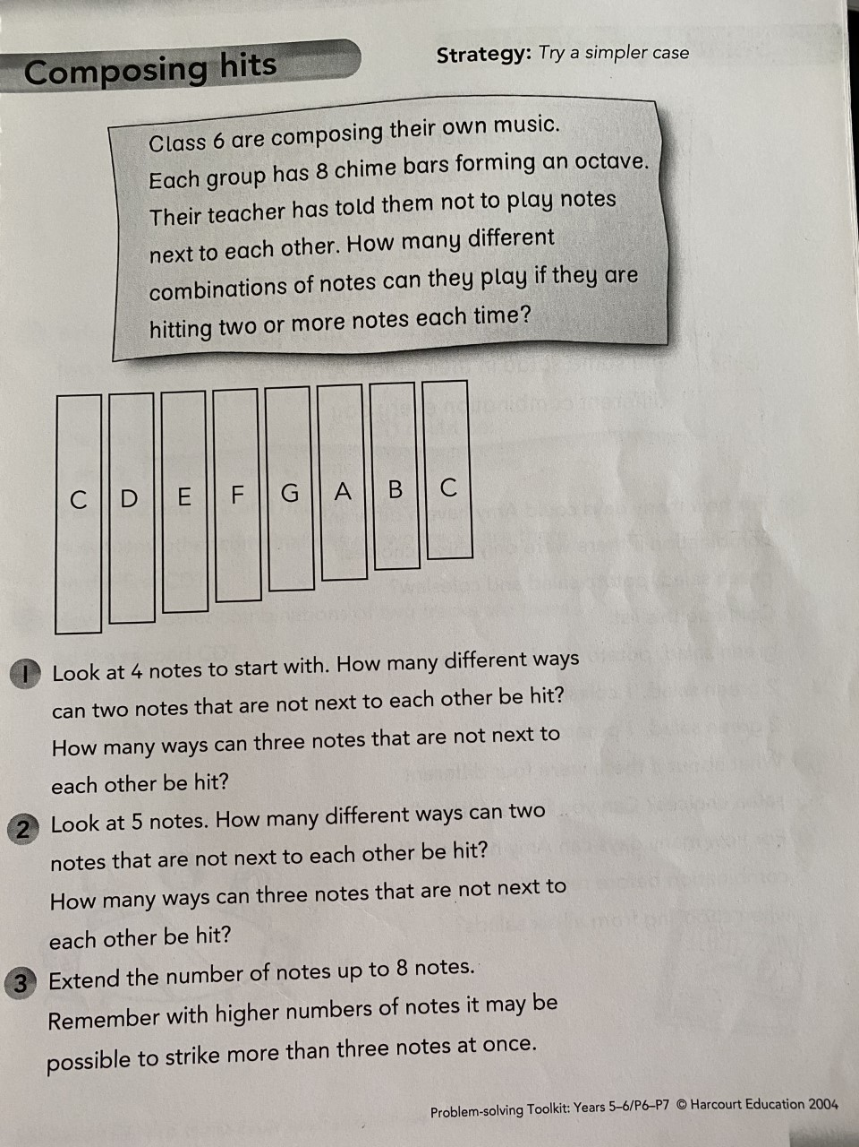

**Triangles**



**Circles**

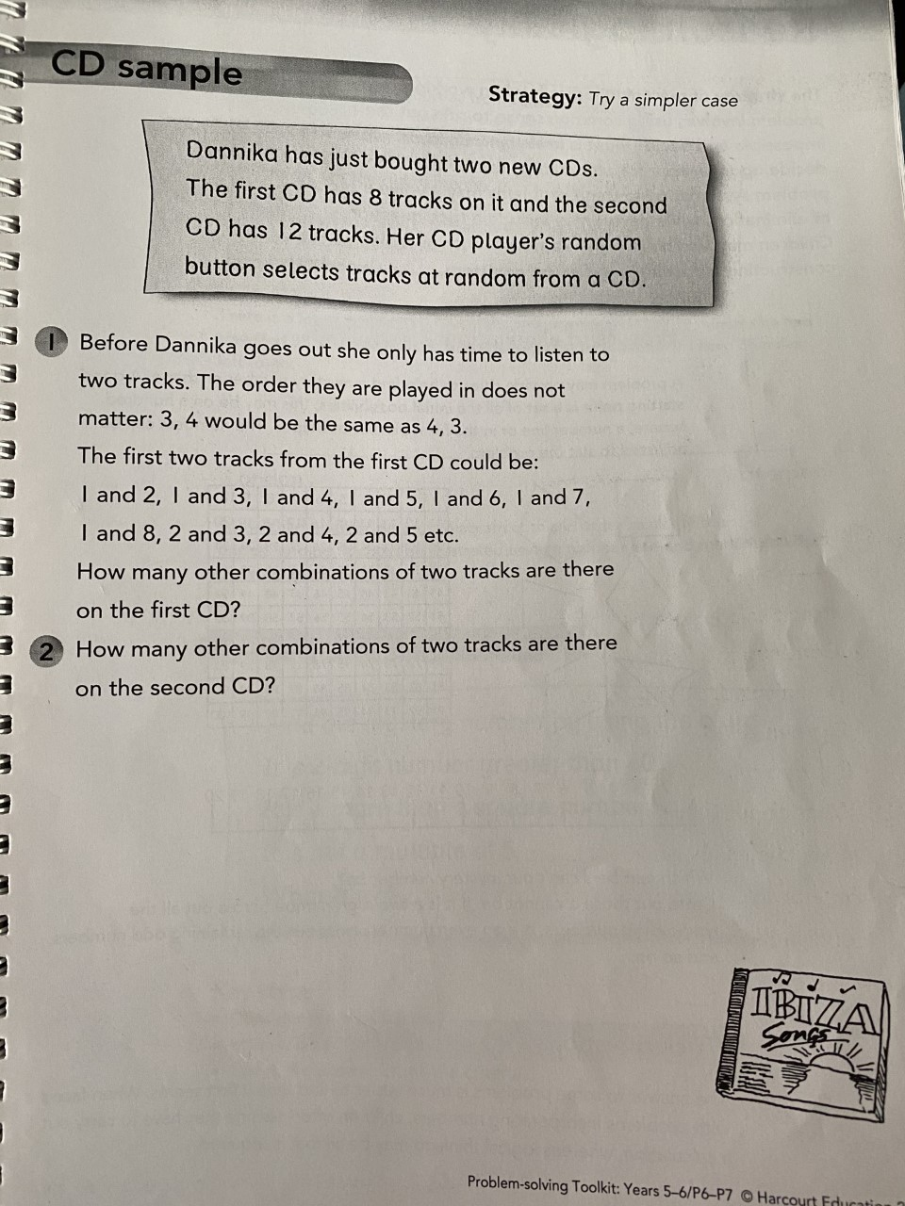

Skills Academy  
LI: to plan ahead.  
With an adult at home, help plan for **one meal** for each day of next week for you and your family. The meals could be different depending on the y requirements of members of your household. You could make a list (see below) and pin it up in the kitchen to help you remember! You can include pets if you want and/or draw pictures of the meals! If you are unable to do this, make up your own imaginary plan for your weekly meals. What would you have? What ingredients would you need? If you are on TEAMS, share your plans with your teacher!

|  |  |
| --- | --- |
| **Monday** | **Dinner** whole family – Spaghetti bolognaise with garlic bread. Ollie the cat – Whiskas chicken in gravy sachet |
| **Tuesday** | **Breakfast** whole family – Porridge or Toast with marmalade |
| **Wednesday** | **Lunch** - Jacket potato with tuna and salad  Big brother – Jacket potato with beans no salad |
| **Thursday** | **Lunch** whole family except mum – Cheese toasties and salad  Mum – Ham toastie and salad |
| **Friday** | **Dinner** whole family – Veggie fajitas |
| **Saturday** | **Lunch** whole family- Ham sandwiches |
| **Sunday** | **Breakfast** whole family except big sister– Omelettes  Big sister – Cereal or toast |

|  |
| --- |
| Spanish  Have a look at this presentation all about Spain and the Spanish language. In the presentation there are words underlined; these will take you to videos and links!  <https://sway.office.com/xlsRkYYWwouqDTAr?ref=email> |

**Reward time ideas!**  
**Space Doodles!** <https://www.youtube.com/watch?v=F79ZaTL_vA0>   
 Explore the NASA kids games website:  
 <https://spaceplace.nasa.gov/menu/play/>**Listen to your favourite music**  
**Play in the garden**   
**Play a board game with someone at home (if they are not too busy!)**  
**Play a game on a device**   
**Just dance videos! (Search ‘Just dance’ on YouTube)**  
**Kahoot!** <https://kahoot.com/schools-u/>