Class: Primary 2 Numeracy and Maths ( Place Value)
Task 1 – WARM UP (TALKING) | Task 2- (WRITTEN TASK) | Task 3- GAME/ PRACTICAL
LI. We are learning to understand 3 digit numbers.  Look at these numbers 50, 100, 150, 200, 250, 300, 350.  What do you notice about them? Discuss this with your adult or older sibling.  Extension- do you think you could make your own sequence of 3 digit numbers and ask someone to notice what you have done (do they always end in the same number, have the same middle number?) | See choice of two tasks below  - Mild- ordering 3 digit numbers  - Hot, ordering, odd and evens, rounding  Please do this in your jotter if you can.  Write and underline the title like this:  7.5.20  We are learning to understand place value in 3 digit numbers Hot (Or write Mild) | Studdy ladder game on your account  AND/ OR  If you have lego can you make a picture similar to this. You could take a picture and send it to the blog.  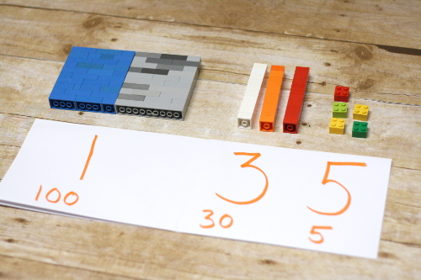

Mild | Hot
Put these numbers in the right order, starting from smallest.  Checking – how many digits does it have?  -What is the starting number?  -What is the middle number?  170  550  110  320  101  99 | 