**Thursday 7.5.20**

**Editing Sentences**  
**LI: to use correct punctuation in a sentence.**   
**Here is a game to start you off! PUNCTUATION SPEED CHECK** <https://www.turtlediary.com/game/identify-correct-punctuation.html>

For your group task, correct the sentences by adding capital letters, full stops and question marks!

Greens

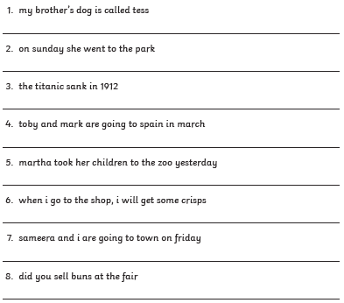

**Reds and Blues**  
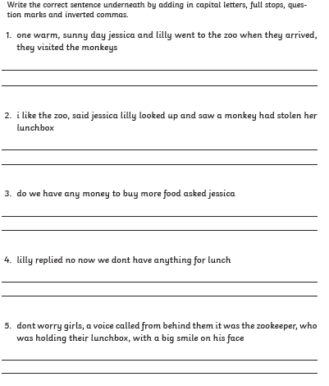

|  |
| --- |
| Some extra literacy games: Prefix and Suffix game (flash required)- <http://flash.topmarks.co.uk/4762>  [**https://www.bbc.co.uk/bitesize/topics/zf2f9j6/articles/z3c6tfr**](https://www.bbc.co.uk/bitesize/topics/zf2f9j6/articles/z3c6tfr) Put your typing skills to the test! |

**Maths – LI – to use my knowledge measuring a perimeter and use it to calculate a surface area.**

**SC**

**I can identity the perimeter on a 2D shape**

**I can multiply the width and height to calculate the total surface area**

**I can put a small ‘2’ at the end of my answers to show surface area which means squared**

**Starter -** <https://www.youtube.com/watch?v=d_6XOBpoDz4>

Main

**Circles - choose at least 3 of the challenge cards**

**Triangles - choose at least 7 of the challenge cards**

**Rectangles – choose at least 9 of the challenge cards**

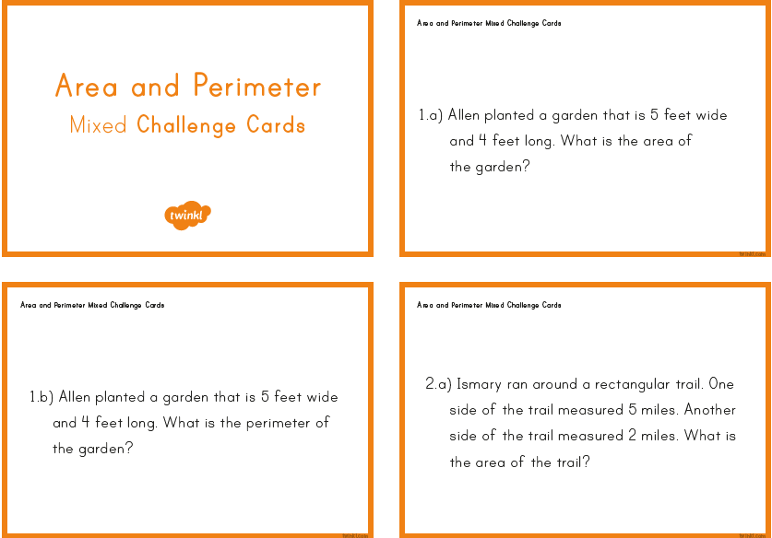

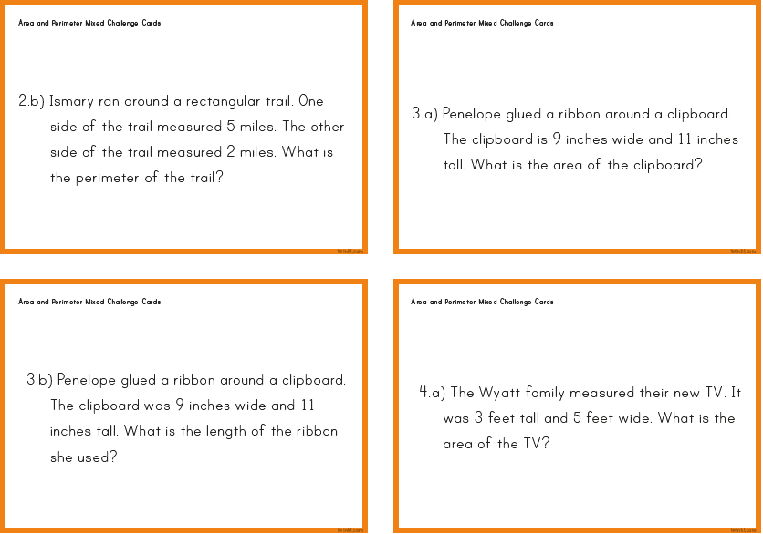

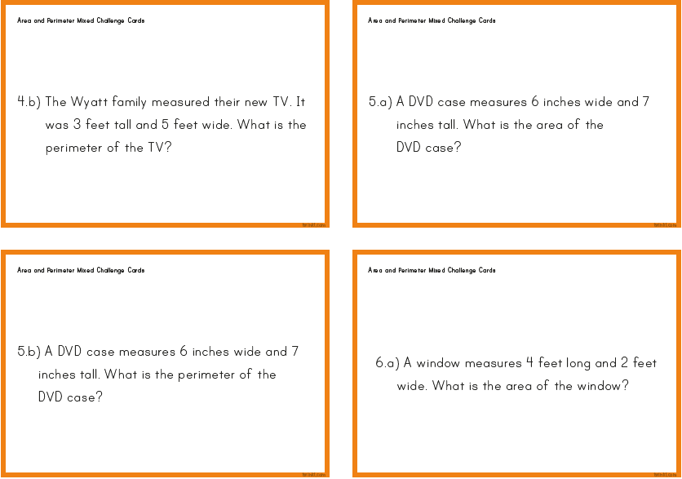

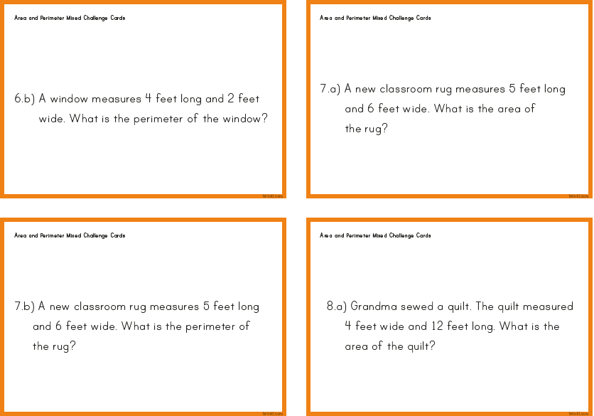

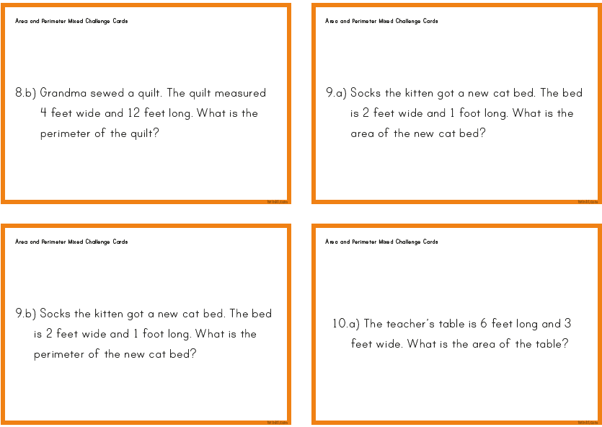

|  |
| --- |
| **Topic**  **LI: to create a mnemonic**   Here are some examples of posters with a mnemonic which is a handy way to remember to order of the planets! (Remember Pluto is not a planet but you can choose to include it at the end!)  Task - Create your own poster with your own mnemonic which will help you learn the order of the planets closest to the sun!  Get creative with your poster, you can create it online or on paper! |

**Music**



**Mr Muller has placed new activities in your charanga inbox**

This can be access here <https://www.charangascotland.co.uk/yumu/login>

If you are unable to access charanga and you don’t have a username or password, let Mr Muller know