Wednesday 6.5.20

Here are your jobs for today.

**Literacy Comprehension**  
**LI: to develop understanding of current events**

For comprehension today you are going to watch the news on Espresso and complete the quiz.   
Login to espresso education   
Username: student21929  
Password: windy29

Step 1)  
Once logged in, select Second Level & News

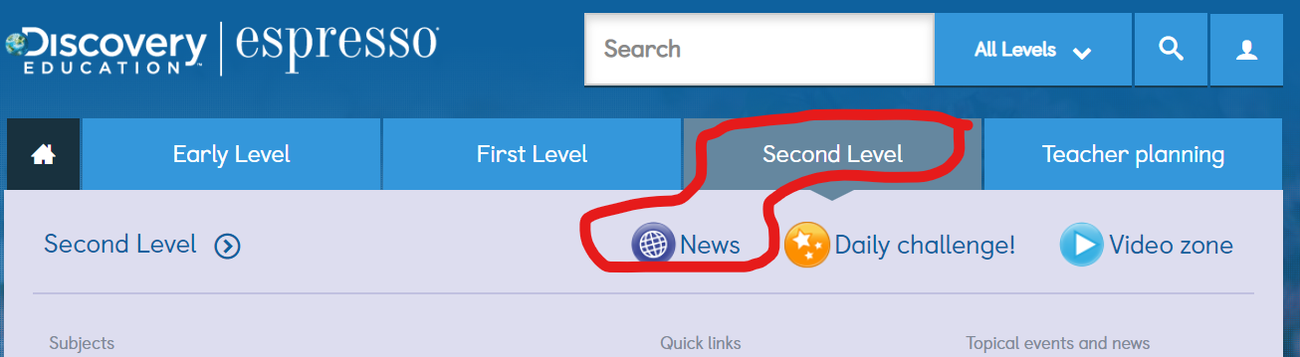

Step 2)   
Select News Bites + Quiz   
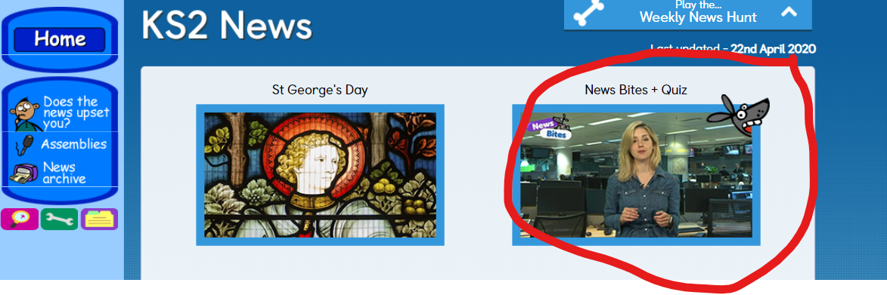

Step 3)  
Watch the news video. Afterwards, select News bites quiz and answer the questions!   
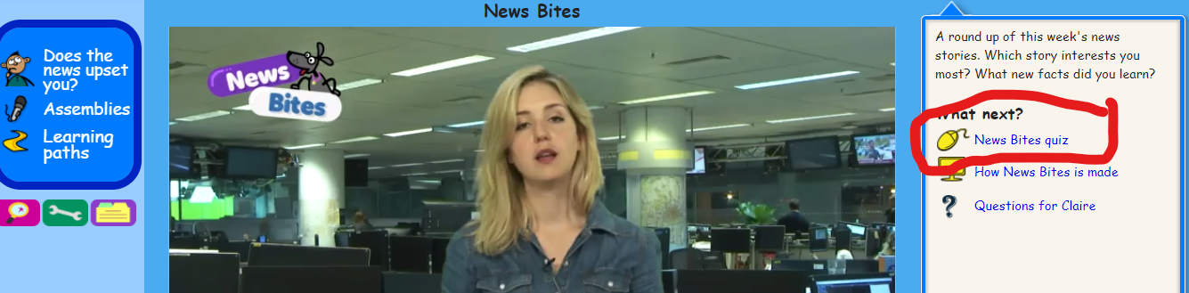

Step 4)  
Write down your score you got for the quiz and share this with your teacher!

**Numeracy**

**Rectangles**: L.I- To be able to calculate equivalent fractions

1) 8/10 2) 2/4 3) 4/16 4) 2/14 5) 4/100 6) 100/800

7) 15/65 8) 8/24 9) 3/30 10) 26/26 11) 17/34 12) 25/120

**Triangles**: L.I- To be able to calculate a percentage

1) 50% of 14 2) 50% of 160 3) 1) 50% of 1800

4) 25% of 300 5) 25% of 200 6) 25% of 40

7) 75% of 400 8) 75% of 1000 9) 75% of 800

10) 10% of 70 11) 10% of 190 11) 10% of 550

12) 5% of 0

**Circles**: L.I- To be able to find simple percentages

1) 50% of 4 2) 50% of 8 3) 50% of 32

4) 50% of 80 5) 50% of 102 6) 50% of 180

7) 50% of 64 8) 50% of 800 9) 25% of 16

10) 25% of 40

**Optional Tasks**

* SumDog
* Active Learn Games

**Art Task - Get Creative**

**L.I. To be able to use line and tone to create an image**

**Before you begin you will need:**

* **some paper (or use your jotter)**
* **Something to draw with e.g. pens, pencils**

**Today’s art lesson is based on a famous American artist called Georgia O’Keeffe. She was well known for creating images of flowers close up. Your task today is to draw a close up image of a flower just like her.**

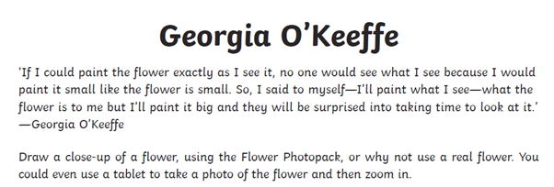

Here are some images to inspire you. You could use your own photo of a flower or even have a look at some real flowers if you any in your garden.

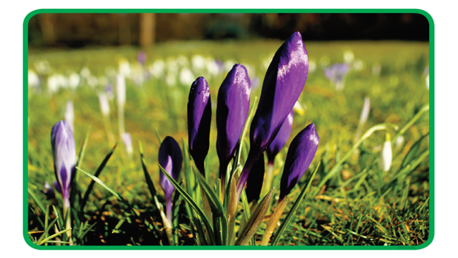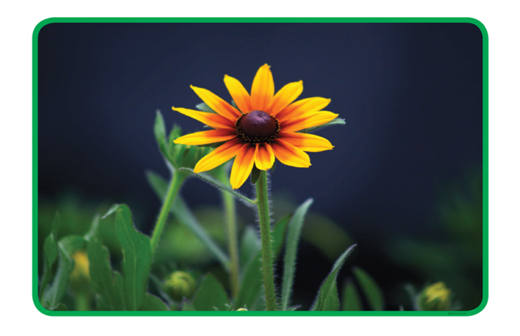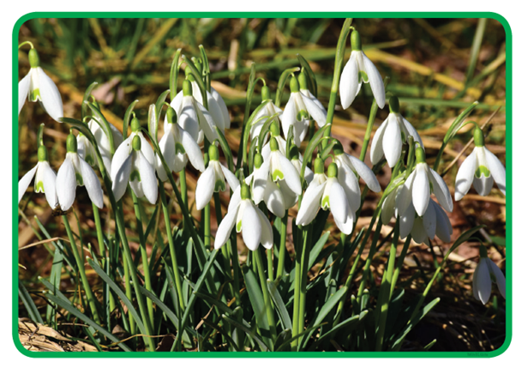

This youtube clip might help you if you are finding this tricky: <https://www.youtube.com/watch?v=ao2IP7f23-8>

**Optional-** Add colour to your drawing using paints, chalks and/or pastels if you have them. Think about different shades of colour, shaded areas of the flower will be darker.

**Optional Extension Task:** Create a fact file about Georgia O’Keeffe. There Is a PowerPoint on Teams in the files section to help.

**P.E – To develop balance, co-ordination and agility**  
**LI: to develop relaxation through breathing exercises**  
Joe Wick’s video will be posted by Mrs Howard but here are some breathing exercises to try!  
Here is a Star Wars themed yoga for anyone who hasn’t tried it! [https://www.youtube.com/watch?v=BEPxPkQY6V8](https://www.youtube.com/watch?v=BEPxPkQY6V8﷟HYPERLINK "https://www.youtube.com/watch?v=BEPxPkQY6V8"﷟HYPERLINK "https://www.youtube.com/watch?v=BEPxPkQY6V8"﷟HYPERLINK "https://www.youtube.com/watch?v=BEPxPkQY6V8")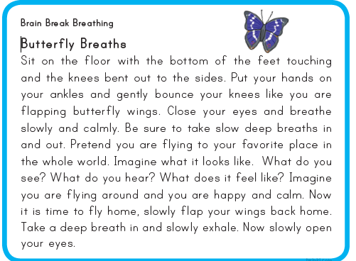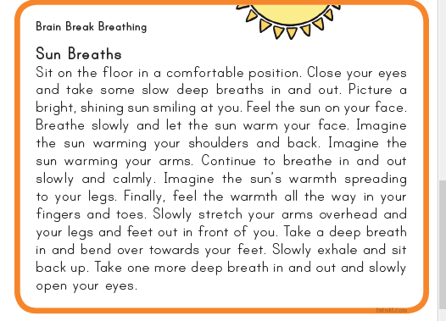"

**Music**



**Mr Muller has placed new activities in your charanga inbox**

This can be access here <https://www.charangascotland.co.uk/yumu/login>

If you are unable to access charanga and you don’t have a username or password, let Mr Muller know