Friday 1.5.20

Are you up for a challenge? The take the times table speed test!
https://www.timestables.co.uk/speed-test/

Take a screen shot or post results to your teacher 😊

Problem Solving
L.I. To use ‘try a simpler case’ strategy
Rectangles
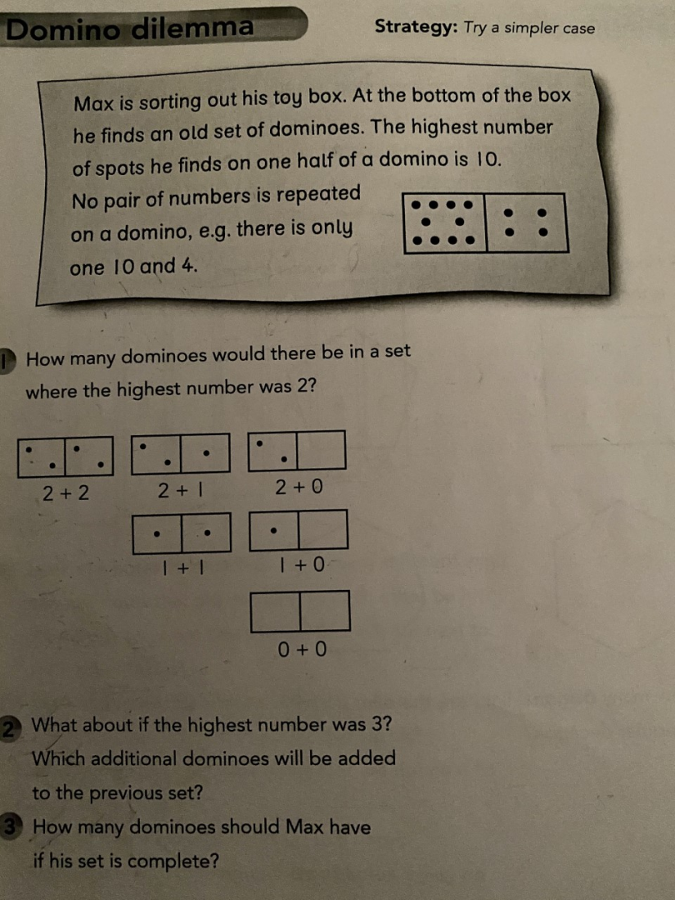

Triangles
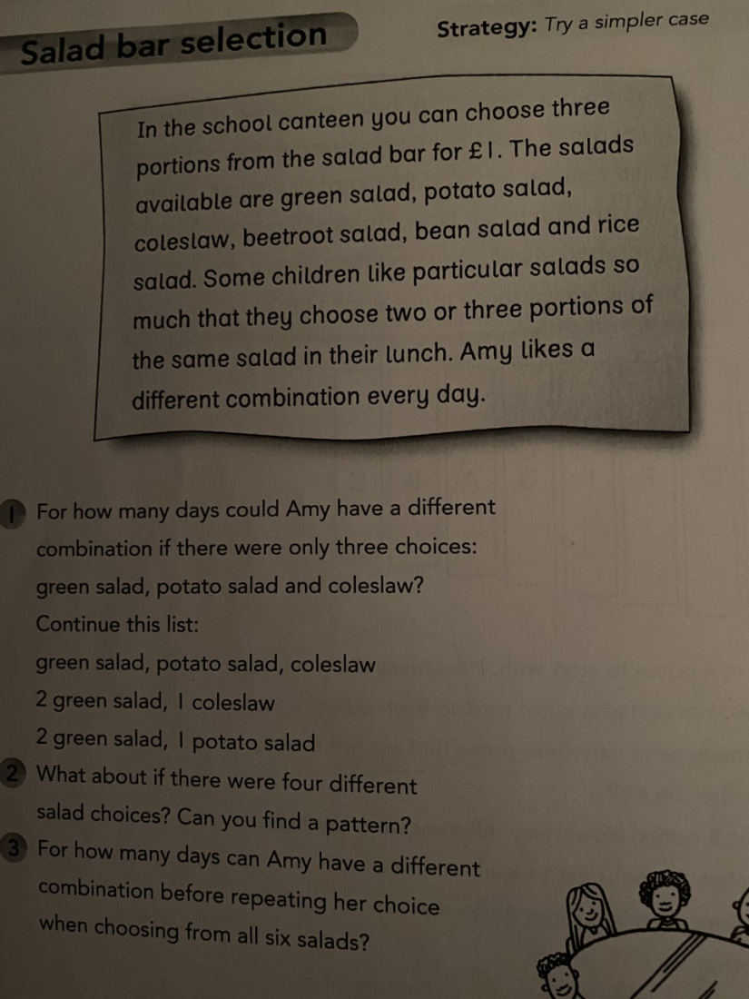
Circles
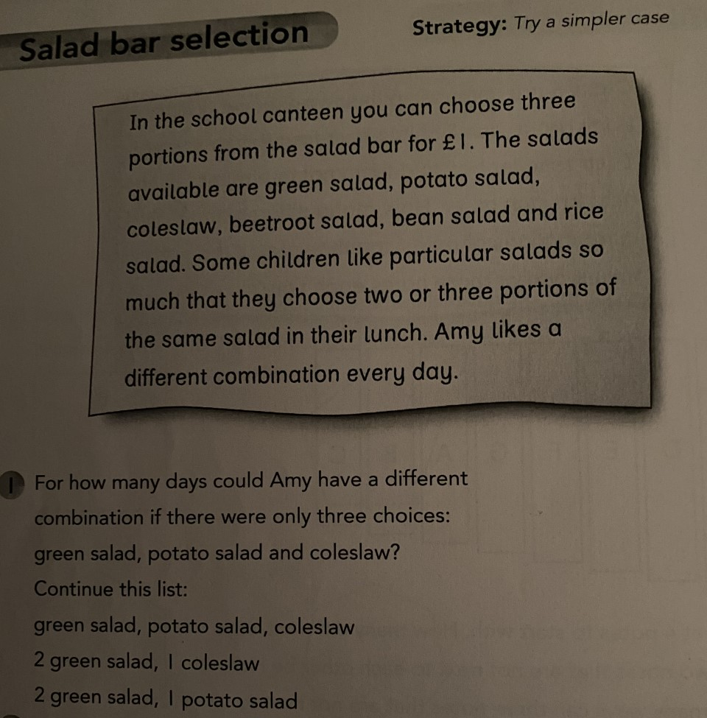

Skills Academy – MOVIE NIGHT!
LI: to plan an event
Plan a movie night for an evening next week for you and your family. Pick 5 films and get your family to vote. You could make posters advertising your movie night. You could create tickets to hand out to members of the family. You could also pick out lots of pillows and blankets to make the movie space extra comfy. Get creative!

Reward time ideas! :D
Listen to your favourite music
Play in the garden
Play a board game with someone at home (if they are not too busy!)
Play a game on a device
Just dance videos! (Search ‘Just dance’ on YouTube)
Kahoot! https://kahoot.com/schools-u/
Explore the NASA kids games website: https://spaceplace.nasa.gov/menu/play/
Cosmic Kids Yoga- https://www.youtube.com/watch?v=bCstmsm9Ows
How to draw a space Alien-
https://www.youtube.com/watch?v=bCstmsm9Ows

