Friday 1.5.20

Typing
L.I. To learn the position of each letter on a keyboard
In this digital age, learning to type quickly and accurately is becoming an increasingly important skill. Once you master touch typing, you will be able to type even faster than you can write AND do it with your eyes closed! Amazing!
Let’s get started. Click on this link and practice ‘Level 1 – home row’
https://www.bbc.co.uk/bitesize/topics/zf2f9j6/articles/z3c6tfr
This website takes you through learning to type step-by-step. If you have access to a laptop, you might find it easier to type on the laptop keyboard however it will still work on tablets/devices.

Problem Solving
Continue logging in to Sumdog and playing in the P5 Competition. It will close at 11am and results announced at 11:30. Remember to answer all 250 questions set yesterday as it gives you a better chance of making it onto the leaderboard.

L.I To act out a situation
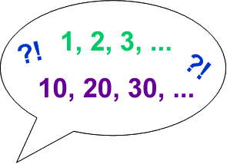
- Which is quicker, counting up to 30 in ones or counting up to 300 in tens? Why?

- Which is quicker, counting up to 40 in ones or counting up to 4,000 in hundreds? Why?

- Which is quicker, counting up to 10 in ones or counting up to 1,000,000 in hundred-thousands? Why?

- Which is quicker, counting up to 20 in ones or counting up to 140 in sevens? Why?

- Which is quicker, counting up to 25 in French or in English? Why?

When you have timed yourselves and decided about the reasons for your results, you could invent some other examples for the class and post them in our Team.
You could predict which was going to be quicker and then try them out to test your prediction.

