Class: Primary 2 Numeracy and Maths ( Place Value)
Task 1 – WARM UP (TALKING) | Task 2- (WRITTEN TASK) | Task 3- GAME/ JOTTER TASK (WRITTEN TASK)
LI. We are learning to understand 3 digit numbers.  Watch explanation on youtube about writing numbers in expanded form, or in simple terms splitting the number up into its hundreds, tens and units. Eg 452, is 400 +50 +2.  Please note the children should be able to understand units and ones mean the same thing so both words should be used.  Expanded Form Video - 1st and 2nd Grade Math  https://www.youtube.com/watch?v=4AF7xj7pmWc | See choice of two tasks below  - write numbers idenifying tens and units,  - or hundreds, tens and units.  Please do this in your jotter if you can.  Write and underline the title like this:  30.4.20  We are learning to understand 3 digit numbers Hot (Or write Mild)  Q1. 542, Five Hundreds, Four Tens and one, 500+40+1=541  If you are doing Mild.  Q1. 4 Tens and 1 , 40+1=41 | Place value basket ball game on topmaks  https://www.topmarks.co.uk/learning-to-count/place-value-basketball

Mild | Hot
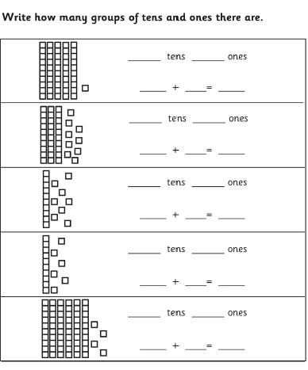 | 