Thursday 30.4.20

Literacy
You might have seen Captain Tom Moore on the news recently; he made headlines by raising almost £30 million for the NHS by walking 100 lengths of his garden. To make this even more incredible, today is Captain Tom’s 100th birthday.
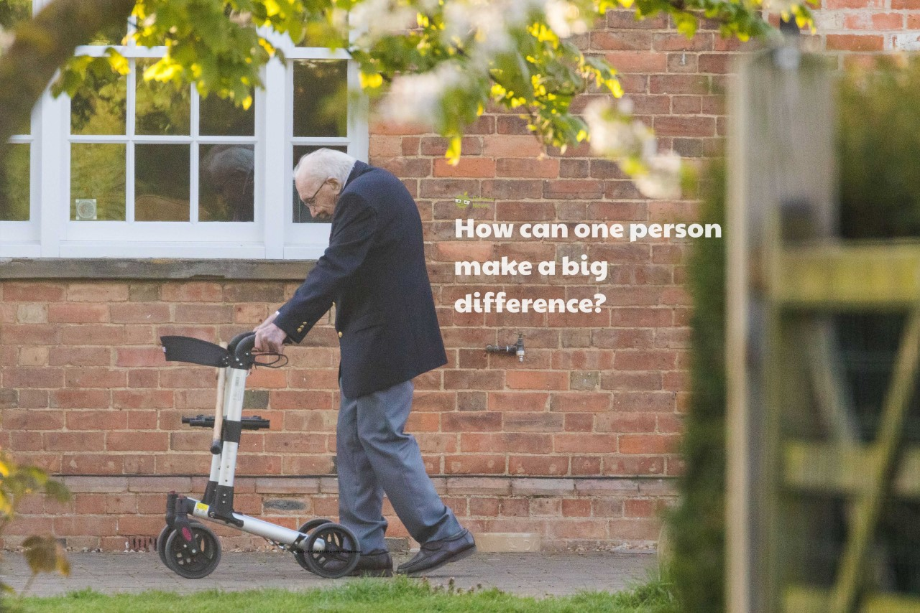
Have a look at the documents attached and complete the following challenges:
Challenge 1: Write a letter or a thank you card and send it to someone who has made a difference in your local community. This could be a teacher, family member or neighbour.
Challenge 2: Draw a picture of Captain Tom completing his challenge

Maths
*ATTENTION – P5 SUMDOG COMPETITION*
Starts 8am Thursday …. Ends 11am Friday! Good luck!
Winners will be announced on Teams at 11:30am on Friday.

Log in to Sumdog and play in the competition. Questions are focused on some of the maths concepts we have worked hard on during the year (shape, measure, time, money).
Answer 250 questions to receive 250 coins! The more you play and answer correctly, the more chance you have of winning!

Winners will receive Teams Praise! 😊 Good luck!

Art
L.I. To create texture with a pencil
Last week we began to look at creating different textures using a pencil. Have a look at this video to watch how the artist creates a 3D appearance on his sphere https://www.bbc.co.uk/bitesize/clips/zxyxfg8

Building on what you practised last week, see if you can replicate these examples.
