Thursday 30.4.20

Grammar and Punctuation (Suffix revision)
LI: to revise suffixes
All Groups - complete the task below
Look at: https://www.youtube.com/watch?v=ibq_bWQDluQ
LI: to identify and write a variety of suffixes
Greens –
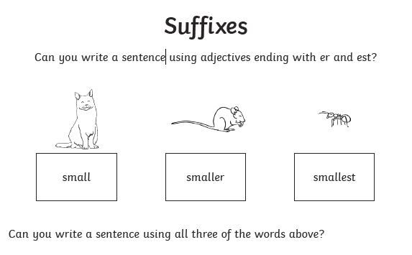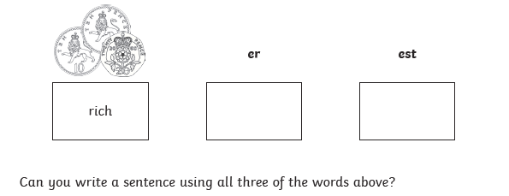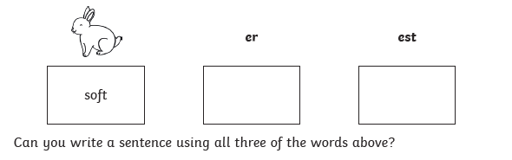
Blues & Reds – Once you have completed the sheet , choose 7 suffix words and include them to write an imaginative paragraph!
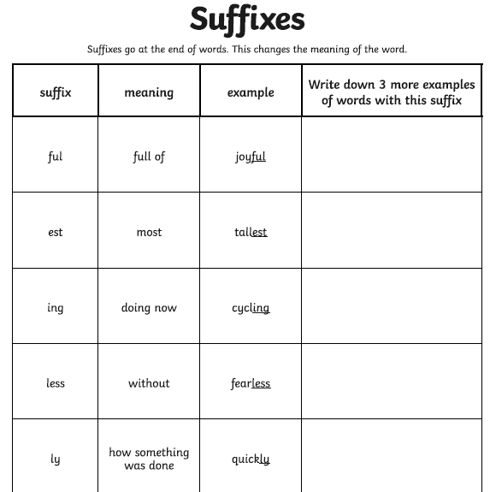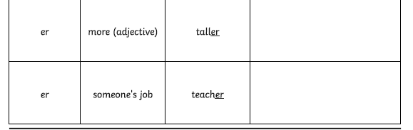

Not Handwriting... but Dance Mat Typing!
https://www.bbc.co.uk/bitesize/topics/zf2f9j6/articles/z3c6tfr Put your typing skills to the test!

Maths – LI – to use my knowledge measuring a perimeter and use it to calculate a surface area.

SC
I can identity the perimeter on a 2D shape
I can multiply the width and height to calculate the total surface area
I can put a small ‘2’ at the end of my answers to show surface area which means squared

Starter - https://www.youtube.com/watch?v=d_6XOBpoDz4

Main
Circles - choose at least 3 of the challenge cards
Triangles - choose at least 8 of the challenge cards
Rectangles – choose at least 10 of the challenge cards

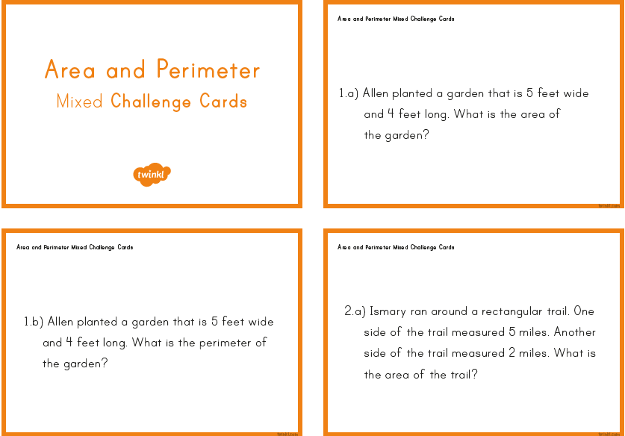
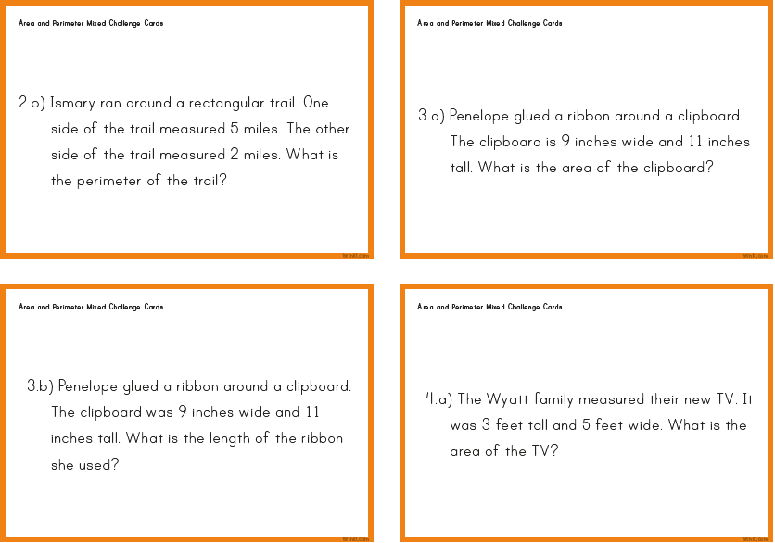
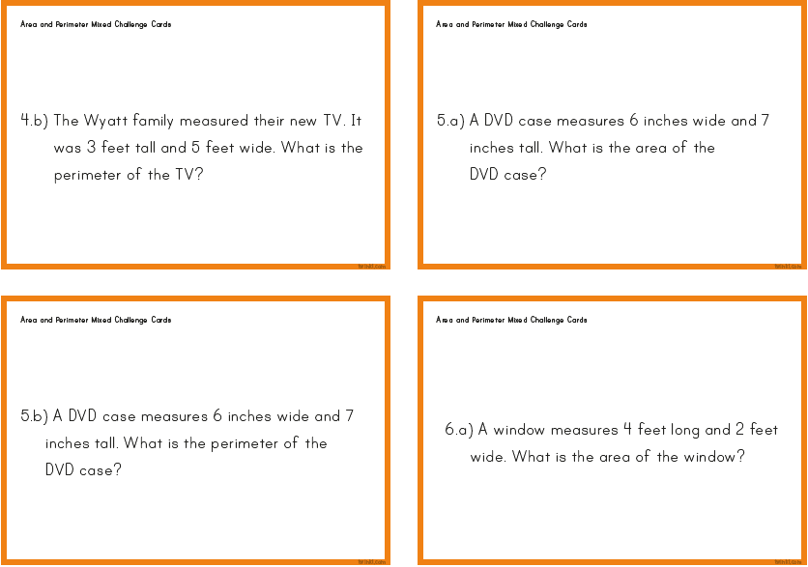
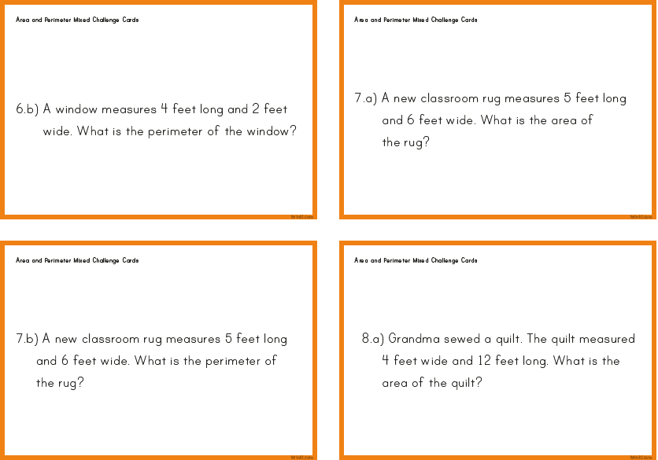
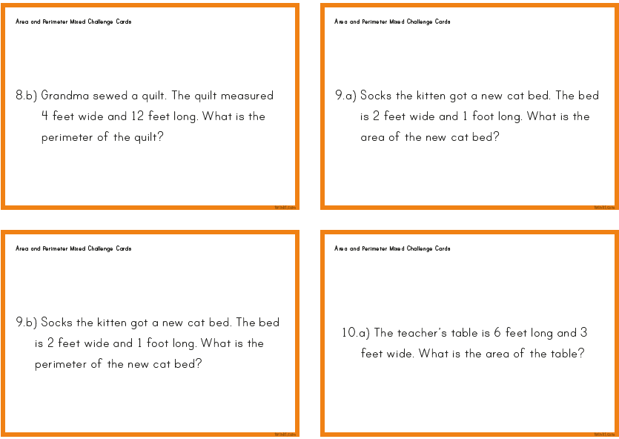

Topic
LI: to understand the impact of climate change
Do this questionnaire to find out about your own carbon footprint - http://footprint.wwf.org.uk/
It will ask you questions about your lifestyle, home and habits. Ask an adult if you are unsure of any questions. Write the results of the questionnaire (It will be in %) in your jotter and answer these questions:
- Are you happy with your results?
- Are there any changes you could make to reduce your carbon footprint?

Music

Mr Muller has placed new activities in your charanga inbox
This can be access here https://www.charangascotland.co.uk/yumu/login
I will give updates throughout the week about who’s access their music learning and who’s earned charanga points. If you are unable to access charanga and you don’t have a username or password, let Mr Muller know

