Wednesday 29.4.20
Here are your jobs for today.
Literacy Comprehension
LI: to read for information about the moon
Select Mild* Spicy ** or Hot ** passage with questions
*Mild passage and questions
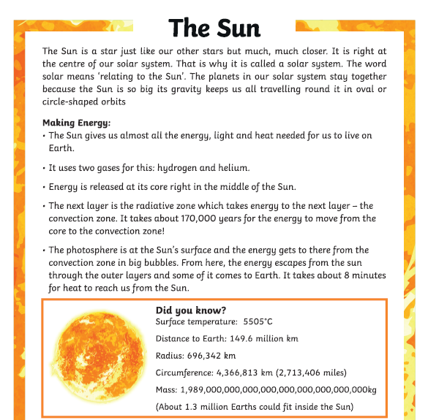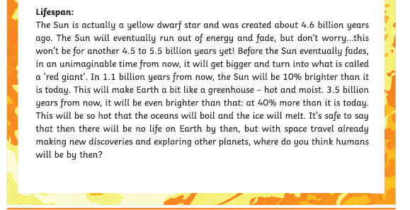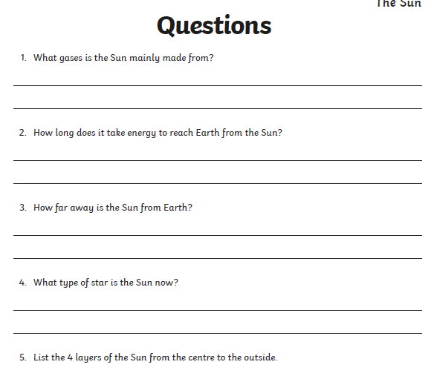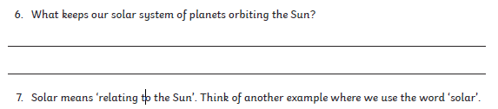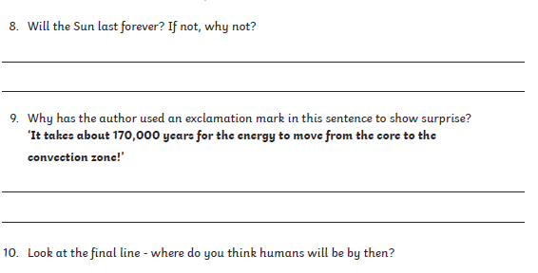

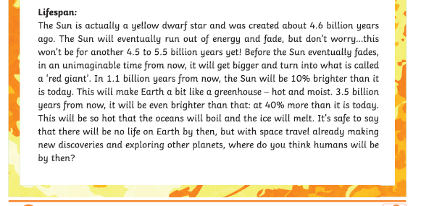
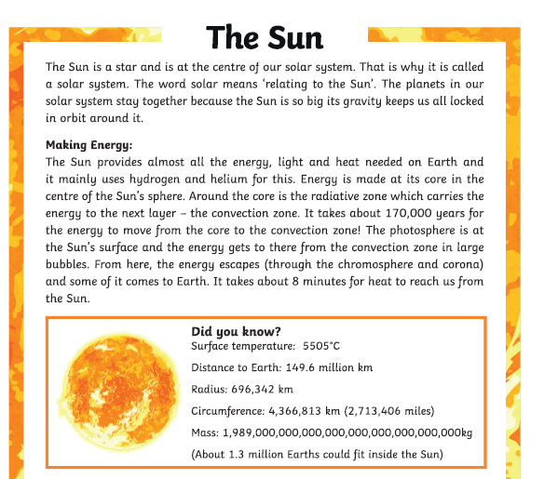
**Spicy passage and questions
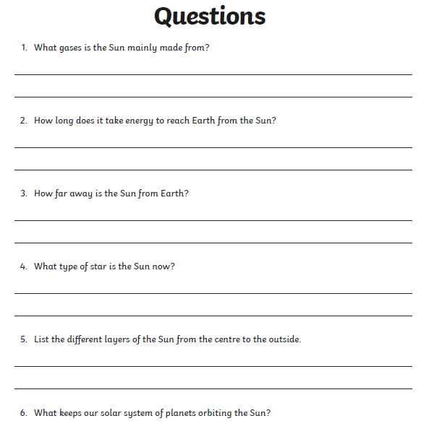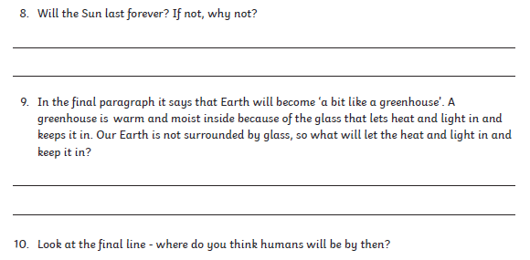
***Hot passage and questions
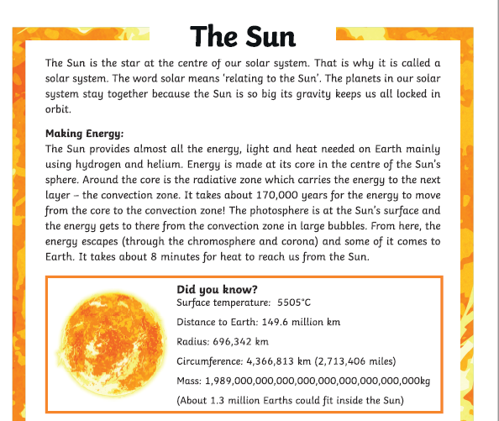

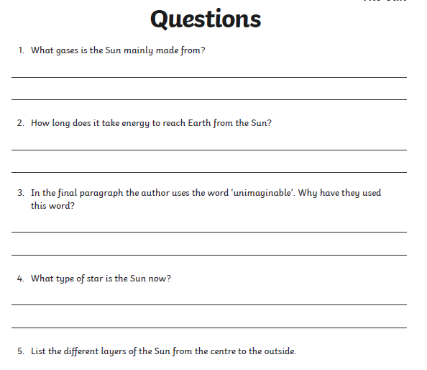
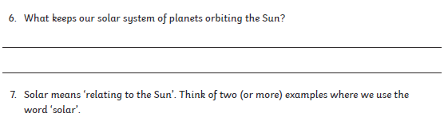
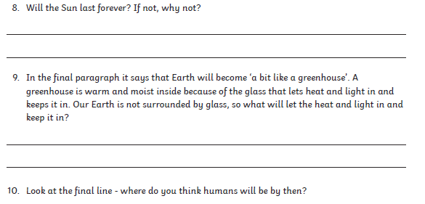
Numeracy
Rectangles: L.I- To be able to calculate equivalent fractions
1) 4/8 2) 6/6 3) 6/9 4) 4/4 5) 40/100 6) 10/400
7) 15/45 8) 8/12 9) 3/36 10) 26/39 11) 7/70 12) 25/150

Triangles: L.I- To be able to calculate a percentage
1) 50% of 10 2) 50% of 130 3) 1) 50% of 1500
4) 25% of 200 5) 25% of 400 6) 25% of 60
7) 75% of 100 8) 75% of 500 9) 75% of 900
10) 10% of 60 11) 10% of 150 11) 10% of 850
12) 5% of 20

Circles: L.I- To be able to find simple percentages
1) 50% of 6 2) 50% of 14 3) 50% of 22
4) 50% of 72 5) 50% of 50 6) 50% of 120
7) 50% of 24 8) 50% of 600 9) 25% of 8
10) 25% of 20

Optional Tasks
- SumDog
- Active Learn Games

Art Task - Get Creative
L.I. To be able to design your own planet
Before you begin you will need:
- some paper (or use your jotter)
- Something to draw with e.g. pens, pencils
- Something round to draw around (or you can just draw your own circle)

Watch this clip on from Glasgow Science Centre at Home: https://www.youtube.com/watch?v=SUQQUjIXZRM&feature=youtu.be
Tip: You might want to pause this clip as you draw and complete each step. This will allow you some thinking time.
You can post your completed planets on TEAMS if you wish. You could also include a brief description of your planet.
Optional Extension Task: Practice your note taking skills by watching the video or part of it again. Whilst you listen carefully can you note some facts that you hear about planets and Space. Mild: 3 Facts Spicy: 5 facts Hot: 10 facts

P.E – To develop stamina and persistence in fitness
Joe Wick’s video will be posted by Mrs Howard, here are some more activities you can do on GoNoodle!
Lateral Stamina - https://family.gonoodle.com/activities/lateral-movements?utm_content=teacher&utm_medium=1600784&utm_campaign=share_link&utm_term=lateral-movements&utm_source=clipboard
Performance Training - https://family.gonoodle.com/activities/performance-training?utm_content=teacher&utm_medium=1600784&utm_campaign=share_link&utm_term=performance-training&utm_source=clipboard

Cat Man in Space! - https://family.gonoodle.com/activities/cat-man-in-outerspace?utm_content=teacher&utm_medium=1600784&utm_campaign=share_link&utm_term=cat-man-in-outerspace&utm_source=clipboard
Baby Shark workout! https://family.gonoodle.com/activities/baby-shark?utm_content=teacher&utm_medium=1600784&utm_campaign=share_link&utm_term=baby-shark&utm_source=clipboard
Music
Mr Muller has placed new activities in your charanga inbox
This can be access here https://www.charangascotland.co.uk/yumu/login
I will give updates throughout the week about who’s access their music learning and who’s earned charanga points. If you are unable to access charanga and you don’t have a username or password, let Mr Muller know

