Wednesday 29.4.20

**Please remember!**

* Work can be completed in your green jotter or on a device/laptop
* Your teacher will only be available between 8.45 – 3.15, if you post after that time we will get back to you in the morning. Break and lunch times still apply
* Do not put too much pressure on yourself to finish things quickly, these can be done throughout the day.
* Remember you have access to apps and links such as Sumdog, Go Noodle, Study Ladder and Activelearn. You can play these any time!
* If you finish all the tasks that we have set you can read, or decide what else to do with the rest of your day
* Try to post work in ‘assignments’ or ‘class notebook’ if you can’t do this, don’t panic. You can always upload a photo to the live chat... but you don’t have to!

Numeracy

Squares





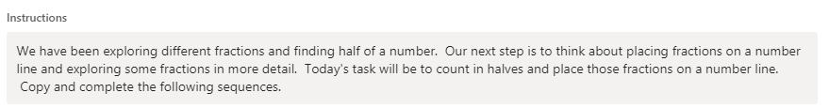

Triangles





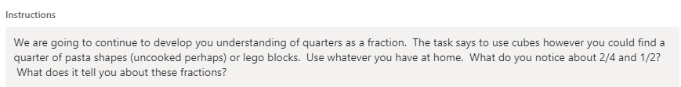

Circles







Rectangles







IDL

LI to make notes on a topic

SC I can find relevant information about Robert the Bruce. I can pick out key information.

Instructions – Read through the powerpoint and take notes about Robert the Bruce. You will use these notes to inform your writing.

Here is a video which also contains lots of information about Robert the Bruce. <https://www.bbc.co.uk/bitesize/topics/z8g86sg/articles/zm2747h>

Literacy – Writing

Apples, Bananas and Cherries







Dragon Fruit

LI to write a narrative

SC I can write a story that matches the picture. I can include relevant words.

