Class: Primary 2 Numeracy and Maths-
Task 1 – WARM UP (TALKING) | Task 2- (WRITTEN TASK) | Task 3- GAME/ JOTTER TASK (WRITTEN TASK)
Count in tens off the decade, this means counting by tens from a number other than a multiple of ten, for example 7, 17, 27, etc.  You can do this whilst passing a ball, bouncing a ball or doing a sequence of different actions like head, shoulders knees and toes. | See the download- Place Value Mystery in the place kitchen.  Some children may find the reading in this activity a challenge so would need some adult support to follow the task. However there are many skills developed from this  task and would be a valuable activity to try! Spoiler alert- the answers are in the end of the document.  If you are struggling then - do this part only .  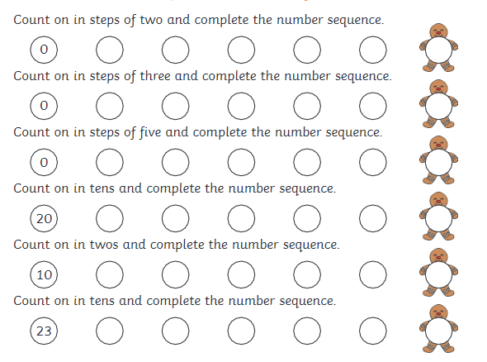 | If you have dice you can play this game, with a dice. If you don’t have dice, write numbers 1 –9 on bits of paper and scatter/ turn them over/ or put in a bag or box so you are selecting a number at random.  Roll the dice 3 times and record the number for each roll in hundreds, ten and unit column - you can write this in green jotter.  Eg Roll a 6, then a 4, then a 2, your number would be 642, saying ‘Six hundred and forty two’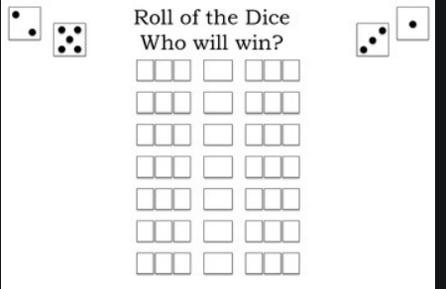.Take turns to do this with a partner 5 or more times each. Look at your numbers you rolled, who rolled the highest number?
Date Issued: To be submitted by:

