Numeracy
L.I. To recall my tables facts quickly and accurately
On Heinemann Active Maths play the games that have been allocated to you. They have been differentiated for your specific group.
Magicians and Ninjas – Canopy Chaos, Clam Collector, Sand Search
Mathletes and Algebros – Bingo, Seaside Scuffle, Scrapheap Scramble

Writing
L.I. To write an autobiographical text
Have a look at the autobiography powerpoint. There are some questions on the slides to help get your brain going. You might want to discuss these questions with an adult in your house, or perhaps just have a think about the points to yourself as they come up.
Once you have read the powerpoint, it is your turn to write your own autobiography. You can use this checklist to make sure you have included all the important points.
Features | 👍👎
Is it written in the first person? (I, me)
Is it in the past tense?
Are there facts about your life?
Are there dates to show when events happened?
Is it in chronological order?
Have you written in clear paragraphs?
Have you described people/events in detail?
Have you thought about VCOP?
Will your writing keep the reader interested?

Topic

L.I. To develop my research skills

You are going to make a leaflet/pamphlet that will convince people that the town/city you have researched is the best. You can research the town that you live in or you can choose another Scottish town or city to research.
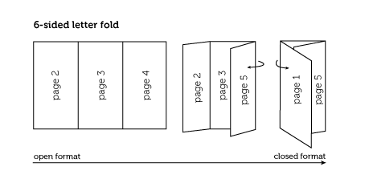
It will look like this, with 6 little pages:

Page 1: The front cover.
- The name of the town/city
- A picture that makes people want to go there

Page 2: Facts about the town/city
- Only good facts that would make people interested
- Something that only your town can offer!
- A picture if you have space (optional)

Page 3: Important places to visit
- At least one important building/landmark/place to see
- A good picture of it

Page 4: The weather, climate and landscape
- Only good things! If you want to talk about bad things, try to make them sound good e.g.: When it rains, the town is well prepared with lots of roofed buildings to walk under and indoor shops.
- A picture (optional)

Page 5: People and customs
- What are some important traditions about the place?
- Is there a really good time of year to go there?

Page 6: The back
- Your name & the reason why you are an expert about the town

