Monday 27.4.20
Hello primary 6! Today we have Literacy, Numeracy and Health Remember Mrs Howard will also be posting tasks for toda in your P.E channel on TEAMS.
Here are your jobs for today:
Literacy (Spelling & Reading)
LI:to identify and spell common words
Read the next chapter in your reading book or a book of your choice for around 30minutes. (If you are unsure what chapter you are on contact your teacher)
Spelling – Common words
Your main task is set below your common words for this week.
If finished, you can also access: https://www.topmarks.co.uk/english-games/7-11-years/spelling-and-grammar and choose from a wide range of fun spelling activities and games! (Some may require flash to work)
Mild common words  over, new, sound, take, only | Spicy and Hot common words  assessment, competition, engagement, industrial, parallel

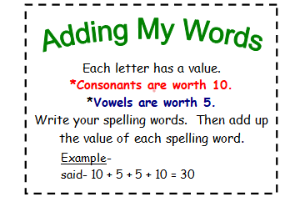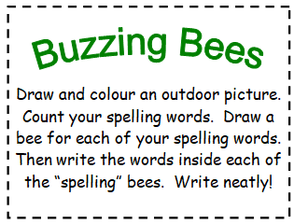

Health
L.I- To know what I can do if I feel worried or anxious
1.Discuss with someone at home or write in jotter what you think feeling worried or anxious means.
2. Watch this clip ’Feeling Worried or Anxious for Kids’
https://www.youtube.com/watch?v=l7g8Atv27Q8
3. Discuss with someone at home or write in jotter:
How did this clip make you feel?
What is the key point or points this clip is trying to show?
What would you do if you were Joey?
Task: In your jotter create a mind map. In the middle write ‘Feeling Worried and Anxious’. Around this include some writing and pictures if you want answering these questions:
- What does feeling worried and anxious mean?
- Who can help you if you feel worried or anxious?
- Relaxation and mindfulness can help people feel calm when they are experiencing feelings of worry and anxiety. Can you think of at least three ways that you like to relax and be mindfull e.g. drawing, listening to music, reading.
Optional Task: Post your ideas of things you like to do relax on TEAMS to share with the class..

Numeracy- Money Revision/Consolidation
Rectangles- TeeJay E p49 Q1-3
L.I- To be able to solve money problems
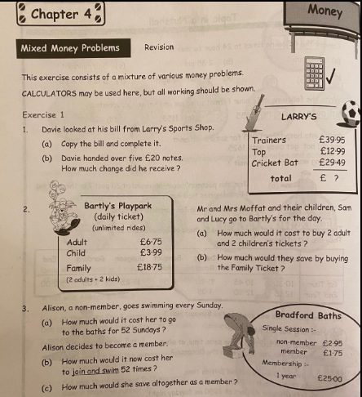

Triangles- TeeJay 2a p70 Q1
L.I- To be able to add and subtract money
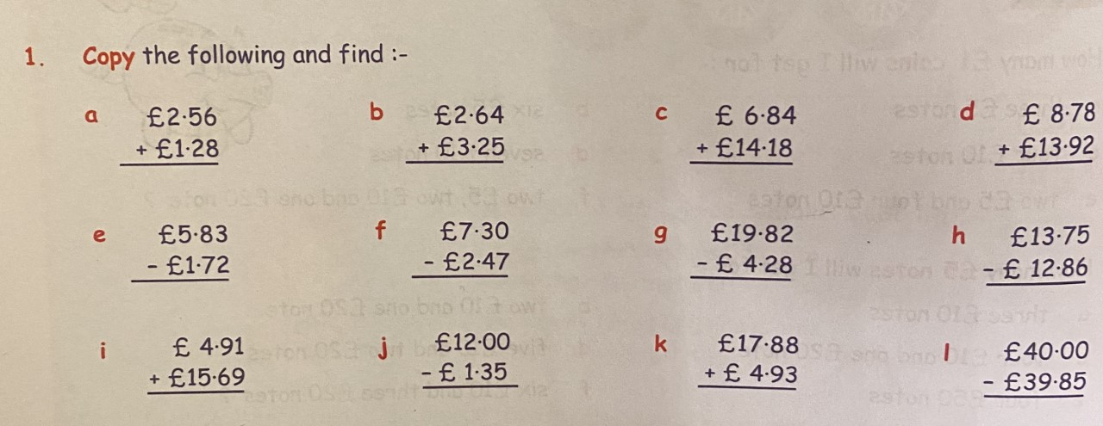

Circles TeeJay C p30 Q4-8
L.I- To be able to add money

