Windyknowe Home Learning Tasks (Daily) Date issued: 27.4.20

P1 Numeracy and Mathematics
Numeracy Task 1 | Maths Task 2 | Money Task 3
Aim: To recognise the tens numbers to 100. To count in tens.  Use sets of 10 of practical objects if you can for this activity. For example, bundles of cotton buds, twigs or cocktail sticks made into sets of 10 with elastic bands or towers of 10 Lego pieces.  Explain that 2 tens make 20, 3 tens make 30, 4 tens make 40 and so on. Show this with the practical materials. Look at how these numbers are written with the first number showing the number of tens and the zero showing that there are no single ones. These numbers are on the next page.  When an adult says a tens number can you show it with practical materials? E.g. here is 40  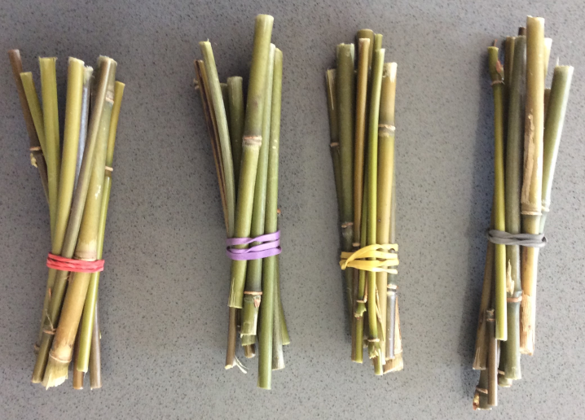  Practise counting in tens from 0 to 100 as you do jumps, claps etc. Look at this video to help. You tube count 10-100 count by 10 song The Singing Walrus  https://www.youtube.com/watch?v=-gmEe0-_ex8&vl=en  Extra challenge: Try the counting in tens activities set on Studyladder. | Aim: To order the days of the week  If you want to, listen to the ‘days of the week’ song to help remind you of the order of the days of the week. Sing along and use the song to put the days of the week into the correct order.  https://www.youtube.com/watch?v=mXMofxtDPUQ  If you have Lego at home, ask an adult to help you to write the days of the week onto 7 pieces that all join together. You could write them onto stickers to stick on or use a sharpie pen to write onto the Lego piece.  Then, mix up the days of the week Lego pieces and see if you can put them altogether into the correct order, use the ‘days of the week’ song to help.  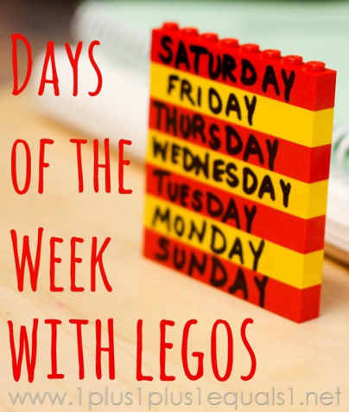  If you don’t have Lego available, how about creating your own train with each carriage being a different day of the week. You could draw a train with 7 carriages or use some junk from around the house to make one. Remember to have each day of the week in the correct order on each of the carriages.  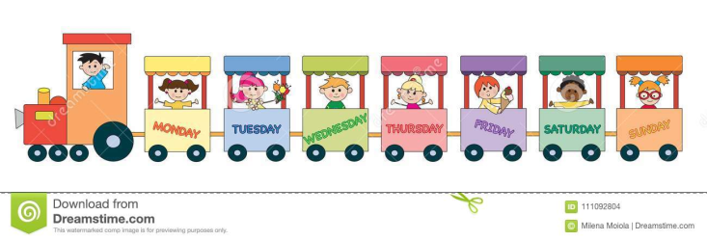 | Aim: To identify and describe coins  Lay out one of each coin. Cover with a cloth and remove one coin. Uncover. Can you work out which coin has been removed? Can you describe it?

10 20 30 40 50 60 70 80 90 100

