Windyknowe Home Learning (Weekly)
Date issued: 27.4.2

P1 Other Curricular Areas
Expressive Arts | Health and Well Being | French
Dance  Aim: To dance creatively to classical music  Move creatively to this music by the famous musical composer Vivaldi. Perhaps think about plants growing, children playing, birds making nests and lambs skipping.  You tube – Vivaldi - Spring  https://www.youtube.com/watch?v=l-dYNttdgl0  Art  Aim: To share my opinions about art.  Put into Google ‘tree of life paintings images’. Which do you like best and why? You may want to make your own tree picture with your own ideas.  Drama  Aim: To use movement to show my ideas  Watch this lovely video of a bean seed growing into a plant: You tube-Bean Time-Lapse - 25 days | Soil cross section https://www.youtube.com/watch?v=w77zPAtVTuI  Can you pretend that you are a tiny dried up seed by curling up small on the floor? Show how you become a little bigger as you absorb water. Show your root beginning to slowly grow out and down. Then show your shoot growing upwards. Next your root and shoot grow even more and your shoot gets two leaves as you reach up to the sun. perhaps an adult can film you doing this so that you can watch it back and talk about your movements. | Aim: To keep healthy through exercise  Look at the ‘What is fitness?’ factfile on Espresso Education to find out why we need to keep our bodies fit.  https://central.espresso.co.uk/espresso/modules/resource_box/health_fitness_ks1/factfiles/factfile_what_is_fitness1.html  Try one of these challenges to keep your body fit and healthy:  Make an obstacle course that includes moving your body over something and under something.  Or  Make your own keep fit routine and ask another person to film you. Perhaps another person in your house could try to copy your routine? | Aim: To revise saying my name in French  Learn a Language: French for Families  The PowerLanguage team would like to offer their support to children and their families whilst they wait out the reopening of schools. Why not take this opportunity to learn French together as a family? Powerlanguage have opened up their successful French for Families course with no subscription fee until the end of June 2020!  Go to powerlanguage.courses/forfamilies to start learning!  Use Lesson 1 and 2 as revision of greetings and saying your name in French.  Amusez-vous bien!  There is also a fun, rainbow colour activity with Camembear from Headstart Languages for you to try!  https://www.headstartlanguages.co.uk/resources/rainbow-fun-with-camembear
RME | Topic | Music
Aim: To share and cooperate with others  As a family, choose a game you can all play together. This might be a board game, computer game or physical game. The important thing is everyone can play together.  Altogether go through the rules for the game and make sure everyone understands. Discuss the importance of turn taking and following the rules of a game.  Now, play your chosen game as a family and enjoy! | Aim: To know how seeds grow. To understand the words root and shoot.  If you managed to plant seeds of any kind keep watching for any signs of growth. Here is a photograph of Mrs Cook’s pea seeds. Bedside the glass is a seed from the packet. It is smaller than the seeds in the jar. Can you think why? It is because the seeds in the jar absorbed water and this started them growing. One seed didn’t grow and went mouldy. The other grew a root downwards and shoot upwards.  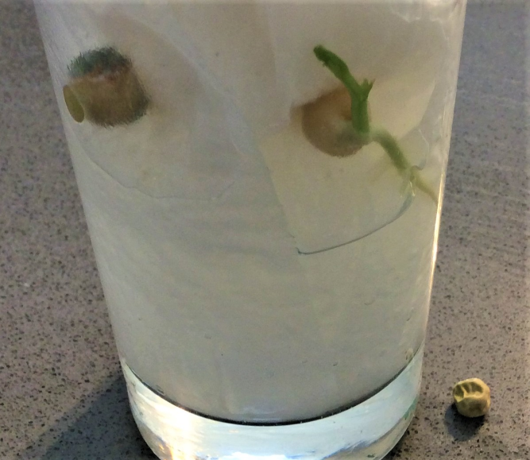  Aim: To sort objects into living, non-living and once living.  Find objects around your home and sort them into 3 sets depending on whether they are living, not living or were once living. Can you explain your thinking to an adult? For example, a wooden object would go in once living because wood comes from trees and trees were living.  Look at these links to see a video and play a game related to this.  Espresso education – first level – science – materials - Videos – What’s it made from?  https://central.espresso.co.uk/espresso/primary_uk/subject/module/video/item1134419/grade1/module1128907/index.html  Espresso education – first level – science – materials - Activities – Which material?  https://central.espresso.co.uk/espresso/primary_uk/subject/module/activity/item1138068/grade1/module1128907/index.html | Aim: To find the pulse  Login to Charanga and click onto the ‘Big Bear Funk’ Yumu pack.  Listen to: Listen and Appraise - I Feel Good by James Brown. Talk about the music using the questions as a guide.  Further down, use the Games Track and find the pulse (the heartbeat of the music) by marching around. Can you find different ways of showing the pulse e.g. tapping, clapping etc?  Click into: Learn to Sing the Song – Big Bear Funk; sing along to the song. Can you follow the shape of the pitch (high and low sounds) with your hand? What can you use for your instrument from around the house? Play your instrument along to the song when it is time.

