Friday 24.4.20
Remember to join Mrs Angus live @11am for p4-7 business meeting– a link will be posted at around 10.45
Problem Solving
L.I. To use ‘try a simpler case’ strategy
Rectangles
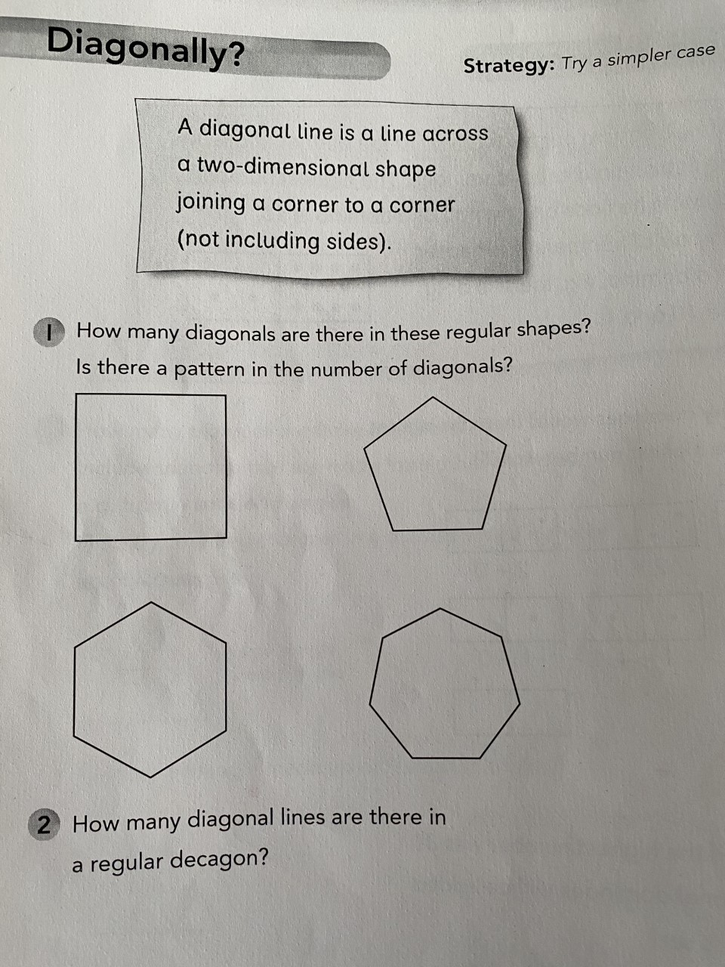
Optional Extension- How many diagonals in a dodecagon?
What about a icosagon?

Triangles
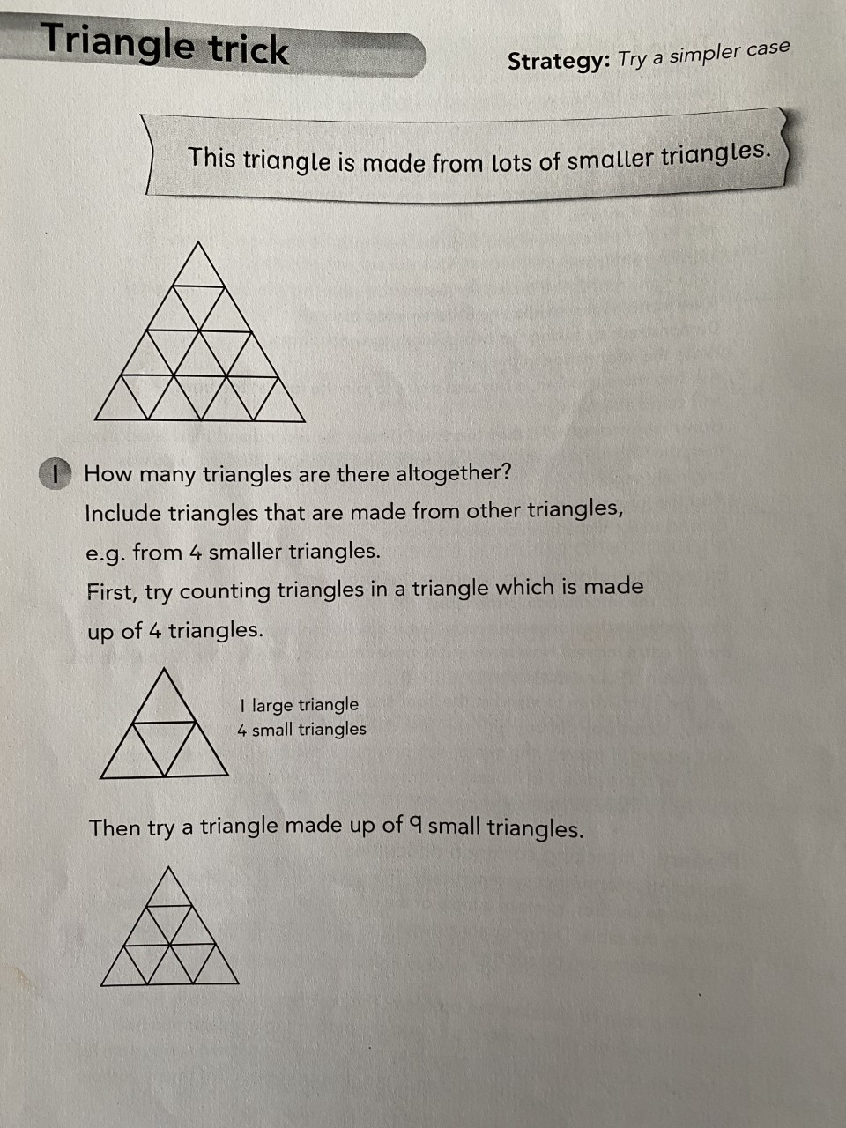
Optional Extension Can you create your own triangle problem like this? You could test someone at home and ask them to count how many triangles they can see.
Circles
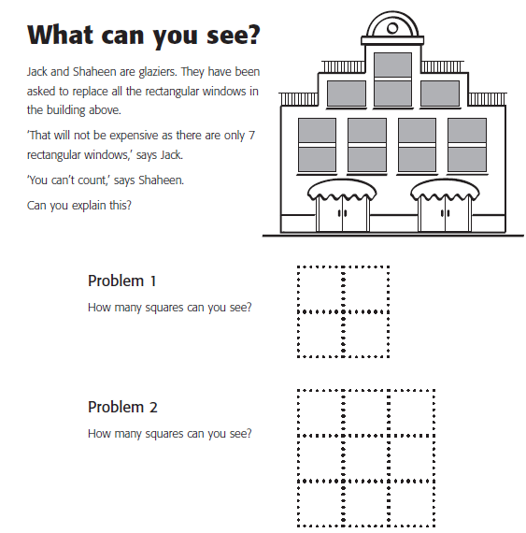
Optional Extension Can you create your own square problem like this? You could test someone at home and ask them to count how many squares they can see.

Skills Academy
LI: to practise organisation skills
Can you organise something in the house? You could organise your books/games/DVDs in alphabetical order, pair up odd socks, organise your t shirts, hanging them up/folding them ordering from light-dark colours. Ask an adult at home for any extra ideas. Get creative!

Reward time ideas! :D
Listen to your favourite music
Play in the garden
Play a board game with someone at home (if they are not too busy!)
Play a game on a device
Just dance videos! (Search ‘Just dance’ on YouTube)
Kahoot! https://kahoot.com/schools-u/
Cosmic Kids Yoga- https://www.youtube.com/watch?v=bCstmsm9Ows
How to draw a space Alien-
https://www.youtube.com/watch?v=bCstmsm9Ows

