Friday 24.4.20

Handwriting
L.I. To join my letters
Write the following poem in your green jotters using your neatest handwriting.
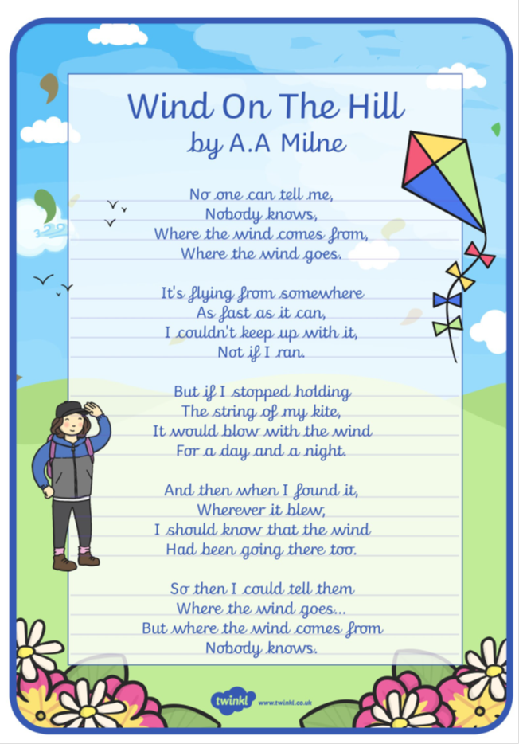

Problem solving

Would you rather? Solve the following problems and explain your answers in your green jotter. You may use a calculator if you have one however challenge yourself mentally first.

Key questions
How will you compare these two scenarios?
How did you get to the answer? (a sum? picture? problem solving strategy?)

Would you rather...
- ...have 30 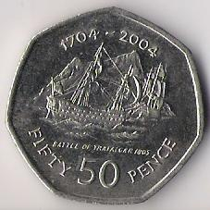 coins or 10 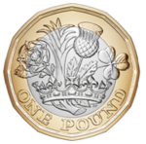 coins?

- … have three halves of a pizza or eight quarters?

- … be bitten by 10% of 200 scottish midgies or 50% of 20 scottish midgies 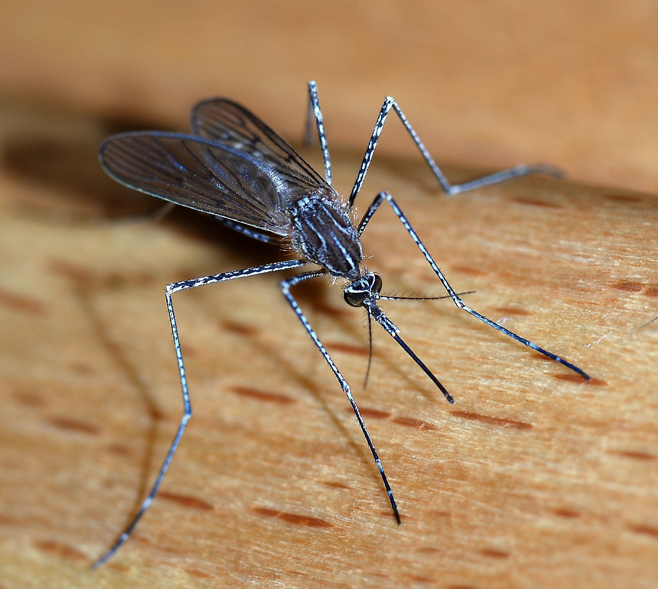

- … sit in a traffic jam for a the time it takes you to do 100 star jumps or the length of time to boil an egg 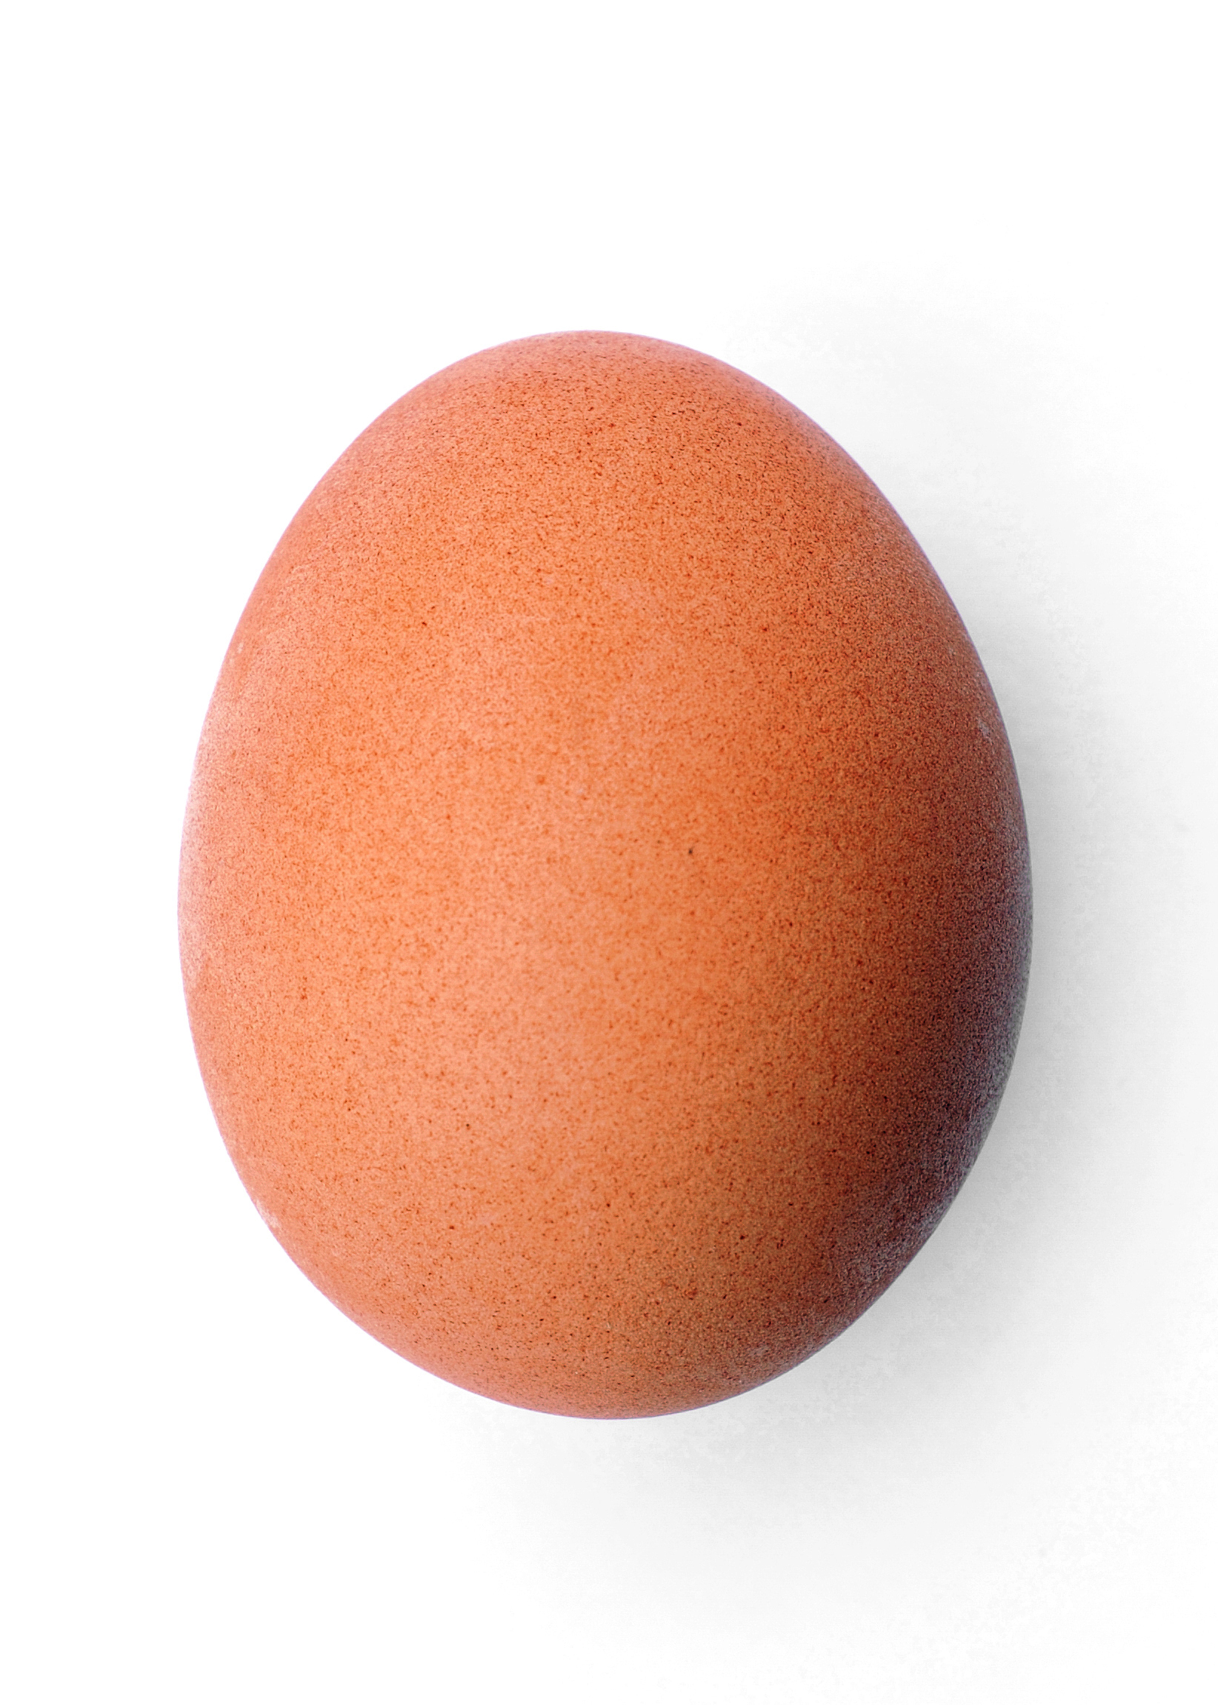
- … eat half of 8 chocolate eggs or a quarter of 20 chocolate eggs? 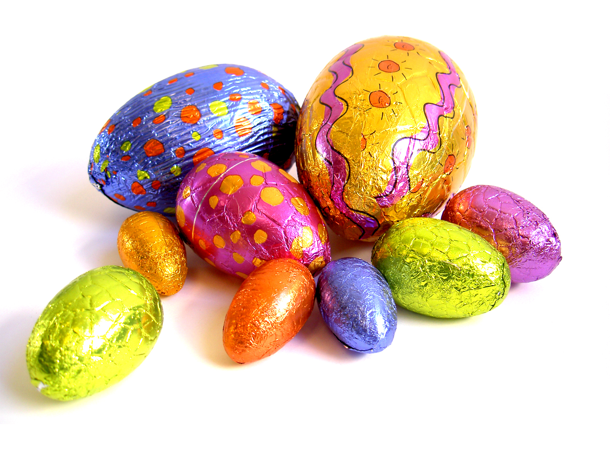

- Now it’s your turn. Create a question for the class and post it on our Teams.

