Thursday 23rd April
Primary 7 there will be a list of 4 core tasks to do at the top of the page and then at the bottom there will be optional extras if you would like to do them. 😊
Get Set
Write down one person who inspires you and explain why.
CORE TASKS FOR TODAY
1) Literacy (grammar & punctuation)
L.I. to use prepositions
A preposition is a word that tells you where something is. To help you understand here is a very catchy song! 😊 Watch: https://www.youtube.com/watch?v=byszemY8Pl8 and note down 5 prepositions of your choice. Then write down a sentence for each preposition you have chosen.
Finally log on to Studyladder and complete the preposition task set.

2) NUMERACY
L.I. to practise my times tables
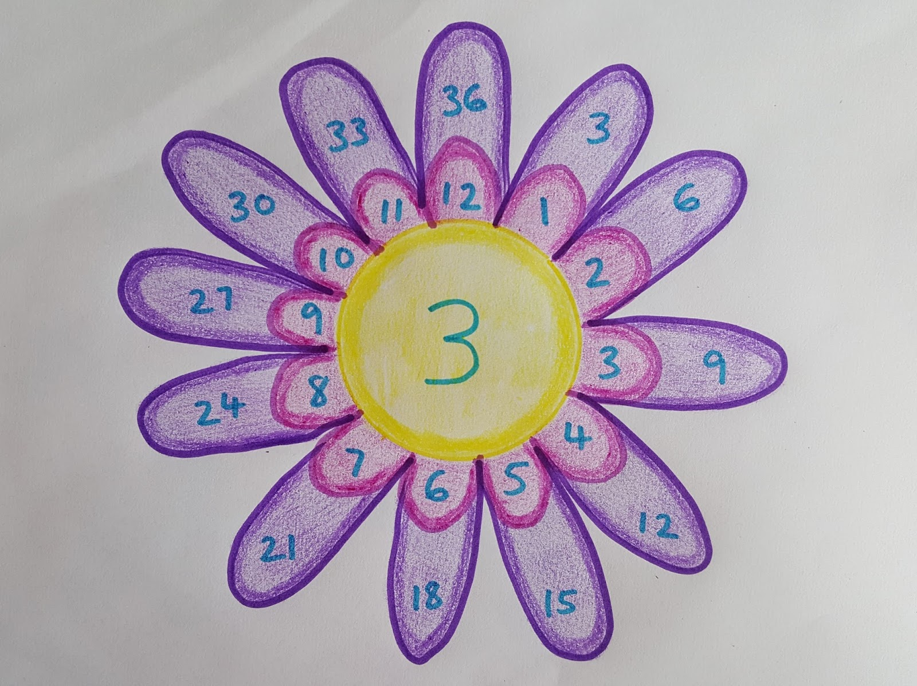
Choose three different times tables which you feel you need to practise the most and create them into multiplication flowers. Here is an example picture:
3) P.E. (from Mrs Howard)
Continue with the P.E. lessons from Mrs Howard. This can be found in the Assignments folder. Assignment Week Beg 20 April for you to do- it's a fun Pentathlon.
4) TOPIC
L.I. to research and present information about a country
Before we finished up for Easter you created a PowerPoint on a country of your choice (apart from the UK and America). Now you must add to you PowerPoint; add any extra information and fun factes that you wish but make sure you have included the key information bullet pointed below:
- Key features about the country: population, language spoken, capital city etc
- How the land is used within that country
- Who the leader/government is
- What their climate it is
- How is that country similar to the UK?
- How is it different from the UK?

Optional tasks for today
If you are looking for something else to do remember you can log in online as often and for as long as you want on the following sites:
- Studyladder https://www.studyladder.co.uk/login/account
- Espresso https://online.espresso.co.uk/espresso/login/Authn/UserPassword
- Sumdog https://www.sumdog.com/user/sign_in
- Active Learn https://www.activelearnprimary.co.uk/login?e=-1&c=0#all
- Charanga with Mr Muller https://charanga.com/site/log-in/ (There will be weekly tasks to complete for the following Monday)
9am P.E. with Joe Wicks
L.I. to improve my stamina and physical fitness
You can click on the link below and take part in a 30-minute Joe Wicks P.E. session to start your day. https://www.youtube.com/channel/UCAxW1XT0iEJo0TYlRfn6rYQ

Handwriting
L.I. to improve my cursive handwriting
Rewrite out your preposition sentences with beautiful, cursive handwriting. Do this twice.

Spelling
L.I. to practise my spelling words
Using your spelling words do sit ups/star jumps/press ups/burpees whilst spelling them out loud.

HWB
L.I. to look after my mental and physical health
Create a poster with 5 top tips to inform people how to look after their mental and physical health during this isolation time. Think about safe activities they could do inside their homes, garden and on their daily exercise walk. The poster can be made with paper or using ICT.

Extras
- Write a poem about the spring
- Look in a mirror and tell yourself 3 things that you like about yourself 😊 Be kind and raise your self esteem.
- Create a picture or your most treasured possession.

Answers will be posted at the end of the school day where possible. You can also listen to our class novel at the end of each day using the online link https://www.youtube.com/watch?v=Lfi82CbVw1c.
Well done for taking part in your Thursday timetable online. Get ready for Wednesday’s timetable tomorrow!

