I Love Animals

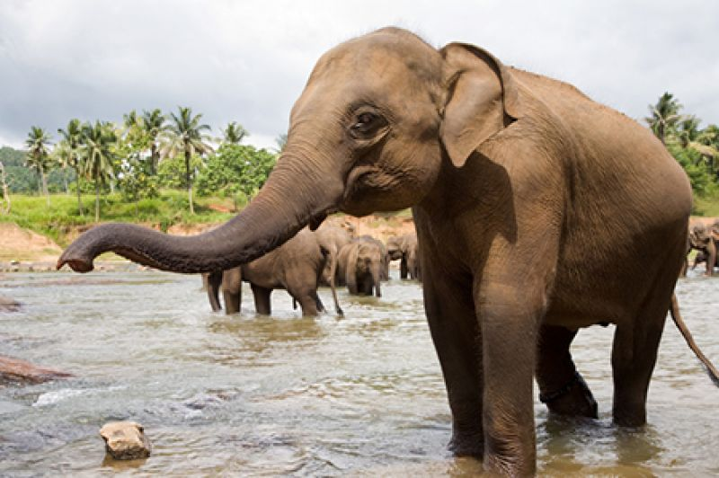
Elephants are big.

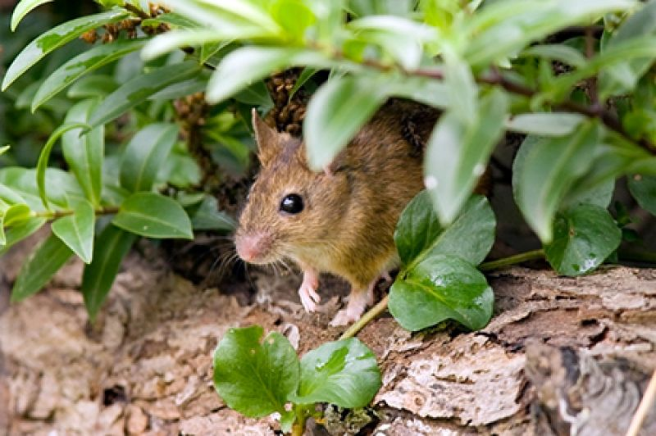
Mice are small.

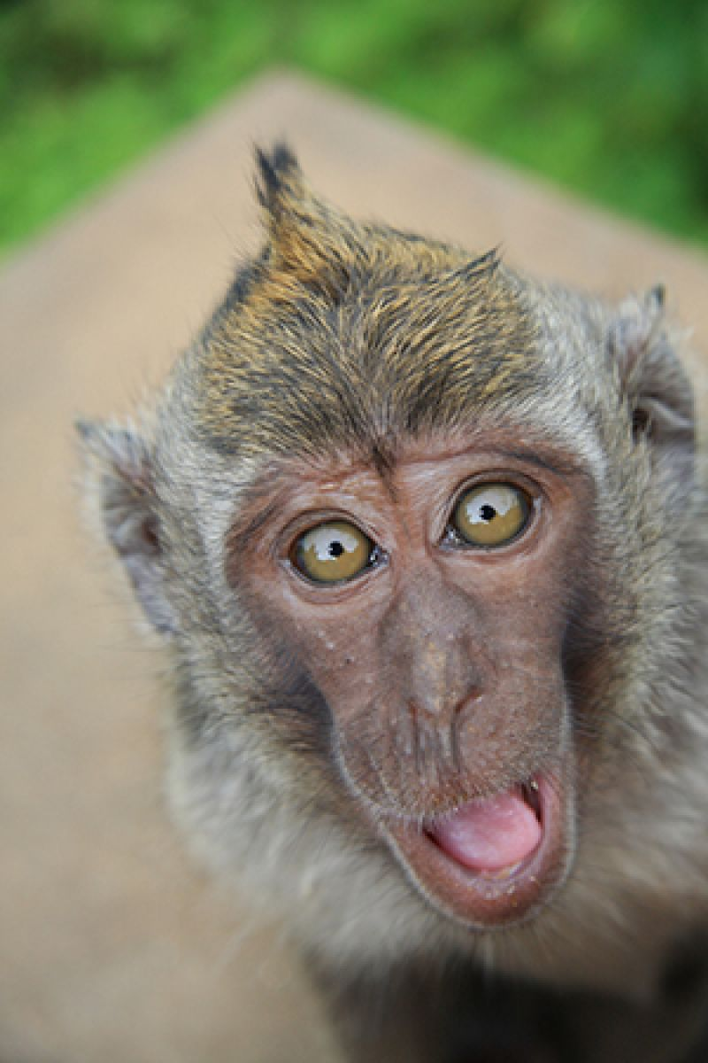
Monkeys are funny.

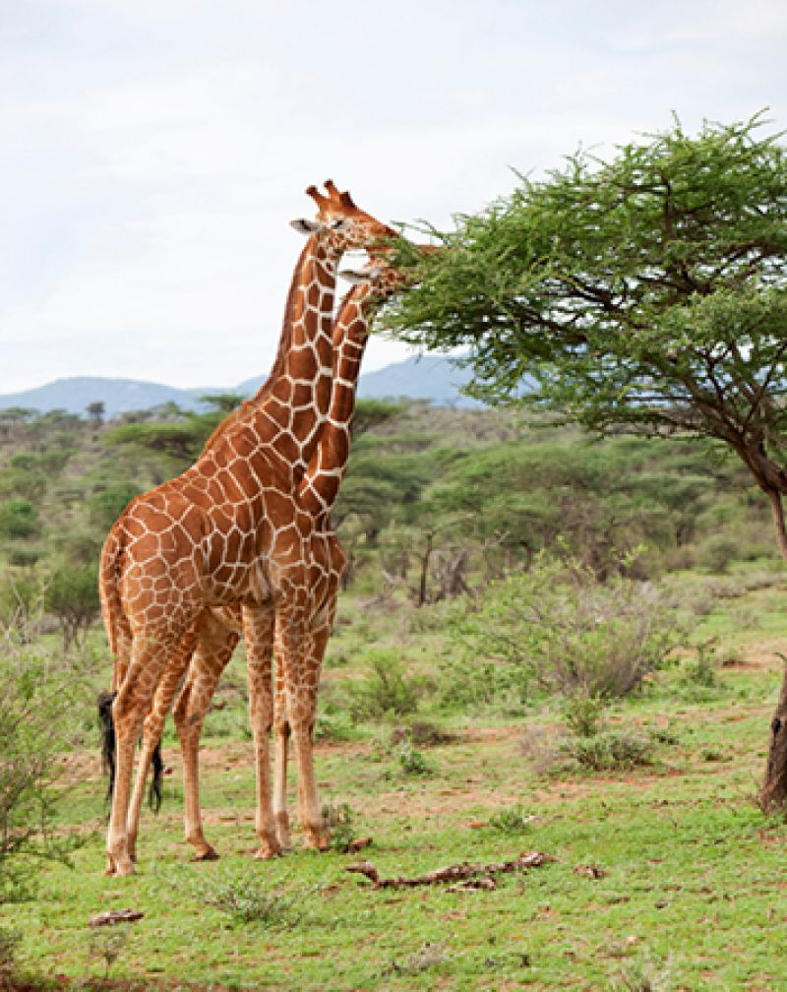
Giraffes are tall.

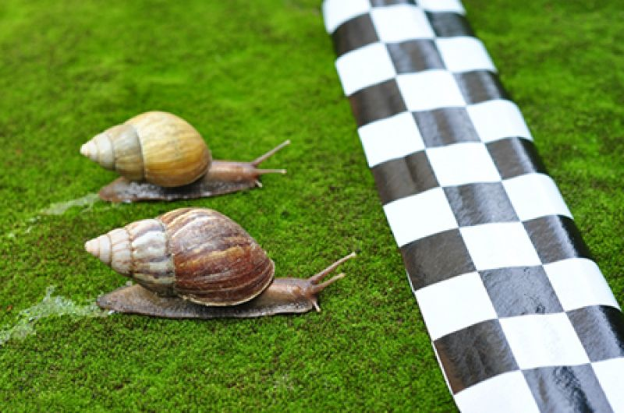
Snails are slow.
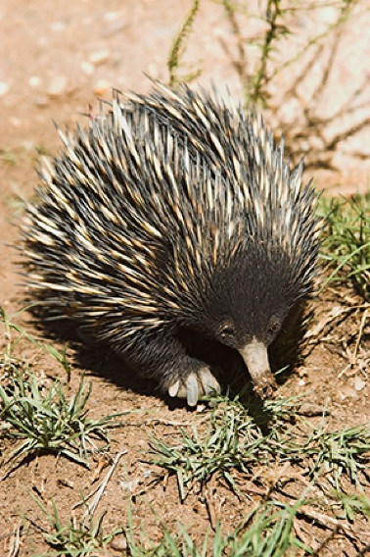
Echidnas have spikes.
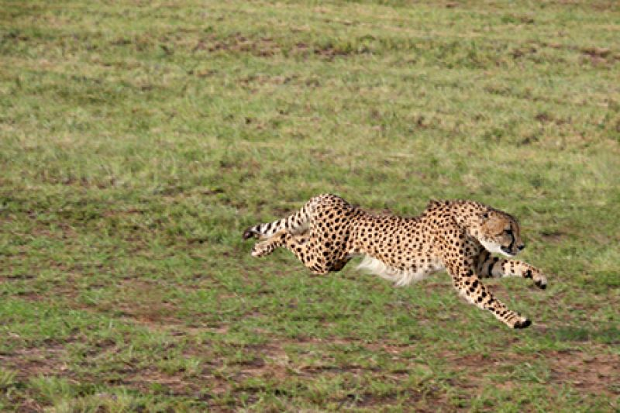

Cheetahs are fast.
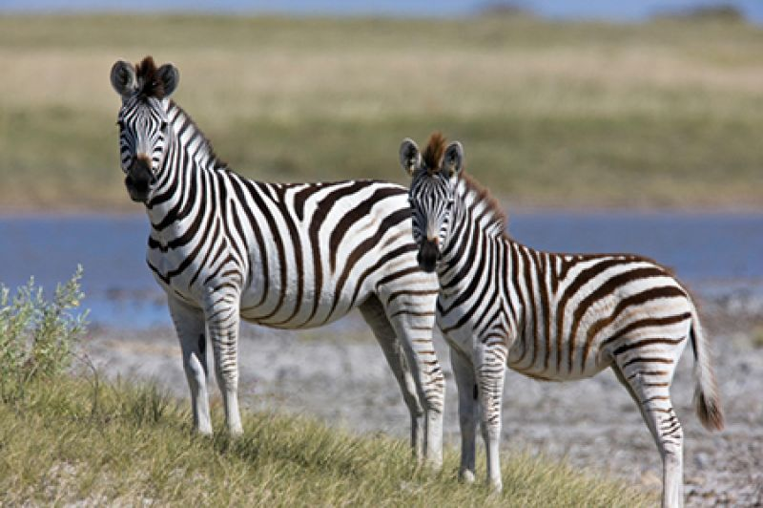
Zebras have stripes

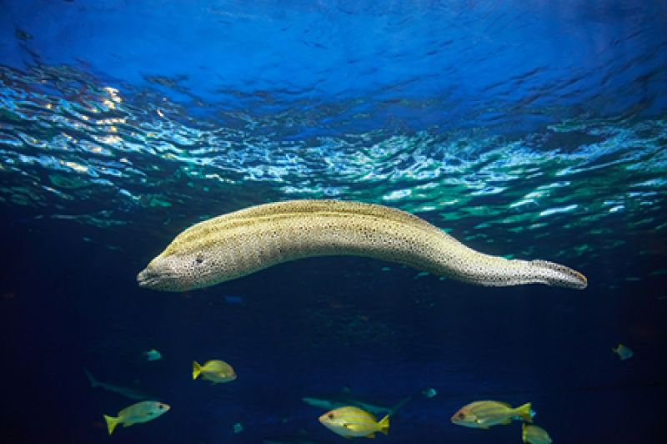
Eels are slippery. 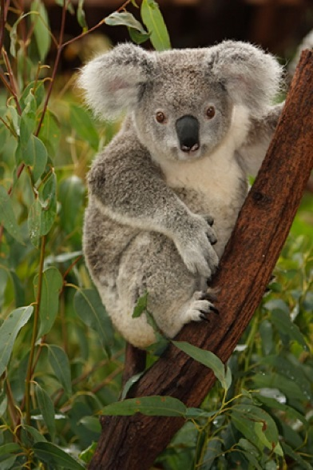
Koalas are cuddly.

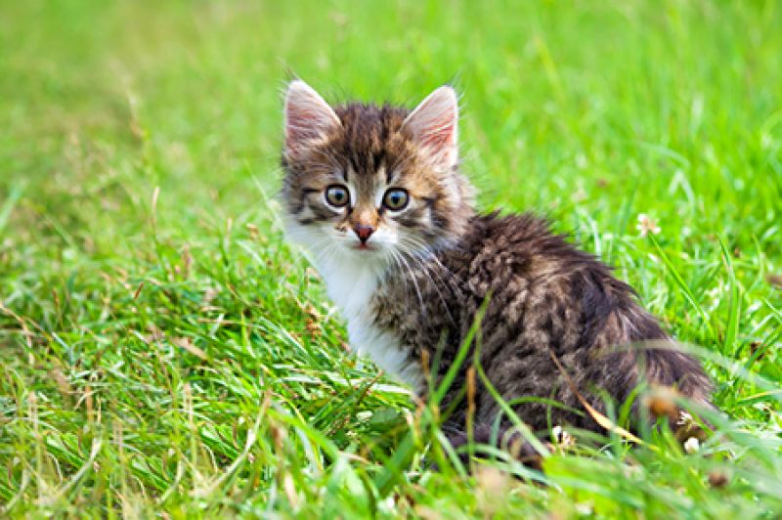Kittens are fluffy.
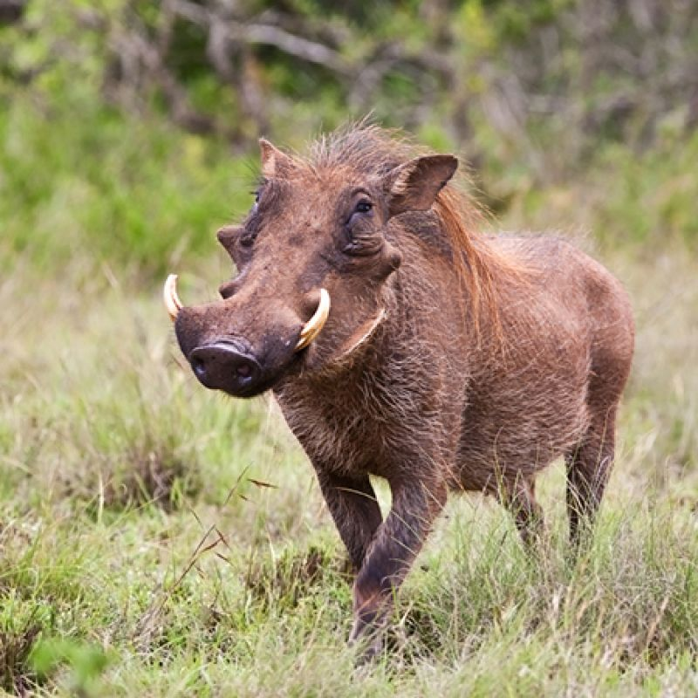
Warthogs are ugly.

Ugly, cuddly or cute.
I love all animals.
Questions on next page

Questions
Copy and complete the sentence.
- Elephants are ____________________.
- Kittens are __________________.
- Cheetas are____________.
- Giraffes are_______________.
- Echidnas have________________.
- Monkeys are__________________.

Try to answer these questions in sentences. Remember to sound out your words.
- Which animal is small?
- Which animal is slippery?
- Which animal is slow?
- Which animals have stripes?

