Thursday 23.4.20

Grammar and Punctuation (Prefix revision)
LI: to revise prefixes
Today we are going to revise prefixes!
Use this video to refresh your memory J : https://www.youtube.com/watch?v=1oI9Jl2xeAE
Below are activities for your group to revise prefixes, you can use online dictionaries on your device to help you. Next week, we are going to revise suffixes!

Greens
SC: I can identify and write different prefixes
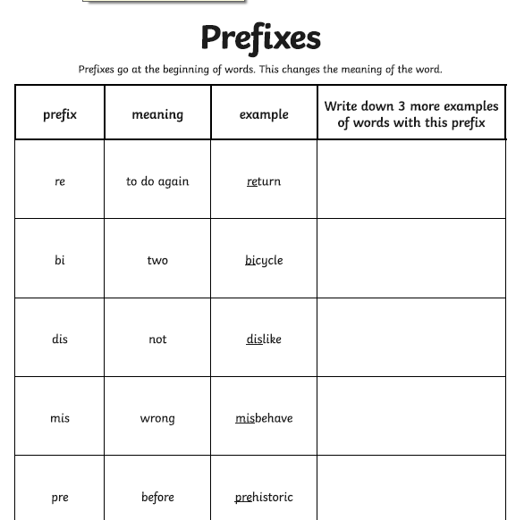

Blues Nelson Grammar Pupil Book 4 Unit 2
SC: I can use a prefix to identify the opposite meaning of a word
Complete Focus section A& B
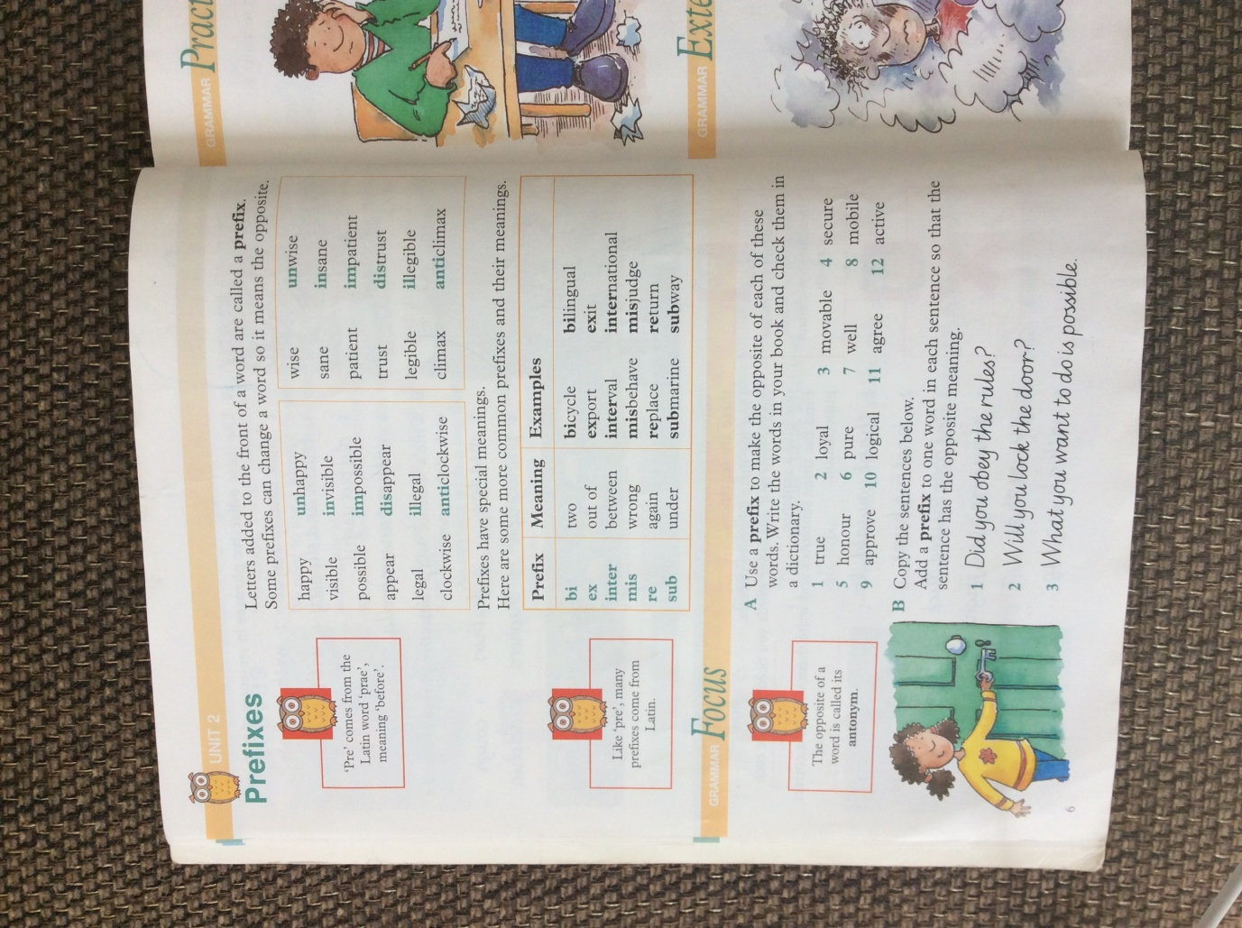

Reds Collins Grammar and Punctuation book 4 (Unit 11)
SC: I can identify and write the correct prefix to a word so that it makes sense
Complete practise parts 1& 2
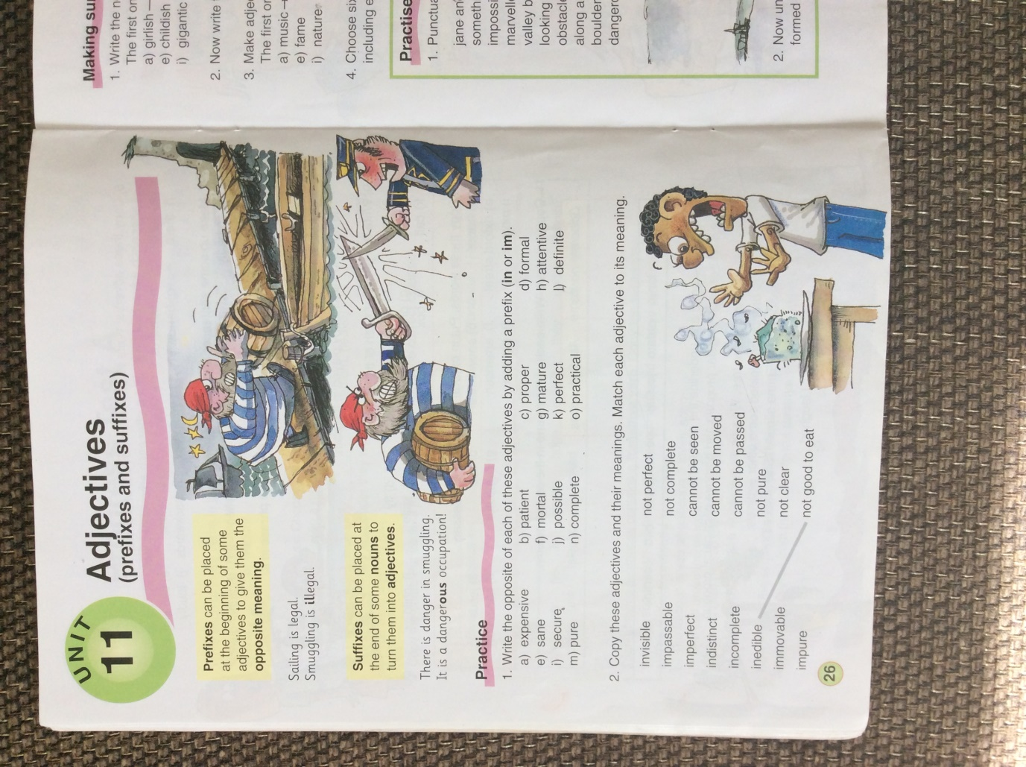

Maths – LI – to use the perimeter of a shape to work out the surface area.

Starter – watch https://www.youtube.com/watch?v=xCdxURXMdFY (from 0:00 to 4:30)
Check out - https://www.activelearnprimary.co.uk/login?c=0 and https://www.studyladder.co.uk/where there are games to help you understand area!

Rectangles

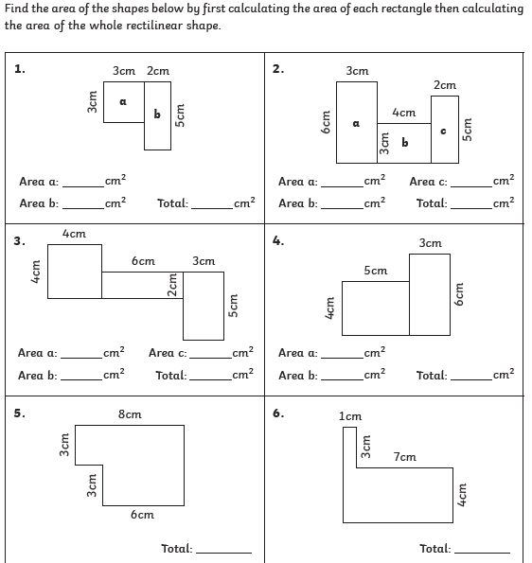

Triangles
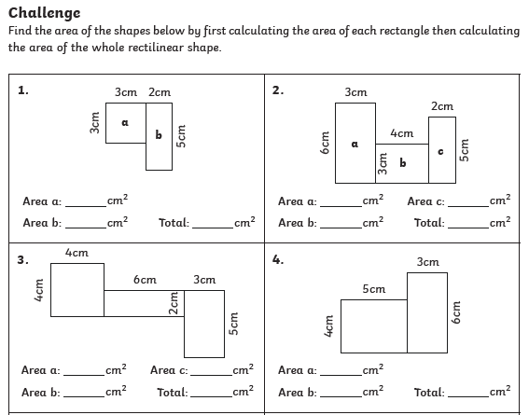

Circles
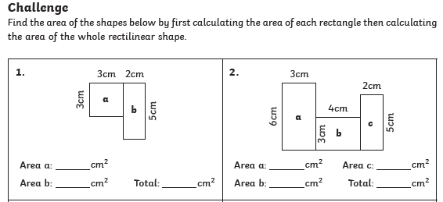

Topic - Climate Change
LI: To understand and explain climate change/global warming (gw)
In your jotter or on a device, create a mind map that helps answer these questions about climate change/global warming (gw):
1) What is climate change/gw?
2) What are the effects of climate change/gw?
3) Who is affected by climate change/gw?
4) Who is responsible for slowing down the effects of climate change/gw?
5) How can we prevent the ongoing effects of climate change/gw?
Here is an example of how your mind map could look, you can choose to include pictures, labels and definitions!
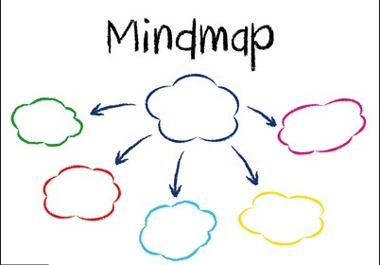

Use these videos to help you:
https://www.youtube.com/watch?v=Sv7OHfpIRfU
https://www.youtube.com/watch?v=Y3gqoDUtmt4

Music

Mr Muller has placed new activities in your charanga inbox
This can be access here https://www.charangascotland.co.uk/yumu/login
I will give updates throughout the week about who’s access their music learning and who’s earned charanga points. If you are unable to access charanga and you don’t have a username or password, let Mr Muller know

