Thursday 23.4.20

Literacy
L.I. To identify and use plural rules
Log in to Studyladder and find the following tasks under ‘Rules’. Complete the tutorial and practice tasks allocated to you.

Alliteration and Metaphor:
‘Plural Rule – words ending in o add – ‘es'
‘Plural Rule – words ending in o - add ‘s’

Personification
Plural Rule – change ‘y’ to ‘i’

Simile
Plural Rule – add ‘es’

Maths
L.I To convert 12 and 24 hour clocks
Warmup: How many places in your life can you see the time? List/draw them in your green jotter

Lesson: Watch this video to remind you about reading between 12 and 24 hour clocks. You may want to take notes (link lizard!)
https://www.youtube.com/watch?v=yFxNCverq80
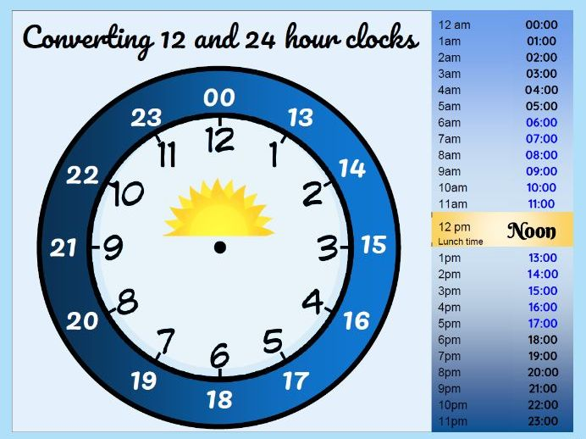
Task: You have an allocated game in your Active Learn account (Robot Revenge). Play bronze, silver and gold until you are feeling confident.
If you’ve forgotten your password, ask an adult to e-mail the school office and we will get this sorted for you.

More? Ok! Make your own video explaining 12 and 24 hour clocks. Pretend you are explaining this to an alien from outer space and don’t miss out a detail! Show an adult at home once you are finished.
Even More? Ok ok! Play sumdog. Let’s see who gets the highest score today!

Art
L.I. To create texture with a pencil
Texture is the feeling, appearance or consistency of an object or material.
It can be natural or man-made, functional or decorative. Artists try to replicate the texture of the subject to make their work look as realistic as possible.
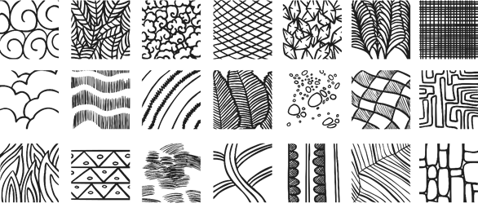

Practise drawing a texture with a pencil by copying these textured squares.
