Windyknowe Home Learning Tasks (Daily) Date issued: 22.4.20

Class P1 Numeracy and Mathematics
Numeracy Task 1 | Mental Maths Task 2 | Money Task 3
Aim: To investigate place value  Using practical items or by drawing a dot or circle, can you show the following numbers? Ask an adult to guess the number you have made?  11  16  18  23  25  29  Example:  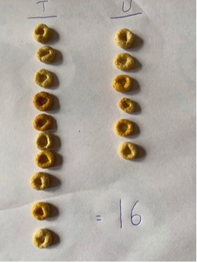 | Aim: To create simple adding sums  Can you create 3 sums adding up to the number in the middle of each triangle? Then choose your own middle numbers and create 2 more sums?  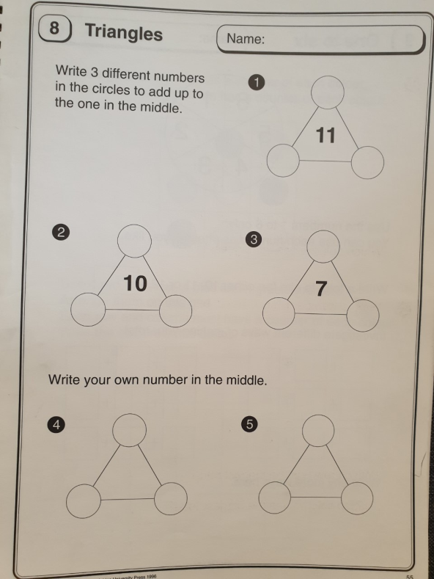 | Aim: To make amounts using coins  