Class: Primary 2 Numeracy and Maths
Task 1 | Task 2 | Task 3
Number Formation warm up.  We are learning to write digits correctly.  Please practise your number formation in any creative way you can.  Please check out this video for some rhymes to help you.  https://www.youtube.com/watch?v=VlfQhHQAUCY  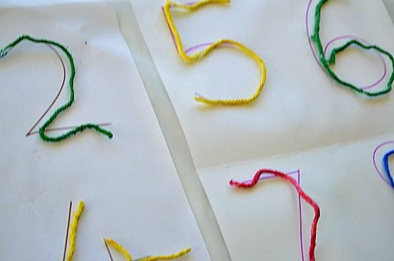  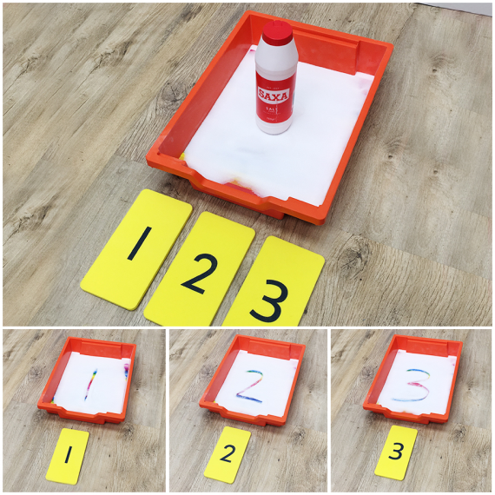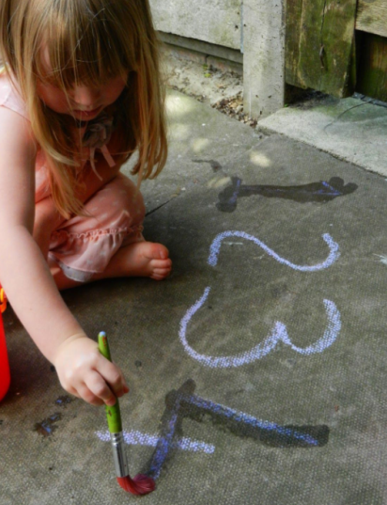 | We are learning to use number facts and mental maths to work out addition and subtraction calculations.  No counters or objects should be used, use relying on counting on/back in head or fingers if needed.  Mild Spicy Hot  2 + Δ = 3 5 + Δ = 7 12 + Δ = 13 15 + Δ = 17 2 - Δ = 1 5 - Δ = 3 12 - Δ = 13 15 - Δ = 13 22 + Δ = 25 25 + Δ = 27 99+ Δ = 101 100 + Δ = 17 22 - Δ = 20 56 - Δ = 54 80 - Δ = 78 100 - Δ = 98 90 + Δ = 92 91 - Δ = 90 Δ + 87 = 89 Δ + 89= 91 989+ Δ = 991 100 + Δ = 102 202 - Δ = 200 189 - Δ = 187 550 - Δ = 548 Δ + 140 = 142 | We are learning to create and complete number sequences by repeatedly adding or subtracting a number.  Play Buzz with someone/ people in your family.  Start from 3 and add on 2 every time- stopping at 31.  What can your BUZZ number/ numbers be? Could 10 be a BUZZ number, if not why not?  You might need to write down your sequence before you play to help you work out what your Buzz Numbers could be.
Date Issued: To be submitted by:
Date Issued: To be submitted by:

