21.4.20

Numeracy
L.I. To identify a number sequence

Nrich Patterns
Ninjas and Magicians can you solve the problem of Button up?
My coat has three different buttons.
Sometimes, I do them up starting with the top button. Sometimes, I start somewhere else.
How many ways can you find to do up my coat?
How will you remember them?
Do you think there are any more? How do you know?

Mathletes and Algebros can you solve the problem of Button up some more?
I have a jacket which has four buttons.
Sometimes, I do the buttons up starting with the top button. Sometimes, I start somewhere else.
How many different ways of buttoning it up can you find?
Look back at the number of different ways you found for buttoning up three buttons and four buttons.
Can you predict the number of ways of buttoning up a coat with five buttons? Six buttons ...?
Key questions
How do you know you have found all the ways?
How could you use the number of ways to button up three buttons to help you work out the number of ways for four buttons?
How will you record what you're doing?

Now play:
https://mathsframe.co.uk/en/resources/resource/42/sequences
Ninjas/magicians: level 4
Mathletes: level 14
Algebros: level 15
You can also change the difficulty within your level. Maybe start on easy and work up to genius!

Writing
L.I. To retell a story
1st Level
Narrative/Description
- To entertain and/or instruct readers by telling a series of events with a problem and a solution
- To describe the characteristics of people, places and things
T P S
I can…
- describe the setting and characters - Where does the story take place? What does the character do and say? What type of person are they?
- describe the main events in order. Tell about the characters’ thoughts and feelings
- use adjectives to describe, shape, colour, size, number, texture
- use action verbs – jumped, escaped
What went well…
Even better if…

2nd Level
Narrative/Description
- To entertain and/or instruct readers by telling a series of events with a problem and a solution
- To describe the characteristics of people, places and things
T P S
I can…
- describe the main events in a sequenced order (characters’ thoughts, feelings, actions and reactions, views and opinions)
- add events which happen because of the main events
- use a variety of adjectives – shape, colour, size, number, texture
- use figurative language such as similes, metaphors, alliteration etc
What went well…
Even better if…

Watch the video ‘Catch It’ on Literacy Shed
https://www.literacyshed.com/catchit.html
You may need to watch it more than once to get a good understanding of the story. In your green jotters or on Word, retell the story as if you are one of the meerkats.
Things to consider:
- The setting – how will you describe the African plains? Can you use super adjectives to describe the area?
- Your feelings – how did you (as the meerkat) feel at different points of the video? Think of how you would feel when you woke up, when you first saw the fruit, when you saw the vulture, and at different points of the plan to retrieve the fruit.

scavenger hunt

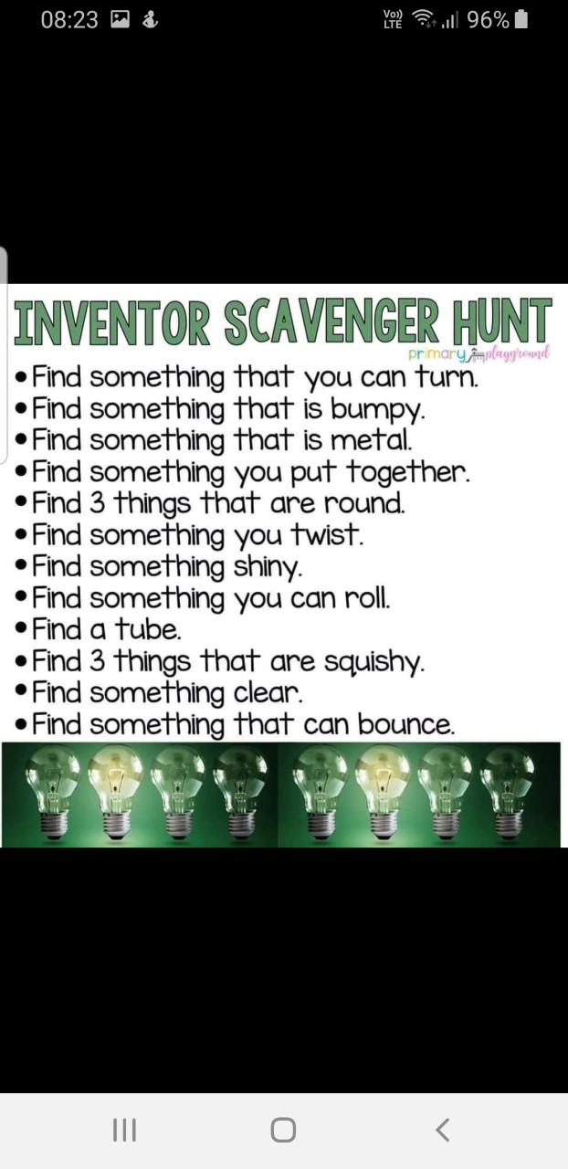
Can you find any of these things around your house? You could write your findings in your green jotter or you could take pictures of some of the things you have found.

