Tuesday 21.4.20
Here are your jobs for today:
Writing
LI: To write a report in the form of a Captain’s log
SC: I can write a diary entry as a captain of a space fleet
Watch: https://www.youtube.com/watch?v=qvPQ4HbGnro
You are a Captain in charge of a large space fleet with a mission to save mankind.
Facing global resource depletion, you decide to send out Space Rovers to find potentially inhabitable planets.
Task - You will write a ‘Captain’s log’ recording the events which take place on this unknown planet that you send the Space Rovers to. What is the planet like? Is it safe? What do the Rovers find and as Captain, what are you going to do with this information? Here is an example of how you could start your log.
Captain Purdie’s log April 21st, 2057 (Make up a date in the future!)
We have discovered a planet which is unknown to us, as captain I have decided to send out my best Space Rovers to check the terrain for any sign of life. On further investigation and collecting evidence of their visit to this strange planet it appears that...
- Include features of the planet
- What happened to the rovers?
- What the outcome of their visit was
- How will you use this evidence and information to help save mankind?
Mrs Magee’s writing group – remember you can use the dictate tool on Word on Glow to dictate your writing and word will type it for you. You still need to read over, check, edit and improve your work. You can also use Clicker to type your work and click the predictor button to help predict words and spell them correctly.
Bonus task for fun: Draw yourself as Space Captain of your fleet! Give yourself a cool uniform that makes you stand out as captain!
Spanish
LI: To learn and revise days of the week in Spanish
Use this video to help you : https://www.youtube.com/watch?v=SQbspMMdJU8
Then test your knowledge with this matching game: https://www.quia.com/mc/360211.html

Numeracy - L.I-To be able to revise and use knowledge and understanding of money
- Active Learn Games- select from the Money Games allocated to you. You can select your own level of difficulty in each game.
Optional Additional Tasks
- Explore the Money Games on Topmarks. You can choose the level of difficulty on most of these. https://www.topmarks.co.uk/maths-games/7-11-years/money
- SumDog
- The Change game: https://natwest.mymoneysense.com/students/students-5-8/the-change-game/

Health
L.I- To know about ways people can help others
- Go to the Newsround website: https://www.bbc.co.uk/newsround/52277760 Read the information about Captain Tom Moore and watch the following clip.
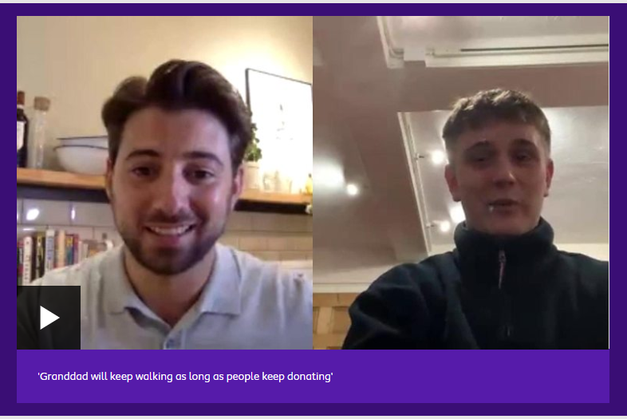
- Think about how this story makes you feel (you can right some notes in your Green Jotter or post on TEAMS).
Optional Tasks (If you have time you can do as many of these as you like, you do not need to do them all)
- Design a reward you think Captain Tom Moore should receive e.g. medal, trophy, certificate
- Draw or write about other people who you think are inspirational
- Design a ‘Thank You’ poster for our Key Workers or choose one role in particular e.g. NHS staff, carers, supermarket workers, postmen and woman, binmen amd women etc.
- Draw Tom Moore or another inspirational person and label with facts and words to describe them.

Topic
LI – complete a research task about space using a computer.
Starter – can you click on the following link and spot where the International Space Station is? Which country is it over? Write answers in your green jotter. https://spotthestation.nasa.gov/tracking_map.cfm

Task
Now use a computer to research the answers to these questions. Write the answers in your green jotters.
- What do you call a man who travels in space?

- When did a man first walk on the moon?

- Name two things that work with the help of satellites.

- Do satellites help people to work out what our weather will be?

- Space probes have people on them?
True or false

- Space stations have people on them?
True or false
- What do astronauts do in the space station?

- Satellites stay in space? True or false

- How many satellites are there floating around in space? 1,000 2,000 3,000

- What do scientists call all this ‘stuff’ floating around in space?

Music

Mr Muller has placed new activities in your charanga inbox
This can be access here https://www.charangascotland.co.uk/yumu/login
I will give updates throughout the week about who’s access their music learning and who’s earned charanga points. If you are unable to access charanga and you don’t have a username or password, let Mr Muller know

