Monday 20.4.20
Please remember!
- Work can be completed in your green jotter or on a device/laptop
- Your teacher will only be available between 8.45 – 3.15, if you post after that time we will get back to you in the morning. Break and lunch times still apply
- Do not put too much pressure on yourself to finish things quickly, these can be done throughout the day.
- Remember you have access to apps and links such as Sumdog, Go Noodle, Study Ladder and Activelearn. You can play these any time!
- If you finish all the tasks that we have set you can read, or decide what else to do with the rest of your day
- Try to post work in ‘assignments’ or ‘class notebook’ if you can’t do this, don’t panic. You can always upload a photo to the live chat... but you don’t have to!

Numeracy – All groups
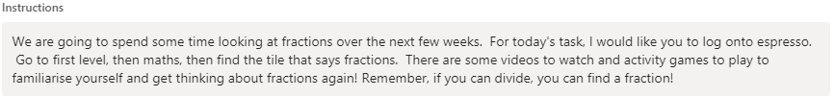
https://www.discoveryeducation.co.uk/

Literacy - Grammar and Punctuation - All Groups
LI to use speech marks
SC I can include all speech marks. I can identify where speech marks should go.
Instructions
Using the template for your group, copy the text and add in the speech marks. Remember that speech marks indicate when someone is talking. They can also be called inverted commas. Here is a video to help
https://www.bbc.co.uk/bitesize/topics/zvwwxnb/articles/ztcp97h

French
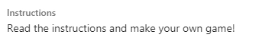
Health and Wellbeing
I have attached Mrs Howard’s PE lesson to the blog post
Health and Wellbeing
