20.4.20

Literacy
L.I. To read for information
Please read the text for the comprehension task allocated to you on Studyladder and answer the questions. Your teacher can see your score online so there is no need to submit it separately.
Simile – Sun safety
Personification - Ants
Alliteration and Metaphor - Reptiles
Please let Miss Hesp or Miss Melrose know if you do not have your Studyladder details.

Numeracy
L.I. To identify and continue a pattern of equal steps

Please complete your workbook page in your green jotters.
Have a go at the Guess my pattern game, you could play it with someone in your house.

Game

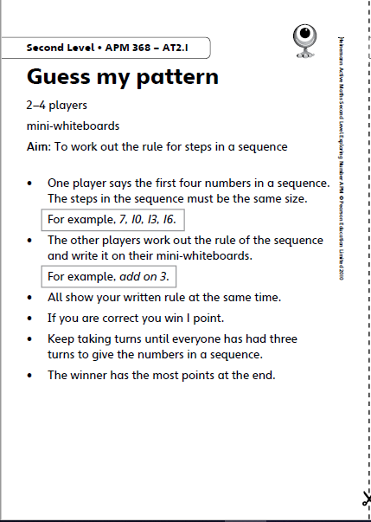

Numeracy Ninjas and Maths Magicians
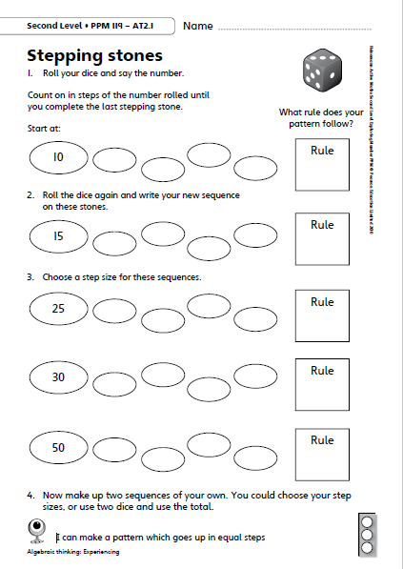

Mathletes

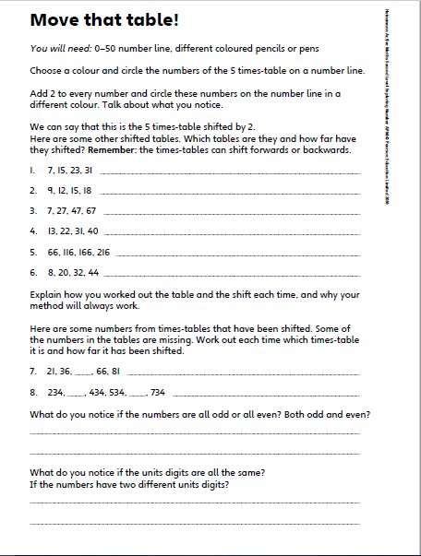
Algebros
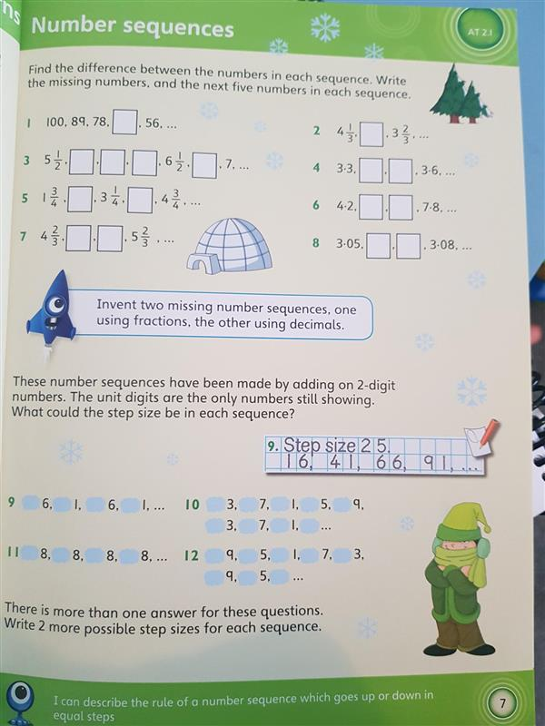

HWB
L.I. To identify calcium-rich foods
Calcium is essential for strong healthy bones. Do some research to find out which foods are rich in calcium. How many do you currently eat and how many would you like to try?
Make a note of your findings in your green jotter.

