Monday 20.4.20
Hello primary 6! Hope you enjoyed your Easter holidays. We have and are still missing you greatly.
Here are your jobs for today:
Literacy (Spelling & Reading)
Read the next chapter in your reading book or a book of your choice for around 30minutes. (If you are unsure what chapter you are on contact your teacher)
Spelling – Prefixes and suffixes
Mild | Spicy | Hot
relay  return  unfit  undo  defrost | disagree  pointless enjoyment  unknown  careful | antifreeze  autobiography  irregular  improper  misjudge

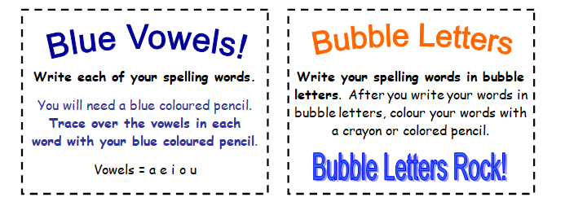

Topic
L.I- To know about the sun, moon and Earth
- Login to Espresso- https://www.discoveryeducation.co.uk/
- Search ‘Earth and Space’ choose Second Level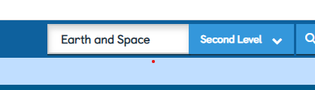
- Choose the ‘Earth and Space’ Module and then click videos. Click and watch the video ‘The Moon’
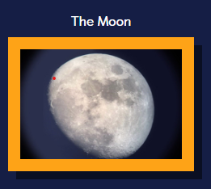
- Write at least two facts that you have learned about the Moon from this clip.
- Click videos again from the menu on the left and then click and watch the video ‘The Phases of the Moon’
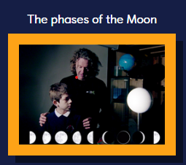
- Write at least two facts that you have learned about the Moon from this clip.
Optional Task: Using the information you have learned can you create a Moon poster, SWAY or PowerPoint including facts and drawings? You may want to research the moon further using the internet or any books you have at home and add this information to your poster.

Numeracy- Money Revision/Consolidation
Rectangles- TeeJay E p57 Q1-2
L.I- To be able to solve money problems

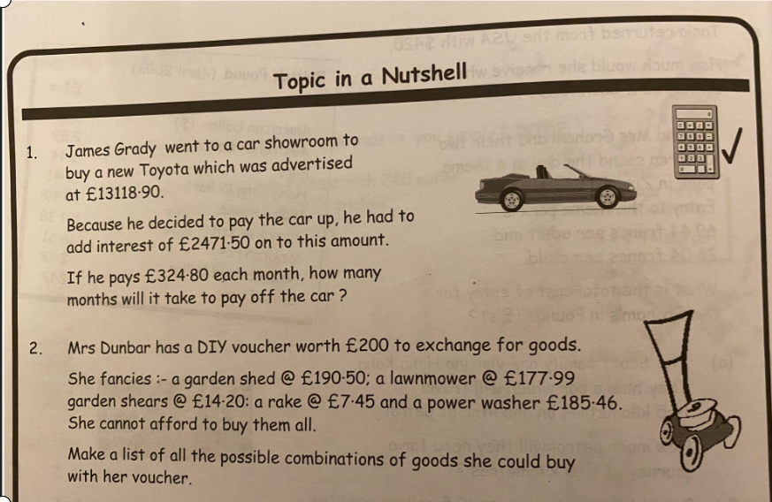

Triangles- TeeJay 2b p79 Q1-3
L.I- To be able to solve money problems
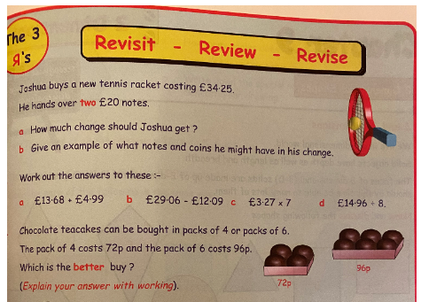

Circles TeeJay C p30 Q4-8
L.I- To be able to solve money problems
