Indoor, Outdoor Easter Egg Game

You will need: Paper, scissors, colours, cello tape, food tins or recycled items (i.e. cereal packet, yoghurt tub)
1. Draw, colour and cut out 6 Easter eggs on paper. (Copy the designs below or create your own.)
2. Write out the fitness feats.
3. Attach your cut outs to the tins or recycled item
4. Now see next page to play the game. Have Fun!
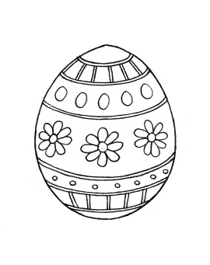
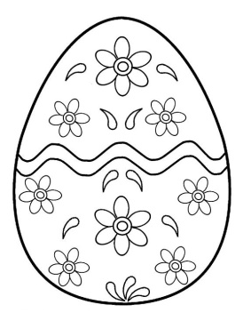
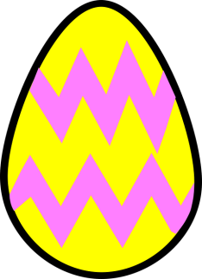

- 30 sec flossing
- 5 moon jumps/tuck jumps
20

- 20 high knees marching
- 20 sec fast feet on the spot as fast as you can

- 5 press ups
- 10 lunges

- 10 step ups ( use 1st stair)
- 15 Jump Jacks

- 10 sit ups
- 10 squats
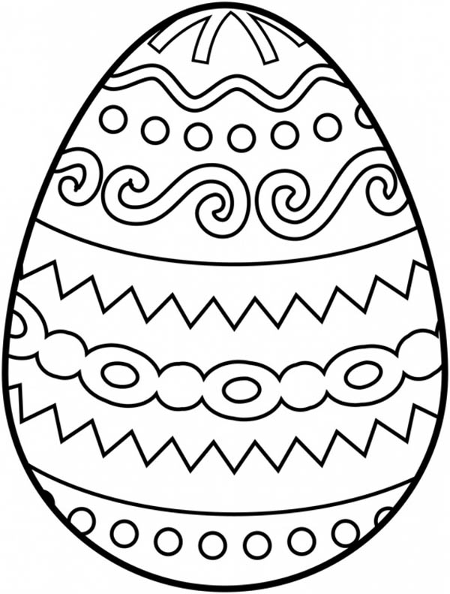

- 10 jumping jacks
- 10 Rocket jumps

