Indoor, Outdoor Easter Egg Game

You will need: Paper, scissors, colours, cello tape, food tins or recycled items (i.e. cereal packet, yoghurt tub)

1. Draw, colour and cut out 6 Easter eggs on paper. (Copy the designs below or create your own.)

2. Write out the fitness feats.

3. Attach your cut outs to the tins or recycled item

4. Now see next page to play the game. Have Fun!

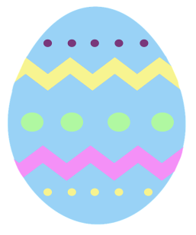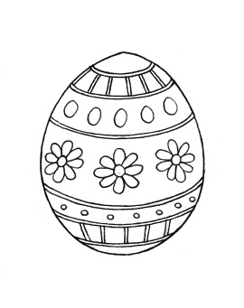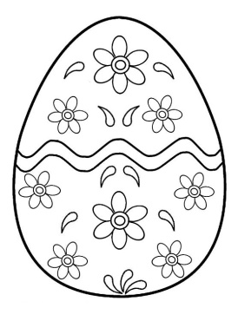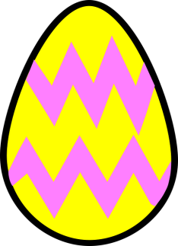

* 20 jog on spot
* 5 bunny hops
* 10 row your boat

20

* 10 high knee marching
* 10 fast feet
* 10 tic tocs
* 5 dance moves
* 10 star jumps
* 5 push ups
* 10 row your boat
* 10 hops on each foot
* 3 moon/tuck jumps
* 5 crab walks
* 5 caterpillar stretches
* 5 frog jumps

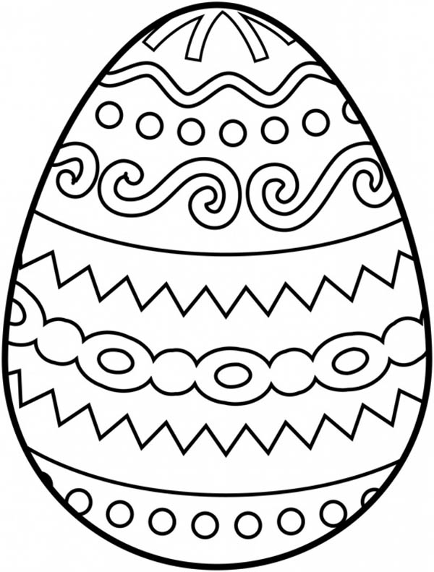

* 10 star jumps
* 5 bunny hops
* 10 tic toc ( feet together) jumps