Friday 3.4.20
Reminder – There is an Easter assembly at 11am. A link will be posted about this before on our Teams page!
Problem Solving
L.I. To use an appropriate strategy to solve a mathematical problem
S.C To use guess, check and improve to solve a problem
Rectangles
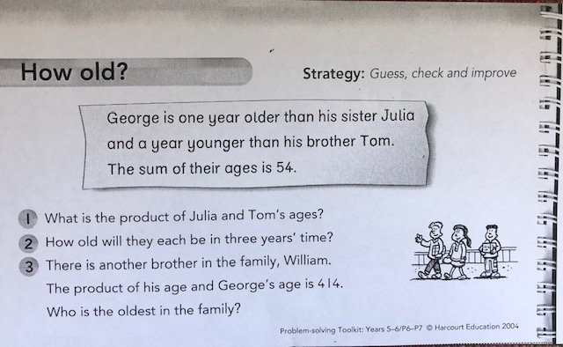
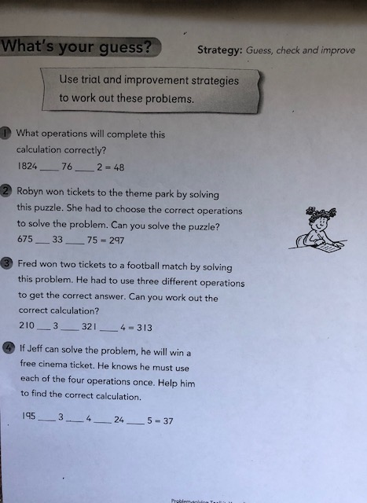

Triangles

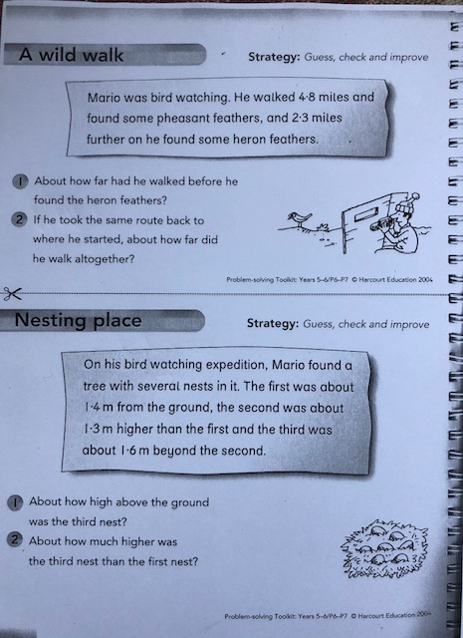
Circles
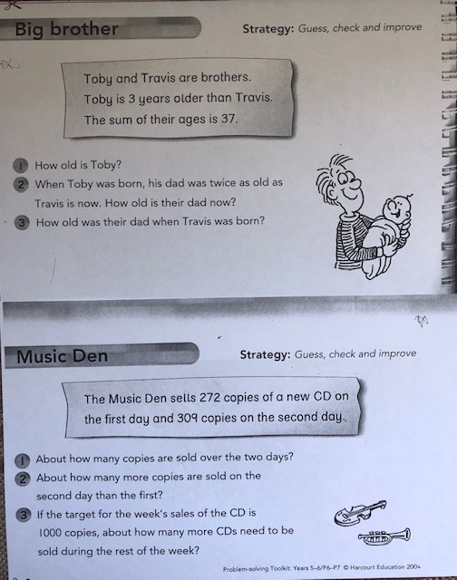
Skills Academy
LI – to create a box by logically linking dots together.
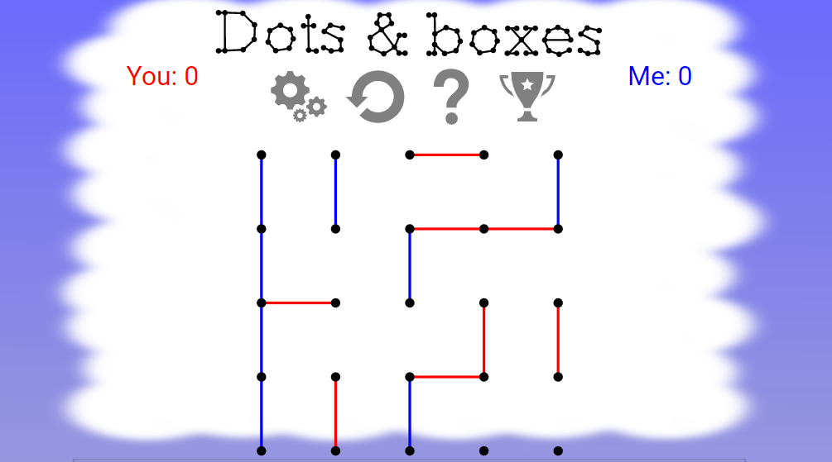
Can you beat your opponent with this fun problem solving game? Create different levels of difficulty.
http://dotsandboxes.org/

Reward time ideas! :D
Listen to your favourite music
Draw or colour an Easter card!
Play a board game with someone at home (if they are not too busy!)
Play a game on a device
Just dance videos! (Search ‘Just dance’ on YouTube)

