Friday 3.4.20
Handwriting
L.I. To join my letters
Write this poem in your jotter using your neatest handwriting, taking care to join your letters accurately.
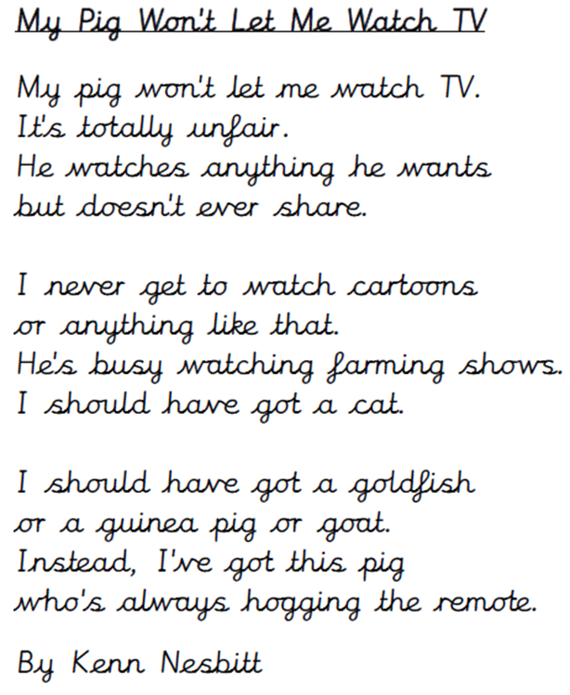

Problem Solving

L.I To apply mathematical reasoning

Always, Sometimes or Never? Shape
Are the following statements always true, sometimes true or never true? Write them out and answer in your jotter. I will post the answers at 11:30 for you to self-mark. Remember... think carefully and draw a picture if you need to!
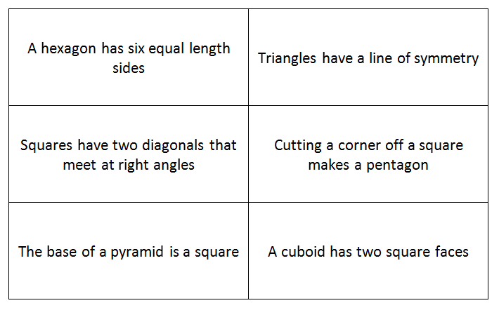
What about these more complex statements?
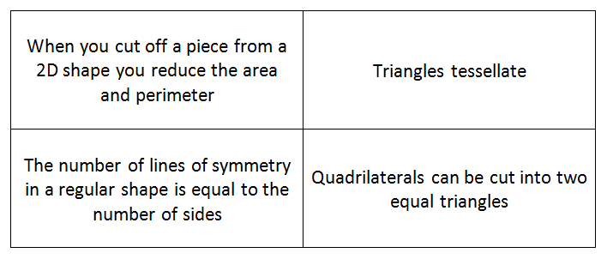

Key questions
Can you think of an example when it isn’t true?
How do you know that it is always true?
Is it possible to check all examples? Is there another way of knowing?

