Thursday 2.4.20

Please remember!
- Work can be completed in your green jotter or on a device/laptop
- You do not need to post on teams to say you have completed a job (we trust you!)
- The online chat is only to be used for questions
- Your teacher will only be available between 8.45 – 3.15 , no posts after that time. Break and lunch times still apply
- Do not put too much pressure on yourself to finish things quickly, these can be done throughout the day
- Remember you have access to apps and links such as Sumdog, Go Noodle and Activelearn. You can play these any time!
- If you finish all the tasks that we have set you can read, or decide what else to do with the rest of your day
- Try to post work in ‘assignments’ or ‘class notebook’ if you can’t do this, don’t panic. You can always upload a photo to the live chat... but you don’t have to!

2.4.20 - Grammar and Punctuation
L.I. To identify what and where punctuation is needed in a text (Literacy)
L.I. To know the key events of the Christian Holy Week (RME)
Below is a piece of text about the key events in the Christian Holy week however, all of the punctuation is missing. Can you be an excellent editor and fix the punctuation? You can simply copy and paste the text on to a new word document and edit using Microsoft Word to save writing out the entire text.

Teaching Points
Remember;
- Capital letters and the beginning of sentences and for proper nouns (Names of special people, places, days of the week etc.) and important words in a title
- Full stops at the end of sentences
- Commas for extra or additional pieces of information or lists. Here is a video link to help if you aren’t sure https://www.youtube.com/watch?v=uXQq4Ug1RIM
- Apostrophes – ‘s for something which belongs to one person. S’ for something belonging to more than one person or when a name already ends in an s (like Jesus!) Here is a video link to help if you aren’t sure
https://www.google.com/search?q=Apostrophe+s+tutorial&rlz=1C1CHBF_en-GBGB818GB818&oq=Apostrophe+s+tutorial&aqs=chrome..69i57.5267j0j1&sourceid=chrome&ie=UTF-8&safe=active&ssui=on#kpvalbx=_ZCGDXpfaMsfrgAbR2YMg26
- Question marks – to show a question

Mild – add all capital letters and full stops
Spicy – add all capital letters, full stops, question marks and commas
Hot – add all capital letters, full stops, question marks, commas and apostrophes

what is easter
easter is an important christian festival it is when christians remember that jesus died on the cross and came back to life three days later holy week begins on palm sunday

what happened on palm sunday
the bible tells us that jesus and his followers went to jerusalem on palm sunday lots of people had heard that jesus was coming so a big crowd had gathered to see him they waved palm leaves in the air and laid them on the ground for jesus to walk on

what happened on maundy thursday
on maundy thursday jesus and his followers had their last meal together known as the last supper jesus washed his friends feet and told them that they should always love one another jesus then gave each person some bread and wine explaining that his friends should share bread and wine after his death to remember him

what happened on good friday
it was on good friday that christians believe that jesus died jesus was made to carry a heavy wooden cross through the city the roman guards nailed Jesus to the cross and placed a crown of thorns on his head

what happened on holy saturday
christians believe that jesus body was placed in a tomb on holy saturday a heavy stone was rolled in front of the entrance and it was guarded by a roman soldier so that no one could take his body

what happened on easter sunday
easter sunday is a happy day for christians because it is the day they believe jesus rose from the dead the bible says that Jesus friends and family went to visit the tomb when they got there the body had gone on that day and for 40 days afterwards jesus friends saw him in lots of different places they realised that god had raised him from the dead

Maths – LI – to use the perimeter of a shape to work out the surface area.

Starter – watch https://www.youtube.com/watch?v=xCdxURXMdFY (from 0:00 to 4:30)
Check out - https://www.activelearnprimary.co.uk/login?c=0 and https://www.studyladder.co.uk/where there are games to help you understand area!

Rectangles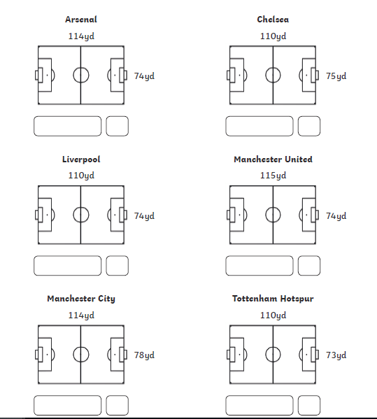

Triangles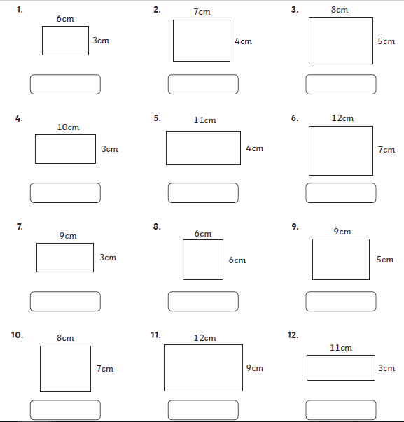

Circles
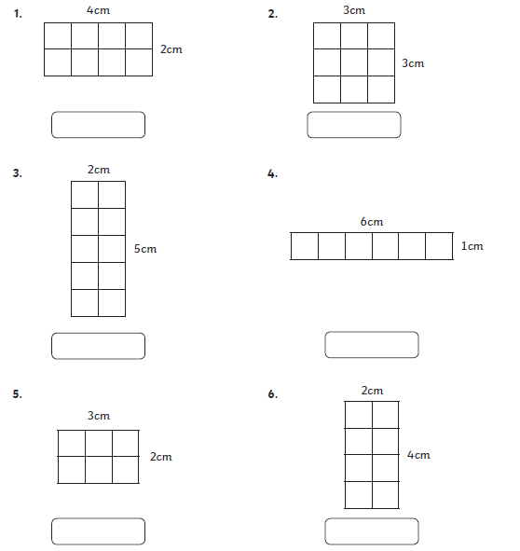

Topic
Choose between mild, spicy and hot.
Make sure you watch the starter clip which describes how Curiosity Rover made its way through space towards Mars.

2.4.20 LI – to understand what the Curiosity Rover is by reading a text (Mild).
Starter - https://www.youtube.com/watch?v=gwinFP8_qIM

The Curiosity rover is a robotic machine about the same size as a car. It is currently exploring Gale Crater, which is near the equator of Mars. The rover is a nuclear-powered robot that is part of NASA's Mars Science Laboratory (MSL).
The MSL mission has four main scientific goals: study Martian climate and geology, search for water, and find out whether Mars could have ever supported life. Curiosity carries the most advanced scientific equipment ever used on the surface of Mars.

- What size is the Curiosity Rover the same size as?
- What does the word explore mean?
- What is the name of the crater on Mars it is currently exploring?
- How is the rover powered?
- How many goals does the rover have?
- Name 2 things that are special about the rover?
- What would you call your rover if it went to a planet?

2.4.20 LI – to understand what the Curiosity Rover is by reading a text. (Spicy)

Starter - https://www.youtube.com/watch?v=gwinFP8_qIM
Spicy
The Curiosity rover is a robotic machine about the same size as a car. It is currently exploring Gale Crater, which is near the equator of Mars. The rover is a nuclear-powered robot that is part of NASA's Mars Science Laboratory (MSL).
The MSL mission has four main scientific goals: study Martian climate and geology, search for water, and find out whether Mars could have ever supported life. Curiosity carries the most advanced scientific equipment ever used on the surface of Mars.
In December 2012, Curiosity's two-year mission was extended indefinitely. On August 5, 2017, NASA celebrated the fifth anniversary of the Curiosity rover landing and related exploratory accomplishments on the planet Mars.
Curiosity's design will serve as the basis for the planned Mars 2020 rover. As of April 1, 2020, Curiosity has been on Mars for Template: Curiosity Mission Timer sols (2795 total days) since landing on August 6, 2012.

- What does the equator mean?
- What energy source fuels the robot?
- What is the name of the crater on Mars it is currently exploring?
- What does the word geology mean?
- Name two of the goals the rover has?
- Name 2 things that are special about the rover?
- What does the word indefinitely mean?
- Why does the word Mars have a capital letter?
- Since 1st April 2020, how many days has Curiosity been on Mars?

2.4.20 LI – to understand what the Curiosity Rover is by reading a text. (Hot)
Starter - https://www.youtube.com/watch?v=gwinFP8_qIM
Hot
The Curiosity rover is a robotic machine about the same size as a car. It is currently exploring Gale Crater, which is near the equator of Mars. The rover is a nuclear-powered robot that is part of NASA's Mars Science Laboratory (MSL).
A NASA panel selected the name Curiosity following a nationwide student contest that attracted more than 9,000 proposals via the Internet and mail. A sixth-grade student from Kansas, twelve-year-old Clara Ma from Sunflower Elementary School in Lenexa, Kansas, submitted the winning entry.
The MSL mission has four main scientific goals: study Martian climate and geology, search for water, and find out whether Mars could have ever supported life. Curiosity carries the most advanced scientific equipment ever used on the surface of Mars.
In December 2012, Curiosity's two-year mission was extended indefinitely. On August 5, 2017, NASA celebrated the fifth anniversary of the Curiosity rover landing and related exploratory accomplishments on the planet Mars.
Curiosity's design will serve as the basis for the planned Mars 2020 rover. As of April 1, 2020, Curiosity has been on Mars for Template: Curiosity Mission Timer sols (2795 total days) since landing on August 6, 2012.

- What does the equator mean?
- Find the meaning of the word panel in the context of this text?
- What energy source powers the robot?
- What is the name of the person who won the student contest to name the rover?
- Why do you think they chose a child to name the rover rather than an adult?
- What does the word submitted mean?
- What does the word Martian mean?
- Name four of the goals the rover has?
- Find 3 facts about Olympus Mons which is a special volcano on Mars.
- What does the word indefinitely mean?
- Work out how many months the rover has been on Mars.
- Imagine you were able to send your own rover to any planet. What planet would you send it to and what goals would you want it to achieve?

