Wednesday 1.4.20
Please remember!
- Work can be completed in your green jotter or on a device/laptop
- Your teacher will only be available between 8.45 – 3.15, if you post after that time we will get back to you in the morning. Break and lunch times still apply
- Do not put too much pressure on yourself to finish things quickly, these can be done throughout the day.
- Remember you have access to apps and links such as Sumdog, Go Noodle, Study Ladder and Activelearn. You can play these any time!
- If you finish all the tasks that we have set you can read, or decide what else to do with the rest of your day
- Try to post work in ‘assignments’ or ‘class notebook’ if you can’t do this, don’t panic. You can always upload a photo to the live chat... but you don’t have to!

IDL

Numeracy
Squares
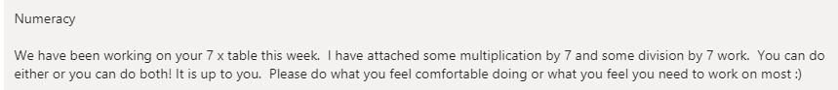

Triangles
Circles
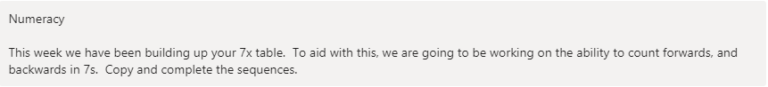

Literacy – Writing
LI to create an animal fact file
SC
