Wednesday 1.4.20
Please remember!
- Work can be completed in your green jotter or on a device/laptop
- You do not need to post on teams to say you have completed a job (we trust you!)
- The online chat is only to be used for questions
- Your teacher will only be available between 8.45 – 3.15 , no posts after that time. Break and lunch times still apply
- Do not put too much pressure on yourself to finish things quickly, these can be done throughout the day
- Remember you have access to apps and links such as Sumdog, Go Noodle and Activelearn. You can play these any time!
- If you finish all the tasks that we have set you can read, or decide what else to do with the rest of your day
- Try to post work in ‘assignments’ or ‘class notebook’ if you can’t do this, don’t panic. You can always upload a photo to the live chat... but you don’t have to!
Here are your jobs for today:
Literacy – Comprehension
Neil Armstrong comprehension – LI: to read for information about an astronaut
Below there are passages and questions all about Neil Armstrong.
You can choose *(mild) **(spicy) ***(hot) passage and questions

Mild passage and questions *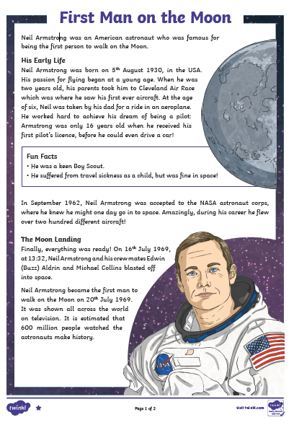
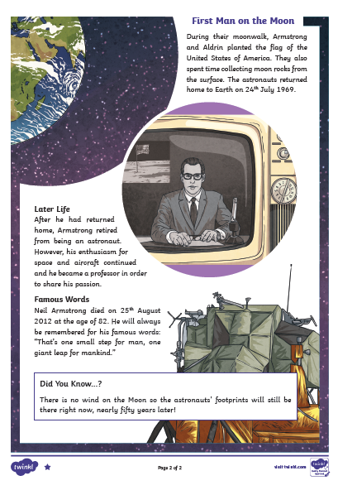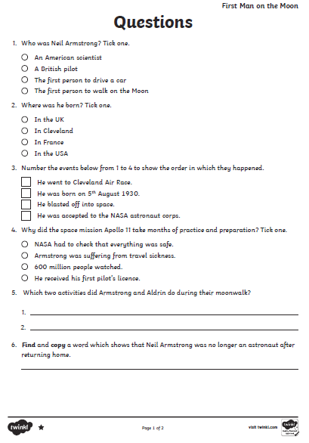
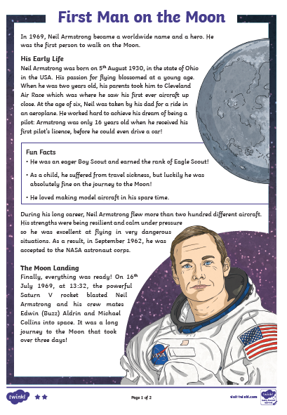
Spicy passage and questions **
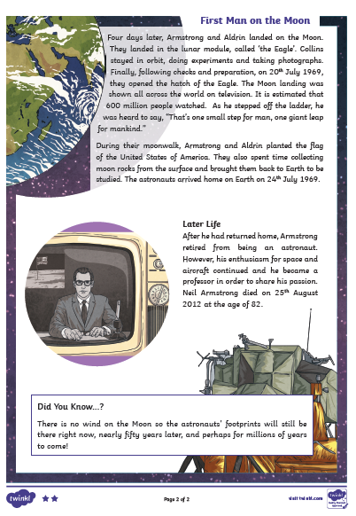
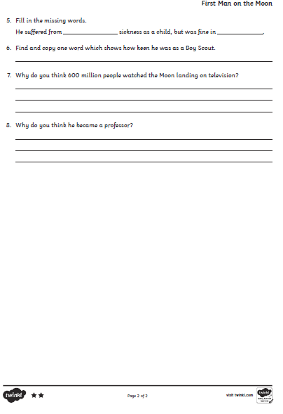
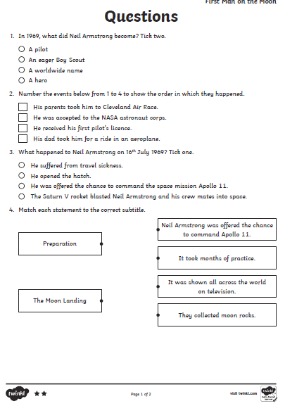
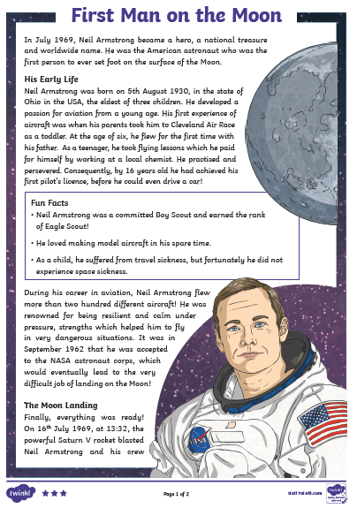
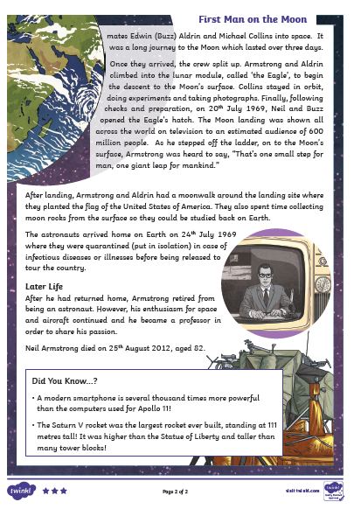
passage and questions ***

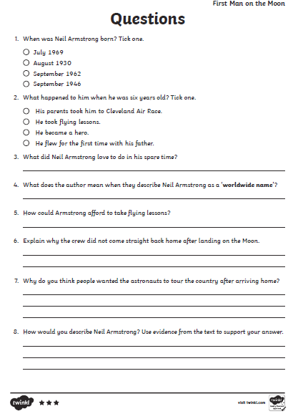
Numeracy
Rectangles: TeeJay E p61
L.I- To be able to be able to add and subtract whole numbers (including negative numbers)
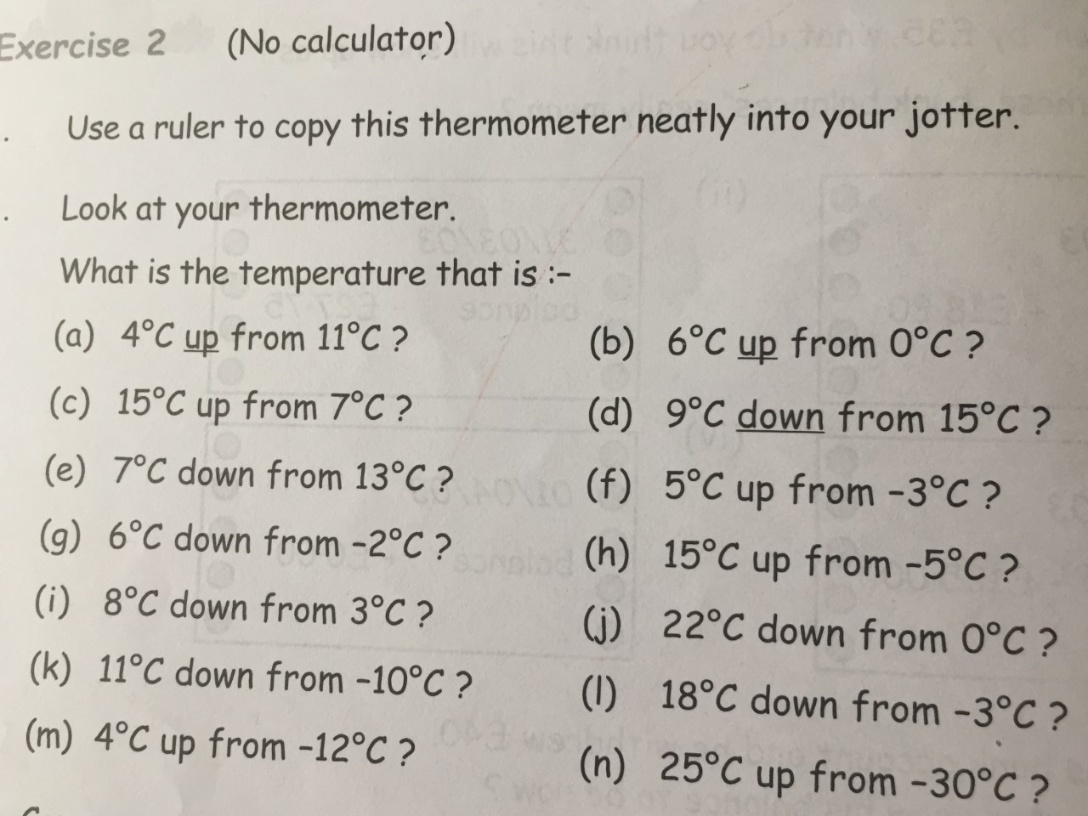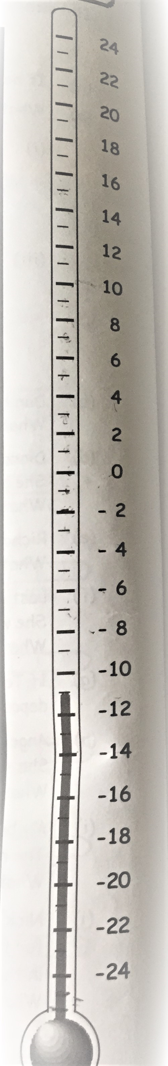
Triangles: TeeJay 2b p82
L.I- To be able to be able to add and subtract whole numbers (including negative numbers)

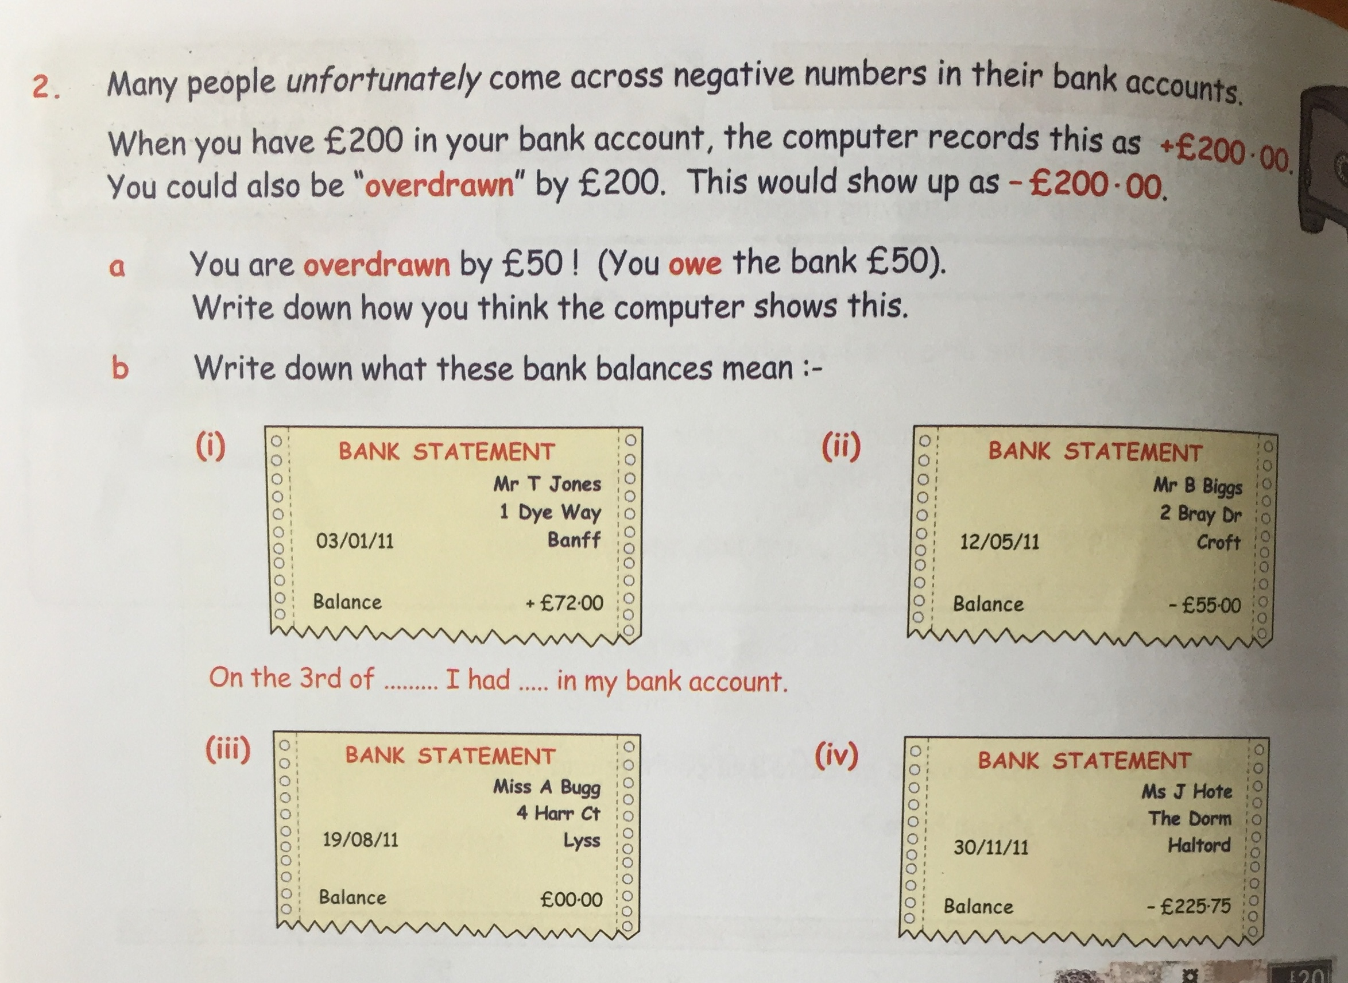

Circles: L.I- To be able to add and subtract whole numbers (including negative numbers)
***Tip- Before starting this task you may want to draw a numberline starting at –20 up to 20
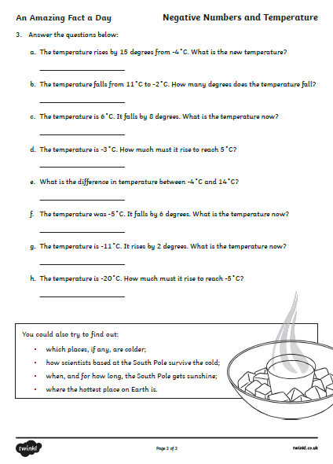

Art – L.I. To experiment with a range of media (resources)
All across the country children are creating rainbows and posting them in their windows to bring smiles to passers-by during the coronavirus outbreak.
The trend has been seen across the world, but became hugely popular in the UK after schools were shut last week.
For art this week we would like you to create a rainbow to put up on a window where passers-by can see it. Send us a picture of your art in the window. You could draw a picture, make a collage or be creative with what you have available. Get creative!
Here is a link with some more information
https://www.bbc.co.uk/newsround/52034134

Here are some ideas;
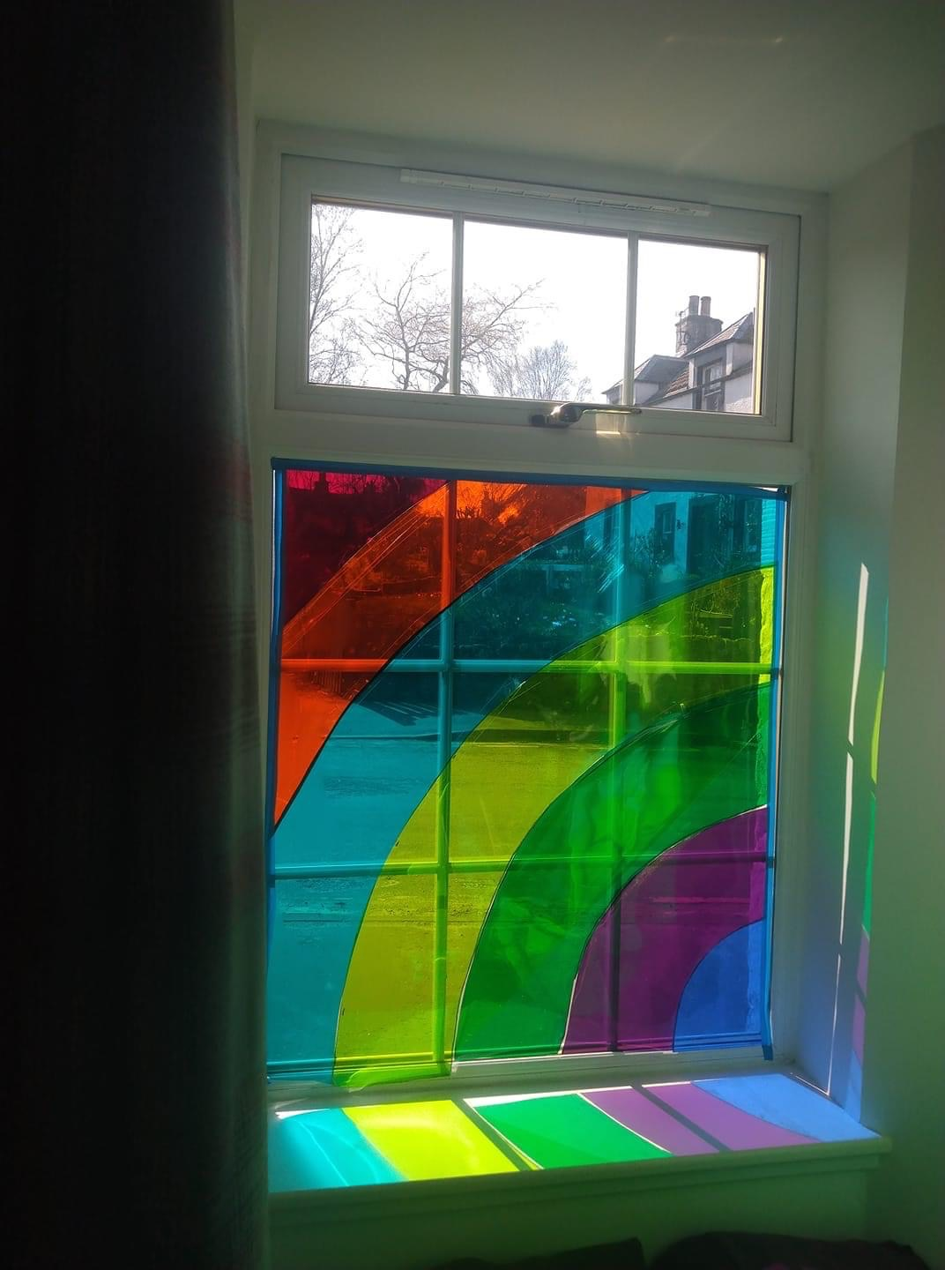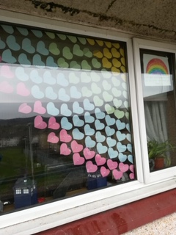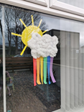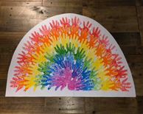

If you have already created a rainbow and put it in your window then can you start creating an Easter Egg design for the Great Big Easter Egg Hunt that I am trying to organise for all the children in West Lothian to take part in?
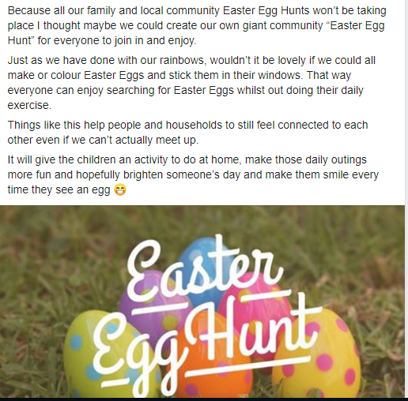

P.E – To develop skills for Hockey

If you haven’t already joined in with the Joe Wicks morning workout, here is a work -out designed especially for hockey players.
https://www.youtube.com/watch?v=t1J8DzXArRw
Today you are going to be employed as a Sports Reporter for a leading sports magazine. Your task for today is to watch the first 20 minutes of the Womens Semi Final at the London 2012 Olympics between England and Argentina. https://www.youtube.com/watch?v=OBMOtVdxXt8
Keep a tally of successful tackles, footwork fouls, shots on goal, Goal Keeper saves and goals scored. You will also need to give your professional opinion on the team performance. Use the sheet below to help to structure you work.
