Wednesday 1.4.20

Spanish
L.I. To identify food and drink in Spanish
Recap the Spanish food and drinks that we have been learning about for the last few weeks in Spanish.
Spanish drinks: Log in to Espresso and type ‘Spanish drinks talking dictionary’ into the search bar. Listen and practise the words.
Spanish food: Read the powerpoint attached to the assignment to remind yourself of the vocabulary.

Once you have done this, test your knowledge by completing the Spanish food and drink quiz! Miss Melrose and Miss Hesp can see your responses so there is no need for you to send us your scores separately.
https://forms.office.com/Pages/ResponsePage.aspx?id=oyzTzM4Wj0KVQTctawUZKVN4vPGb1bZIoOuE2jSG68VUODUyME5STlhJVFRURjBLTkdYSVQ5Ulk4Ni4u

P.E.
L.I. To develop my physical fitness
Get your heart rate up by joining in with Joe Wicks’ live workouts at 9am. https://www.youtube.com/user/thebodycoach1/

Literacy
Spelling Test!
Ask an adult to read out your spelling words, like I would do in class. How did you get on? Share your score with your teacher.
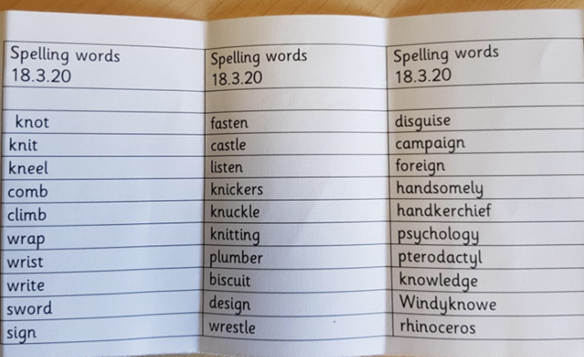
- frog
- drum
- flag
- pram
- stem
- plum
- skip
- clap

New spelling words:
- ibolda – Yesterday I went bowling and ibolda strike
- ittlefitter – I bought my sister a top for her birthday and I hope that ittlefitter
- dondon – when I got home from the shop, it dondon me that I forgot the milk
- catchew – if you try and run away, I will catchew
- eyesmelter – my dog was so stinky that eyesmelter from far away
- winthow – my football team practises all the time, but we never winthow
- freeda – when you finish your work, you are freeda enjoy the rest of your day
- lieberry – you almost got away with it but you don’t lieberry well
- daneeze – when you walk in the pool, the water will go up to daneeze
- ordorsum – if you get hungry, you can ordorsum pizza

L.I. To follow instructions
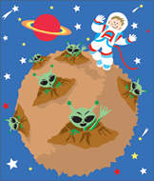
keew ym .1 ksat
yad | snalp
yadnom | .pihsecaps a dliub
yadseut | .noom eht ot ylf
yadsendew | .eltsac noom eht dliub
yadsruht | .seert noom eht tnalp
yadirf | .neila na yrram
yadrutas | .sdik noom ruof evah
yadnus | .noom eht fo tnediserp eht emoceb

erutuf eht ni efil ruoy ward .2 ksat
erutuf eht ni efil s’rehcaet ruoy ward .3 ksat

Numeracy
L.I. To identify and continue a pattern
Please complete the Heinemann Active Maths workbook page.
If you’re finished, play Sequences which is the allocated game on Active Learn.

Numeracy Ninjas/Maths Magicians
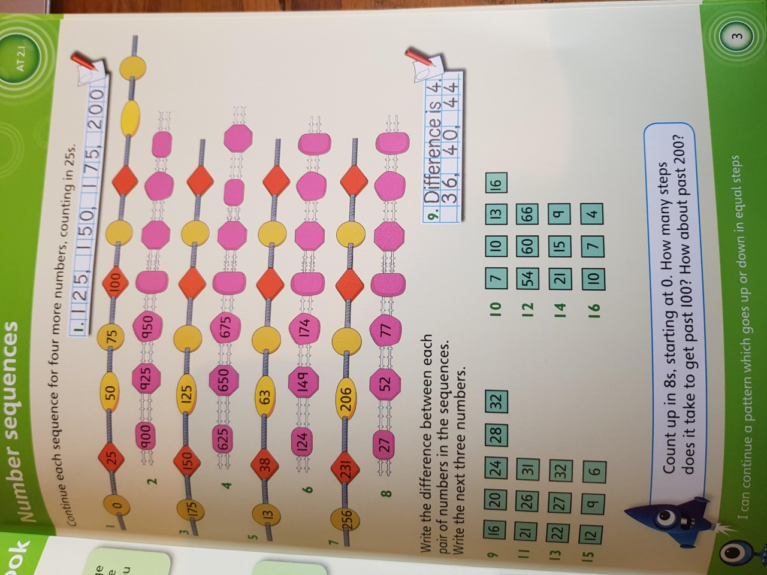

Mathletes
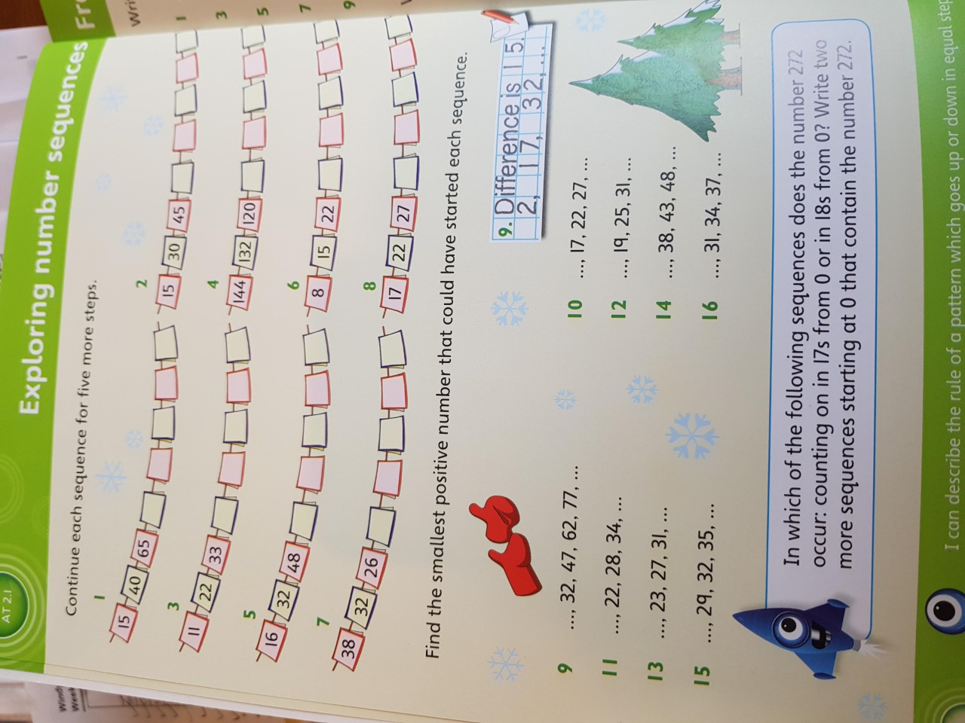

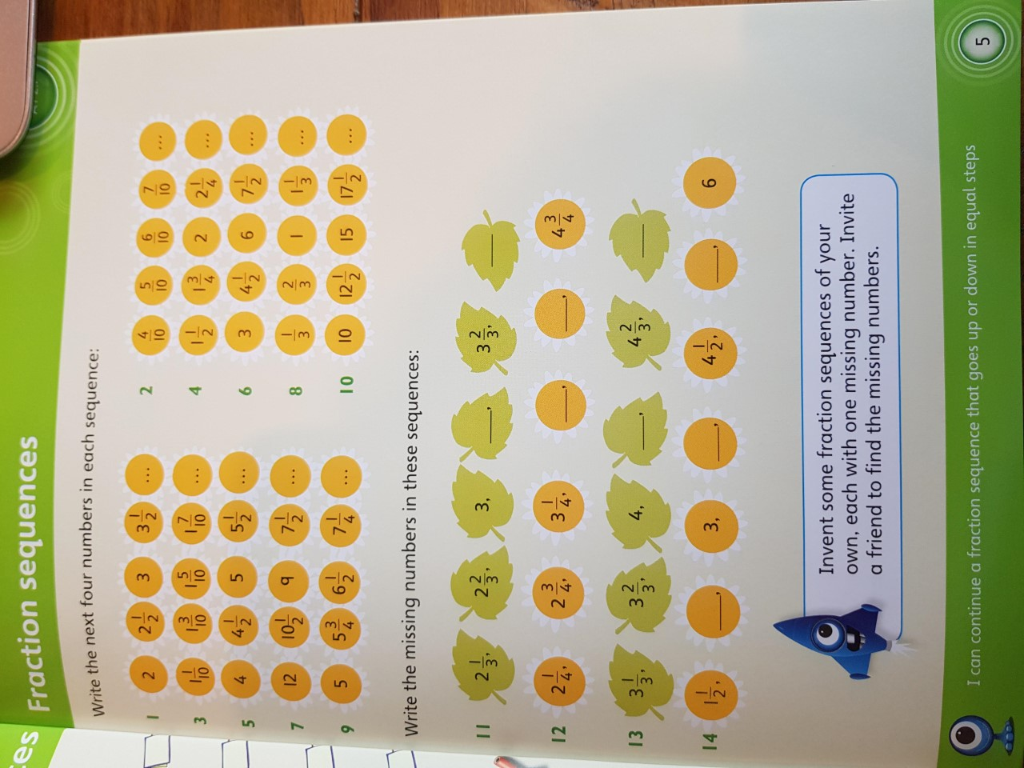
Algebro

